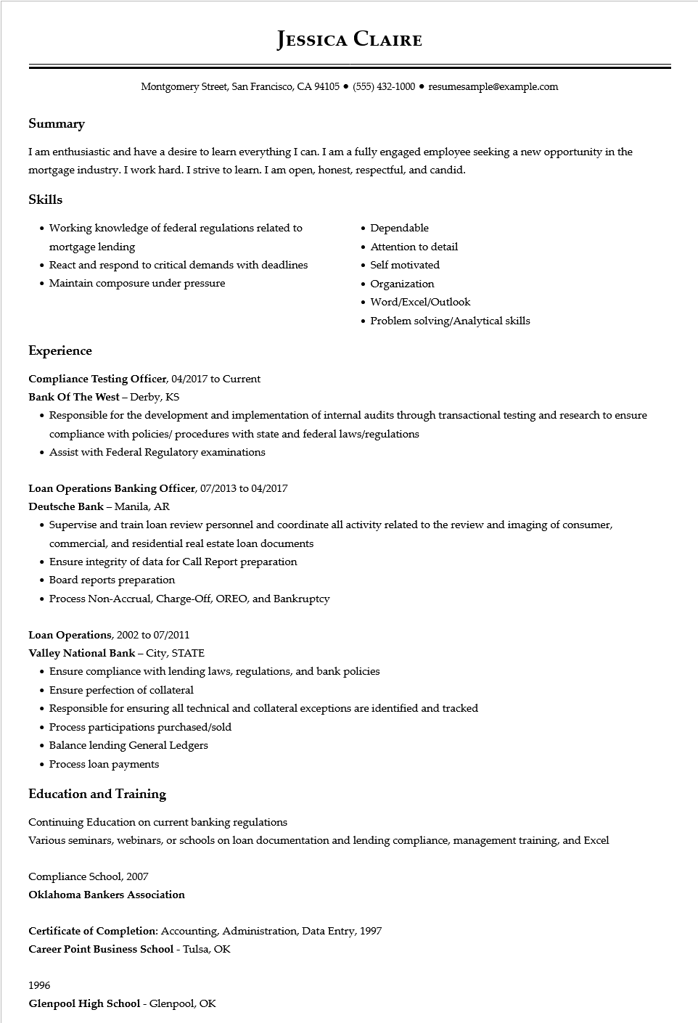

**JESSICA CLAIRE**

Montgomery Street, San Francisco, CA 94105 ● (555) 432-1000⚫ resumesample@example.com

**Summary**

I am enthusiastic and have a desire to learn everything I can. I am a fully engaged employee seeking a new opportunity in the mortgage industry. I work hard. I strive to learn. I am open, honest, respectful, and candid.

Skills

• Working knowledge of federal regulations related to mortgage lending

• React and respond to critical demands with deadlines • Maintain composure under pressure

• Dependable

• Attention to detail

• Self motivated

• Organization

• Word/Excel/Outlook

• Problem solving/Analytical skills

**Experience**

**Compliance Testing Officer, 04/2017 to Current**

Bank Of The West - Derby, KS

• Responsible for the development and implementation of internal audits through transactional testing and research to ensure compliance with policies/procedures with state and federal laws/regulations

• Assist with Federal Regulatory examinations

Loan Operations Banking Officer, 07/2013 to 04/2017

Deutsche Bank - Manila, AR

• Supervise and train loan review personnel and coordinate all activity related to the review and imaging of consumer, commercial, and residential real estate loan documents

• Ensure integrity of data for Call Report preparation

• Board reports preparation

• Process Non-Accrual, Charge-Off, OREO, and Bankruptcy

Loan Operations, 2002 to 07/2011

**Valley National Bank - City, STATE**

• Ensure compliance with lending laws, regulations, and bank policies

• Ensure perfection of collateral

• Responsible for ensuring all technical and collateral exceptions are identified and tracked

• Process participations purchased/sold

• Balance lending General Ledgers

• Process loan payments

**Education and Training**

Continuing Education on current banking regulations

Various seminars, webinars, or schools on loan documentation and lending compliance, management training, and Excel

Compliance School, 2007

**Oklahoma Bankers Association**

Certificate of Completion: Accounting, Administration, Data Entry, 1997

**Career Point Business School - Tulsa, OK**

1996

**Glenpool High School - Glenpool, OK**