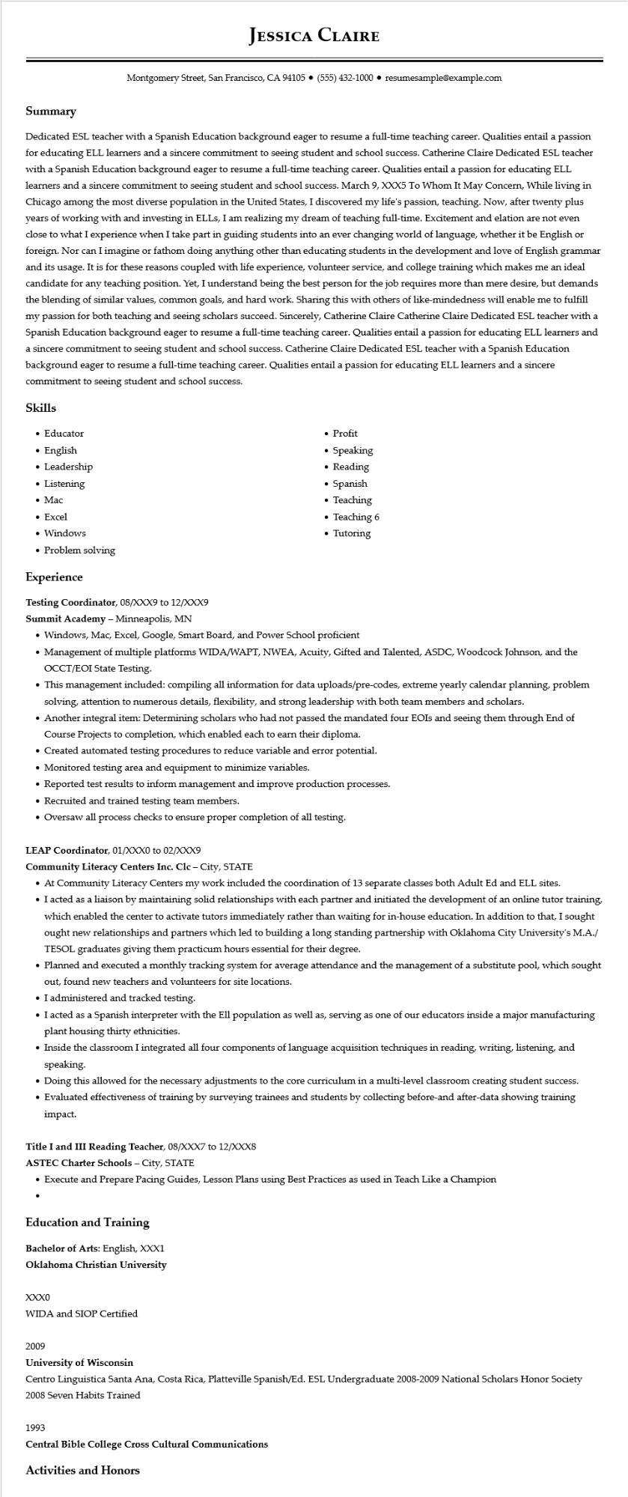

**JESSICA CLAIRE**

Montgomery Street, San Francisco, CA 94105⚫ (555) 432-1000⚫ resumesample@example.com

**Summary**

Dedicated ESL teacher with a Spanish Education background eager to resume a full-time teaching career. Qualities entail a passion for educating ELL learners and a sincere commitment to seeing student and school success. Catherine Claire Dedicated ESL teacher with a Spanish Education background eager to resume a full-time teaching career. Qualities entail a passion for educating ELL learners and a sincere commitment to seeing student and school success. March 9, XXX5 To Whom It May Concern, While living in Chicago among the most diverse population in the United States, I discovered my life's passion, teaching. Now, after twenty plus years of working with and investing in ELLs, I am realizing my dream of teaching full-time. Excitement and elation are not even close to what I experience when I take part in guiding students into an ever changing world of language, whether it be English or foreign. Nor can I imagine or fathom doing anything other than educating students in the development and love of English grammar and its usage. It is for these reasons coupled with life experience, volunteer service, and college training which makes me an ideal candidate for any teaching position. Yet, I understand being the best person for the job requires more than mere desire, but demands the blending of similar values, common goals, and hard work. Sharing this with others of like-mindedness will enable me to fulfill my passion for both teaching and seeing scholars succeed. Sincerely, Catherine Claire Catherine Claire Dedicated ESL teacher with a Spanish Education background eager to resume a full-time teaching career. Qualities entail a passion for educating ELL learners and a sincere commitment to seeing student and school success. Catherine Claire Dedicated ESL teacher with a Spanish Education background eager to resume a full-time teaching career. Qualities entail a passion for educating ELL learners and a sincere commitment to seeing student and school success.

**Skills**

• Educator

• English

• Leadership

• Listening

• Mac

• Excel

• Windows

• Problem solving

**Experience**

Testing Coordinator, 08/XXX9 to 12/XXX9

Summit Academy - Minneapolis, MN

• Profit

• Speaking

• Reading

·

Spanish

• Teaching

• Teaching 6

• Tutoring

• Windows, Mac, Excel, Google, Smart Board, and Power School proficient

• Management of multiple platforms WIDA/WAPT, NWEA, Acuity, Gifted and Talented, ASDC, Woodcock Johnson, and the OCCT/EOI State Testing.

• This management included: compiling all information for data uploads/pre-codes, extreme yearly calendar planning, problem solving, attention to numerous details, flexibility, and strong leadership with both team members and scholars.

• Another integral item: Determining scholars who had not passed the mandated four EOIs and seeing them through End of Course Projects to completion, which enabled each to earn their diploma.

• Created automated testing procedures to reduce variable and error potential.

• Monitored testing area and equipment to minimize variables.

• Reported test results to inform management and improve production processes.

• Recruited and trained testing team members.

• Oversaw all process checks to ensure proper completion of all testing.

**LEAP Coordinator, 01/XXX0 to 02/XXX9**

**Community Literacy Centers Inc. Clc - City, STATE**

• At Community Literacy Centers my work included the coordination of 13 separate classes both Adult Ed and ELL sites.

• I acted as a liaison by maintaining solid relationships with each partner and initiated the development of an online tutor training, which enabled the center to activate tutors immediately rather than waiting for in-house education. In addition to that, I sought ought new relationships and partners which led to building a long standing partnership with Oklahoma City University's M.A./ TESOL graduates giving them practicum hours essential for their degree.

• Planned and executed a monthly tracking system for average attendance and the management of a substitute pool, which sought out, found new teachers and volunteers for site locations.

⚫ I administered and tracked testing.

• I acted as a Spanish interpreter with the Ell population as well as, serving as one of our educators inside a major manufacturing plant housing thirty ethnicities.

• Inside the classroom I integrated all four components of language acquisition techniques in reading, writing, listening, and speaking.

• Doing this allowed for the necessary adjustments to the core curriculum in a multi-level classroom creating student success.

• Evaluated effectiveness of training by surveying trainees and students by collecting before-and after-data showing training impact.

**Title I and III Reading Teacher, 08/XXX7 to 12/XXX8**

ASTEC Charter Schools - City, STATE

• Execute and Prepare Pacing Guides, Lesson Plans using Best Practices as used in Teach Like a Champion

**Education and Training**

Bachelor of Arts: English, XXX1

**Oklahoma Christian University**

XXX0

WIDA and SIOP Certified

2009

University of Wisconsin

Centro Linguistica Santa Ana, Costa Rica, Platteville Spanish/Ed. ESL Undergraduate 2008-2009 National Scholars Honor Society 2008 Seven Habits Trained

1993

**Central Bible College Cross Cultural Communications**

**Activities and Honors**