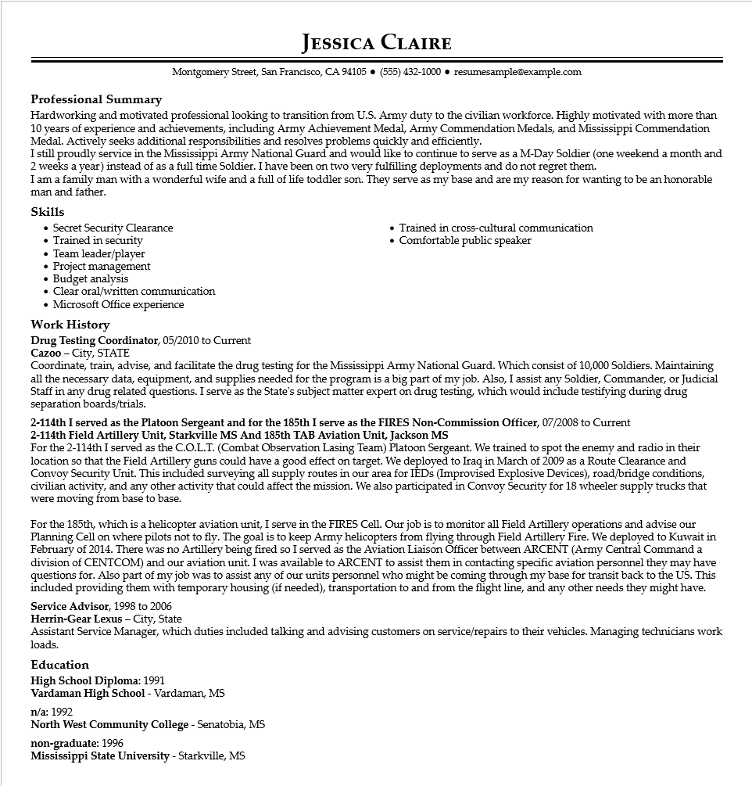

**Professional Summary**

**JESSICA CLAIRE**

Montgomery Street, San Francisco, CA 94105 (555) 432-1000⚫ resumesample@example.com

Hardworking and motivated professional looking to transition from U.S. Army duty to the civilian workforce. Highly motivated with more than 10 years of experience and achievements, including Army Achievement Medal, Army Commendation Medals, and Mississippi Commendation Medal. Actively seeks additional responsibilities and resolves problems quickly and efficiently.

I still proudly service in the Mississippi Army National Guard and would like to continue to serve as a M-Day Soldier (one weekend a month and 2 weeks a year) instead of as a full time Soldier. I have been on two very fulfilling deployments and do not regret them.

I am a family man with a wonderful wife and a full of life toddler son. They serve as my base and are my reason for wanting to be an honorable man and father.

**Skills**

Secret Security Clearance

• Trained in security

• Team leader/player

• Project management

• Budget analysis

Clear oral/written communication

• Microsoft Office experience

**Work History**

Drug Testing Coordinator, 05/2010 to Current

Cazoo - City, STATE

• Trained in cross-cultural communication Comfortable public speaker

Coordinate, train, advise, and facilitate the drug testing for the Mississippi Army National Guard. Which consist of 10,000 Soldiers. Maintaining all the necessary data, equipment, and supplies needed for the program is a big part of my job. Also, I assist any Soldier, Commander, or Judicial Staff in any drug related questions. I serve as the State's subject matter expert on drug testing, which would include testifying during drug separation boards/trials.

2-114th I served as the Platoon Sergeant and for the 185th I serve as the FIRES Non-Commission Officer, 07/2008 to Current 2-114th Field Artillery Unit, Starkville MS And 185th TAB Aviation Unit, Jackson MS

For the 2-114th I served as the C.O.L.T. (Combat Observation Lasing Team) Platoon Sergeant. We trained to spot the enemy and radio in their location so that the Field Artillery guns could have a good effect on target. We deployed to Iraq in March of 2009 as a Route Clearance and Convoy Security Unit. This included surveying all supply routes in our area for IEDs (Improvised Explosive Devices), road/bridge conditions, civilian activity, and any other activity that could affect the mission. We also participated in Convoy Security for 18 wheeler supply trucks that were moving from base to base.

For the 185th, which is a helicopter aviation unit, I serve in the FIRES Cell. Our job is to monitor all Field Artillery operations and advise our Planning Cell on where pilots not to fly. The goal is to keep Army helicopters from flying through Field Artillery Fire. We deployed to Kuwait in February of 2014. There was no Artillery being fired so I served as the Aviation Liaison Officer between ARCENT (Army Central Command a division of CENTCOM) and our aviation unit. I was available to ARCENT to assist them in contacting specific aviation personnel they may have questions for. Also part of my job was to assist any of our units personnel who might be coming through my base for transit back to the US. This included providing them with temporary housing (if needed), transportation to and from the flight line, and any other needs they might have. Service Advisor, 1998 to 2006

Herrin-Gear Lexus - City, State

Assistant Service Manager, which duties included talking and advising customers on service/repairs to their vehicles. Managing technicians work loads.

**Education**

**High School Diploma: 1991**

Vardaman High School - Vardaman, MS

n/a: 1992

North West Community College - Senatobia, MS

**non-graduate: 1996**

Mississippi State University - Starkville, MS