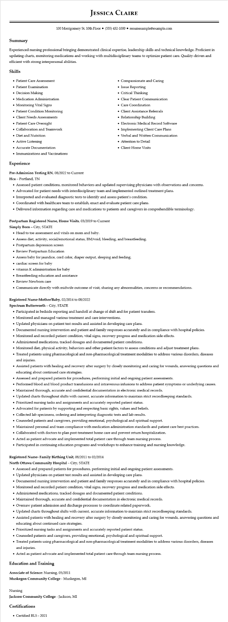

**JESSICA CLAIRE**

100 Montgomery St. 10th Floor⚫ (555) 432-1000⚫ resumesample@example.com

**Summary**

Experienced nursing professional bringing demonstrated clinical expertise, leadership skills and technical knowledge. Proficient in updating charts, monitoring medications and working with multidisciplinary teams to optimize patient care. Quality-driven and efficient with strong interpersonal abilities.

**Skills**

• Patient Care Assessment

• Patient Examination

• Decision Making

• Medication Administration

• Monitoring Vital Signs

• Patient Condition Monitoring

• Client Needs Assessments

• Patient Care Oversight

• Collaboration and Teamwork

• Diet and Nutrition

• Active Listening

• Accurate Documentation

• Immunizations and Vaccinations

**Experience**

**Pre-Admission Testing RN, 08/2022 to Current**

Hca - Portland, TN

• Compassionate and Caring

• Issue Reporting

• Critical Thinking

• Clear Patient Communication

• Care Coordination

• Client Assistance Referrals

• Relationship Building

• Electronic Medical Record Software

• Implementing Client Care Plans

• Verbal and Written Communication • Attention to Detail

• Client Home Visits

• Assessed patient conditions, monitored behaviors and updated supervising physicians with observations and concerns.

• Advocated for patient needs with interdisciplinary team and implemented outlined treatment plans.

• Interpreted and evaluated diagnostic tests to identify and assess patient's condition.

• Coordinated with healthcare team to establish, enact and evaluate patient care plans.

• Delivered information regarding care and medications to patients and caregivers in comprehendible terminology.

Postpartum Registered Nurse, Home Visits, 03/2019 to Current

**Simply Born - City, STATE**

• Head to toe assessment and vitals on mom and baby.

• Assess diet, activity, social/emotional status, BM/void, bleeding, and breastfeeding.

• Postpartum depression screen

• Review Postpartum Education

• Assess baby for jaundice, cord color, diaper output, sleeping and feeding.

⚫ cardiac screen for baby

• vitamin K administration for baby

• Breastfeeding education and assistance

• Review Newborn care

• Communicate directly with midwife outcome of visit, sharing any abnormalities, concerns or recommendations.

**Registered Nurse-Mother/Baby, 02/2014 to 08/2022**

Spectrum Butterworth - City, STATE

• Participated in bedside reporting and handoff at change of shift and for patient transfers.

• Monitored and managed various treatment and care interventions.

• Updated physicians on patient test results and assisted in developing care plans.

• Documented nursing intervention and patient and family responses accurately and in compliance with hospital policies.

• Monitored and recorded patient condition, vital signs, recovery progress and medication side effects.

• Administered medications, tracked dosages and documented patient conditions.

• Monitored diet, physical activity, behaviors and other patient factors to assess conditions and adjust treatment plans.

• Treated patients using pharmacological and non-pharmacological treatment modalities to address various disorders, diseases and injuries.

• Assisted patients with healing and recovery after surgery by closely monitoring and caring for wounds, answering questions and educating about continued care strategies.

• Assessed and prepared patients for procedures, performing initial and ongoing patient assessments.

• Performed blood and blood product transfusions and intravenous infusions to address patient symptoms or underlying causes.

• Maintained thorough, accurate and confidential documentation in electronic medical records.

• Updated charts throughout shifts with current, accurate information to maintain strict recordkeeping standards.

• Prioritized nursing tasks and assignments and accurately reported patient status.

• Advocated for patients by supporting and respecting basic rights, values and beliefs.

• Collected lab specimens, ordering and interpreting diagnostic tests and lab results.

• Counseled patients and caregivers, providing emotional, psychological and spiritual support.

• Maintained personal and team compliance with medication administration standards and patient care best practices.

• Collaborated with doctors to plan post-treatment home care and prevent return hospitalization.

• Acted as patient advocate and implemented total patient care through team nursing process.

• Participated in continuing education programs and workshops to enhance training and nursing knowledge.

**Registered Nurse-Family Birthing Unit, 08/2011 to 02/2014**

**North Ottawa Community Hospital - City, STATE**

• Assessed and prepared patients for procedures, performing initial and ongoing patient assessments.

• Updated physicians on patient test results and assisted in developing care plans.

• Documented nursing intervention and patient and family responses accurately and in compliance with hospital policies.

• Monitored and recorded patient condition, vital signs, recovery progress and medication side effects.

• Administered medications, tracked dosages and documented patient conditions.

• Maintained thorough, accurate and confidential documentation in electronic medical records.

• Oversaw patient admission and discharge processes to coordinate related paperwork.

·

Updated charts throughout shifts with current, accurate information to maintain strict recordkeeping standards.

• Assisted patients with healing and recovery after surgery by closely monitoring and caring for wounds, answering questions and educating about continued care strategies.

• Prioritized nursing tasks and assignments and accurately reported patient status.

• Counseled patients and caregivers, providing emotional, psychological and spiritual support.

• Treated patients using pharmacological and non-pharmacological treatment modalities to address various disorders, diseases

and injuries.

• Acted as patient advocate and implemented total patient care through team nursing process.

**Education and Training**

Associate of Science: Nursing, 05/2011

**Muskegon Community College - Muskegon, MI**

Nursing

**Jackson Community College - Jackson, MI**

**Certifications**

• Certified BLS - 2021