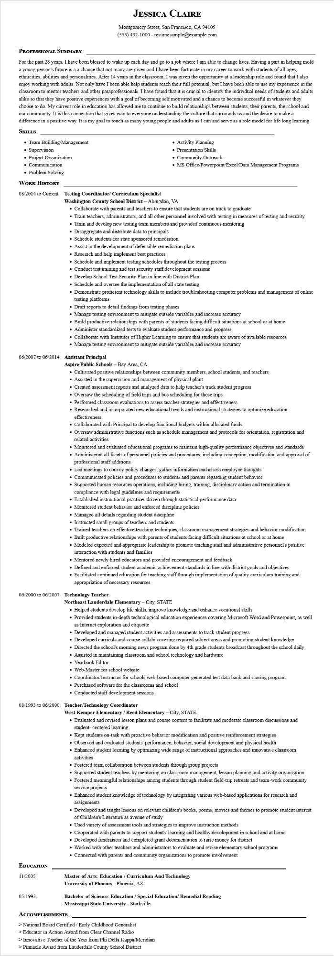

**JESSICA CLAIRE**

Montgomery Street, San Francisco, CA 94105

(555) 432-1000 - resumesample@example.com

**PROFESSIONAL SUMMARY**

For the past 28 years, I have been blessed to wake up each day and go to a job where I am able to change lives. Having a part in helping mold young person's future is a a chance that not many are given and I have been fortunate in my career to work with students of all ages, ethnicities, abilities and personalities. After 14 years in the classroom, I was given the opportunity at a leadership role and found that I also enjoy working with adults. Not only have I been able help students reach their full potential, but I have been able to use my experience in the classroom to mentor teachers and other paraprofessionals. I have found that it is crucial to identify the individual needs of students and adults alike so that they have positive experiences with a goal of becoming self motivated and a chance to become successful in whatever they choose to do. My current role in education has allowed me to continue to build relationships between students, their parents, the school and our community. It is this connection that gives way to everyone understanding the culture that surrounds us and the desire to make a difference in a positive way. It is my goal to touch as many young people and adults as I can and serve as a role model for life long learning. SKILLS

• Team Building/Management

• Supervision

• Project Organization

• Communication

• Problem Solving

**WORK HISTORY**

**08/2014 to Current Testing Coordinator/ Curriculum Specialist**

• Activity Planning

• Presentation Skills

• Community Outreach

• MS Office/Powerpoint/Excel/Data Management Programs

**Washington County School District - Abingdon, VA**

• Collaborate with parents and teachers to ensure that students are on track to graduate

• Train teachers, administrators, and all other personnel involved with testing in measures of testing and security

• Train and develop new testing team members and provided continuous mentoring

• Disaggregate and distribute data to principals

• Schedule students for state sponsored remediation

• Assist in the development of defensible remediation plans

• Research and help implement best practices

• Schedule and implement testing schedules throughout the testing process

• Conduct test training and test security staff development sessions

• Develop School Test Security Plan in line with District Plan

• Schedule and oversee the implementation of all state testing

• Demonstrate proficient technology skills to include troubleshooting computer problems and management of online testing platforms

• Draft reports to detail findings from testing phases

• Manage testing environment to mitigate outside variables and increase accuracy

• Build productive relationships with parents of students facing difficult situations at school or at home

• Administer standardized tests to evaluate student performance and progress

• Collaborate with Institutes of Higher Learning to ensure that students are aware of available resources

• Manage testing environment to mitigate outside variables and increase accuracy

**06/2007 to 06/2014 Assistant Principal**

**Aspire Public Schools - Bay Area, CA**

• Cultivated positive relationships between community members, school students, and teachers

• Assisted in the supervision and management of physical plant

• Created assessment reports and analyzed data to help teacher's track student progress

• Oversaw the scheduling of field trips and bus scheduling for those trips

• Performed classroom evaluations to assess teacher strategies and effectiveness

• Researched and incorporated new educational trends and instructional strategies to optimize education effectiveness

• Collaborated with Principal to develop functional budgets within allocated funds

• Oversaw administrative functions such as schedule management and protocols for orientation, registration and related activities

• Monitored and evaluated educational programs to maintain high-quality performance objectives and standards

• Administered all facets of personnel policies and procedures, including conception, modification and approval of professional staff additions

• Led meetings to convey policy changes, gather information and assess employee thoughts

• Communicated policies and procedures to students and parents regarding student behavior

• Supported human resources operations, including hiring, training, disciplinary action and termination in compliance with legal guidelines and requirements

• Established instructional practices driven through statistical performance data

• Monitored student behavior and enforced discipline policies

• Managed all details regarding student discipline

• Instructed small groups of teachers and students

• Trained teachers on effective teaching techniques, classroom management strategies and behavior modification

• Built productive relationships with parents of students facing difficult situations at school or at home

• Modeled expected and appropriate leadership to promote teaching staff and administrative personnel's positive interaction with students and families

• Mentored newly hired educators and provided encouragement and feedback

• Defined and enforced student academic achievement standards in line with district goals and objectives

• Facilitated continued education for teaching staff through implementation of quality curriculum training and appropriation of necessary resources

**06/2000 to 06/2007 Technology Teacher**

**Northeast Lauderdale Elementary - City, STATE**

• Helped students develop life skills, improve knowledge and enhance vocational skills

• Provided students in-depth technological education experiences covering Microsoft Word and Powerpoint, as well as Internet exploration and etiquette

• Developed and managed student activities and assessments to track student progress

• Developed curricula and course syllabi covering required subject areas and promoting student knowledge

• Directed the school's morning news program done by 4th grade students broadcast throughout the school daily

• Assisted in maintaining classroom and school technology and hardware

• Yearbook Editor

• Web-Master for school website

• Coordinator/Instructor for schools web-based computer generated test data bank and scoring program

• Purchased software for the classrooms and school

• Conducted staff development sessions

**08/1993 to 06/2000 Teacher/Technology Coordinator**

**West Kemper Elementary / Reed Elementary - City, STATE**

• Evaluated and revised lesson plans and course content to facilitate and moderate classroom discussions and student-centered learning

• Kept students on-task with proactive behavior modification and positive reinforcement strategies

• Observed and evaluated students' performance, behavior, social development and physical health

• Enhanced student learning by optimizing wide range of instructional approaches and innovative classroom activities

• Fostered team collaboration between students through group projects

• Supported student teachers by mentoring on classroom management, lesson planning and activity organization

• Fostered meaningful relationships among students through student field-trip retreats and team-work community service projects

• Enhanced student knowledge of technology by integrating various web-based applications for research and

assignments

• Developed and taught lessons on relevant children's books, poems, movies and themes to promote student interest of Children's Literature as avenue of study

• Used variety of assessment tools and strategies to improve instruction methods

• Cooperated with parents to support students' learning and healthy development in school and at home

• Developed fundraisers and completed grant documentation to raise money for district

• Worked with other teachers and administrators to evaluate and revise elementary school programs

• Connected with parents and community organizations to promote involvement

**EDUCATION**

11/2005

05/1993

**Master of Arts: Education/Curriculum And Technology**

**University of Phoenix - Phoenix, AZ**

**Bachelor of Science: Education / Special Education/ Remedial Reading Mississippi State University - Starkville**

**ACCOMPLISHMENTS**

> National Board Certified/Early Childhood Generalist

> Educator in Action Award from Clear Channel Radio

> Innovative Teacher of the Year from Phi Delta Kappa/Meridian

> Pinnacle Award from Lauderdale County School District