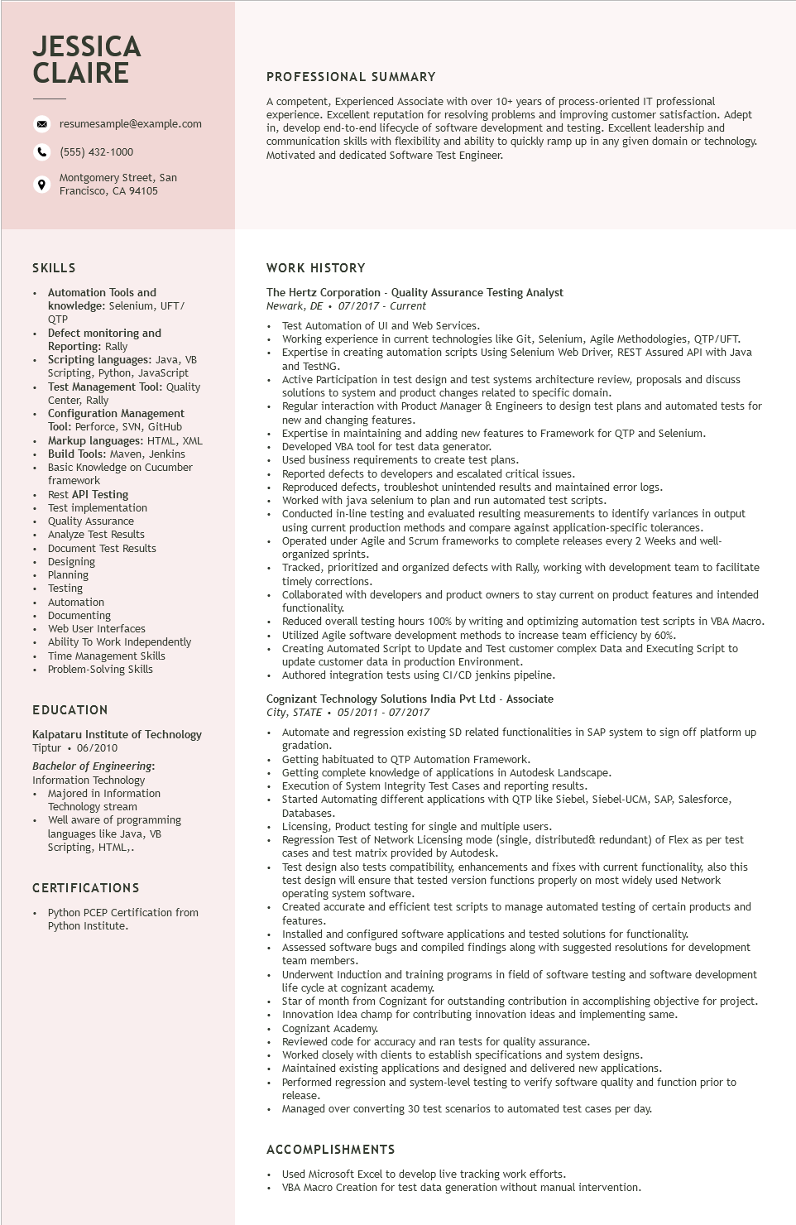

**JESSICA CLAIRE**

°

resumesample@example.com

(555) 432-1000

Montgomery Street, San Francisco, CA 94105

**PROFESSIONAL SUMMARY**

A competent, Experienced Associate with over 10+ years of process-oriented IT professional experience. Excellent reputation for resolving problems and improving customer satisfaction. Adept in, develop end-to-end lifecycle of software development and testing. Excellent leadership and communication skills with flexibility and ability to quickly ramp up in any given domain or technology. Motivated and dedicated Software Test Engineer.

SKILLS

Automation Tools and

knowledge: Selenium, UFT/

QTP

Defect monitoring and

Reporting:

Rally

Scripting languages: Java, VB Scripting, Python, JavaScript Test Management Tool: Quality Center, Rally

Configuration Management Tool: Perfor

Perforce, SVN, GitHub

Markup languages: HTML, XML Build Tools: Maven, Jenkins Basic Knowledge on Cucumber framework

Rest API Testing

Test implementation

• Quality Assurance Analyze Test Results

Document Test Results

• Designing Planning

Testing resting

• Automation Autor

• Documenting

Web User Interfaces

• Ability To Work Independently

Time Management Skills

• Problem-Solving Skills

EDUCATION

Kalpataru Institute of Technology Tiptur 06/2010

Bachelor of Engineering:

Information Technology

• Majored in Information Technology stream

Well aware of programming languages like Java, VB Scripting, HTML,.

CERTIFICATIONS

Python PCEP Certification from Python Institute.

WORK HISTORY

The Hertz Corporation - Quality Assurance Testing Analyst

*Newark, DE⚫ 07/2017 - Current*

•

Test Automation of UI and Web Services.

• Working experience in current technologies like Git, Selenium, Agile Methodologies, QTP/UFT. Expertise in creating automation scripts Using Selenium Web Driver, REST Assured API with Java and TestNG.

• Active Participation in test design and test systems architecture review, proposals and discuss solutions to system and product changes related to specific domain.

Regular interaction with Product Manager & Engineers to design test plans and automated tests for new and changing features.

New

Expertise in maintaining and adding new features to Framework for QTP and Selenium.

Developed VBA tool for test data generator.

Used business requirements to create test plans.

Reported defects to developers and escalated critical issues.

Reproduced defects, troubleshot unintended results and maintained error logs.

Worked with java selenium to plan and run automated test scripts.

Conducted in-line testing and evaluated resulting measurements to identify variances in output

using current production methods and compare against application-specific tolerances. Operated under Agile and Scrum frameworks to complete releases every 2 Weeks and well- organized d sprints.

Tracked, prioritized and organized defects with Rally, working with development team to facilitate timely corrections.

Collaborated with developers and product owners to stay current on product features and intended functionality.

Reduced overall testing hours 100% by writing and optimizing automation test scripts in VBA Macro. Utilized Agile software development methods to increase team efficiency by 60%.

Creating Automated Script to Update and Test customer complex Data and Executing Script to

update customer data in production Environment.

Authored integration tests using CI/CD jenkins pipeline.

Cognizant Technology Solutions India Pvt Ltd - Associate

*City, STATE⚫ 05/2011- 07/2017*

Automate and regression existing SD related functionalities in SAP system to sign off platform up gradation.

Getting habituated to QTP Automation Framework.

Getting

complete knowledge of applications in Autodesk Landscape.

Execution of System Integrity Test Cases and reporting results.

Started Automating different applications with QTP like Siebel, Siebel-UCM, SAP, Salesforce, Databases.

Licensing, Product testing for single and multiple users.

Regression Test of Network Licensing mode (single, distributed& redundant) of Flex as per test cases and test matrix provided by Autodesk.

Test design also tests compatibility, enhancements and fixes with current functionality, also this test design will ensure that tested version functions properly on most widely used Network operating system software.

Created accurate and efficient test scripts to manage automated testing of certain products and features.

Installed and configured software applications and tested solutions for functionality.

Assessed software bugs and compiled findings along with suggested resolutions for development team members.

Underwent Induction and training programs in field of software testing and software development life cycle at cognizant academy.

life

Star of month from Cognizant for outstanding contribution in accomplishing objective for project. Innovation Idea champ for contributing innovation ideas and implementing same.

Cognizant Academy.

Reviewed code for accuracy and ran tests for quality assurance.

Worked closely with clients to establish specifications and system designs.

Maintained existing applications and designed and delivered new applications.

• Performed regression and system-level testing to verify software quality and function prior to release.

• Managed over converting 30 test scenarios to automated test cases per day.

ACCOMPLISHMENTS

Used Microsoft Excel to develop live tracking work efforts.

VBA Macro Creation for test data generation without manual intervention.