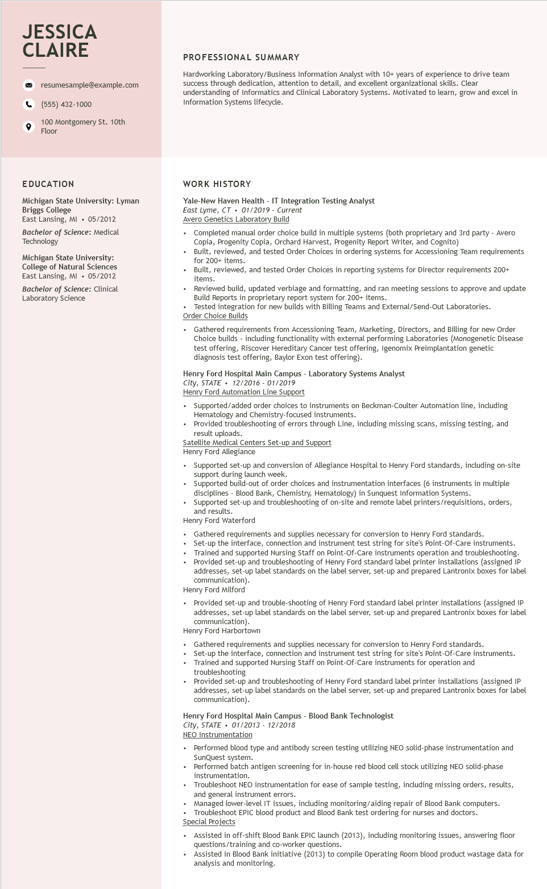

**JESSICA CLAIRE**

resumesample@example.com

(555) 432-1000

100 Montgomery St. 10th Floor

PROFESSIONAL SUMMARY

Hardworking Laboratory/Business Information Analyst with 10+ years of experience to drive team success through dedication, attention to detail, and excellent organizational skills. Clear understanding of Informatics and Clinical Laboratory Systems. Motivated to learn, grow and excel in Information Systems lifecycle.

**EDUCATION**

Michigan State University: Lyman Briggs College

East Lansing, MI ⚫ 05/2012

Bachelor of Science: Medical Technology

Michigan State University: College of Natural Sciences East Lansing, MI ⚫ 05/2012

Bachelor of Science: Clinical Laboratory Science

WORK HISTORY

Yale-New Haven Health - IT Integration Testing Analyst

*East Lyme, CT*

*01/2019 Current*

Avero Genetics Laboratory Build

• Completed manual order choice build in multiple systems (both proprietary and 3rd party - Avero Copia, Progenity Copia, Orchard Harvest, Progenity Report Writer, and Cognito)

Built, reviewed, and tested Order Choices in ordering systems for Accessioning Team requirements for 200+ items.

• Built, reviewed, and tested Order Choices in reporting systems for Director requirements 200+ items.

Reviewed build, updated verbiage and formatting, and ran meeting sessions to approve and update Build Reports in proprietary report system for 200+ items.

• Tested integration for new builds with Billing Teams and External/Send-Out Laboratories. Order Choice Builds

Gathered requirements from Accessioning Team, Marketing, Directors, and Billing for new Order Choice builds - including functionality with external performing Laboratories (Monogenetic Disease test offering, Riscover Hereditary Cancer test offering, Igenomix Preimplantation genetic diagnosis test offering, Baylor Exon test offering).

Henry Ford Hospital Main Campus - Laboratory Systems Analyst

*City, STATE 12/2016 01/2019*

Henry Ford Automation Line Support

• Supported/added order choices to instruments on Beckman-Coulter Automation line, including Hematology and Chemistry-focused instruments.

Provided troubleshooting of errors through Line, including missing scans, missing testing, and result uploads.

Satellite Medical Centers Set-up and Support

Henry Ford Allegiance

Supported set-up and conversion of Allegiance Hospital to Henry Ford standards, including on-site support during launch week.

Supported build-out of order choices and instrumentation interfaces (6 instruments in multiple disciplines - Blood Bank, Chemistry, Hematology) in Sunquest Information Systems.

• Supported set-up and troubleshooting of on-site and remote label printers/requisitions, orders, and results.

Henry Ford Waterford

Gathered requirements and supplies necessary for conversion to Henry Ford standards.

• Set-up the interface, connection and instrument test string for site's Point-Of-Care instruments. Trained and supported Nursing Staff on Point-Of-Care instruments operation and troubleshooting. Provided set-up and troubleshooting of Henry Ford standard label printer installations (assigned IP addresses, set-up label standards on the label server, set-up and prepared Lantronix boxes for label communication).

Henry Ford Milford

.

Provided set-up and trouble-shooting of Henry Ford standard label printer installations (assigned IP addresses, set-up label standards on the label server, set-up and prepared Lantronix boxes for label communication).

Henry Ford Harbortown

Gathered requirements and supplies necessary for conversion to Henry Ford standards.

Set-up the interface, connection and instrument test string for site's Point-Of-Care instruments. Trained and supported Nursing Staff on Point-Of-Care instruments for operation and troubleshooting

Provided set-up and troubleshooting of Henry Ford standard label printer installations (assigned IP addresses, set-up label standards on the label server, set-up and prepared Lantronix boxes for label communication).

Henry Ford Hospital Main Campus - Blood Bank Technologist

*City, STATE. 01/2013 - 12/2018*

NEO Instrumentation

.

·

Performed blood type and antibody screen testing utilizing NEO solid-phase instrumentation and SunQuest system.

Performed batch antigen screening for in-house red blood cell stock utilizing NEO solid-phase instrumentation.

Troubleshoot NEO instrumentation for ease of sample testing, including missing orders, results, and general instrument errors.

Managed lower-level IT issues, including monitoring/aiding repair of Blood Bank computers. Troubleshoot EPIC blood product and Blood Bank test ordering for nurses and doctors.

Special Projects

•

Assisted in off-shift Blood Bank EPIC launch (2013), including monitoring issues, answering floor questions/training and co-worker questions.

Assisted in Blood Bank initiative (2013) to compile Operating Room blood product wastage data for analysis and monitoring.