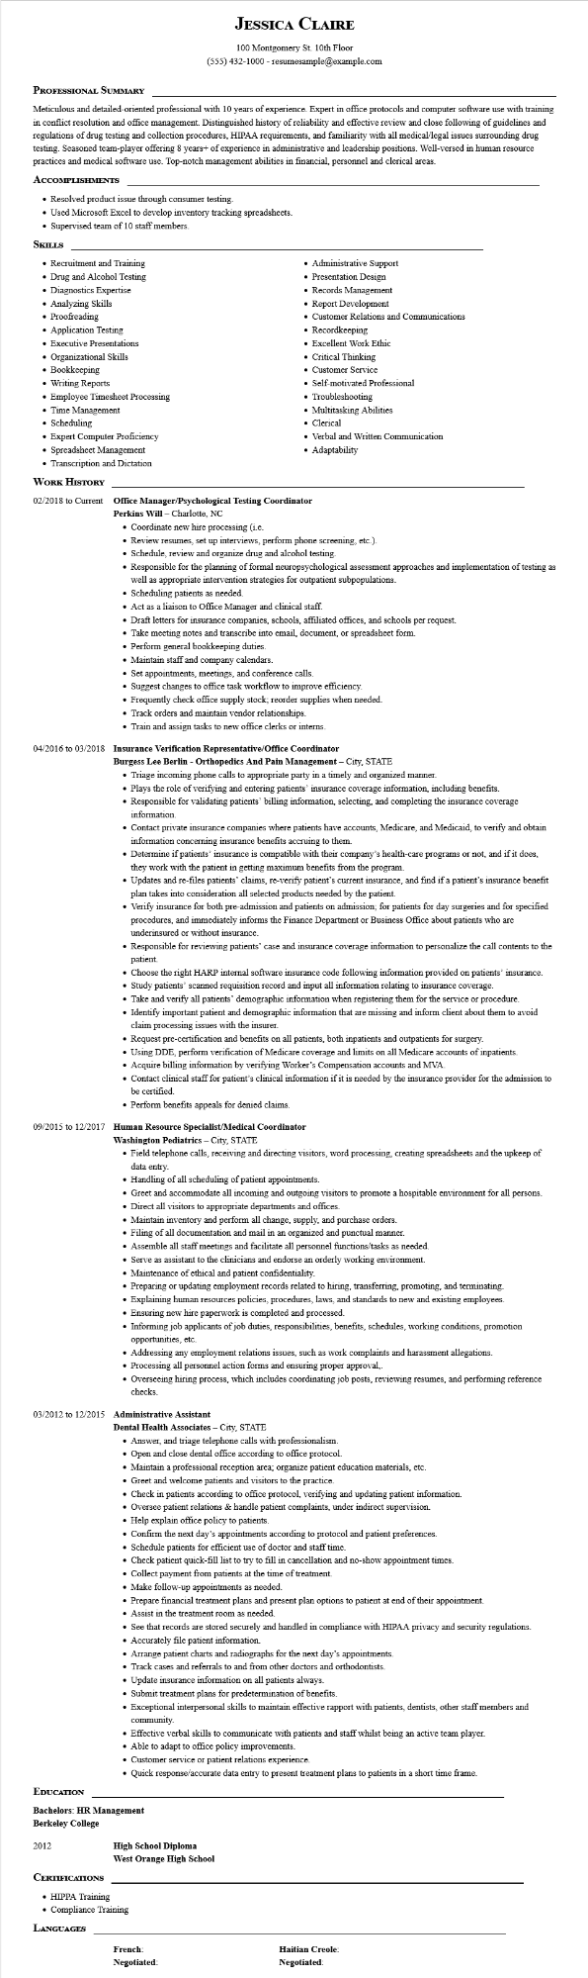

**JESSICA CLAIRE**

100 Montgomery St. 10th Floor

(555) 432-1000 - resumesample@example.com

**PROFESSIONAL SUMMARY**

Meticulous and detailed-oriented professional with 10 years of experience. Expert in office protocols and computer software use with training in conflict resolution and office management. Distinguished history of reliability and effective review and close following of guidelines and regulations of drug testing and collection procedures, HIPAA requirements, and familiarity with all medical/legal issues surrounding drug testing. Seasoned team-player offering 8 years+ of experience in administrative and leadership positions. Well-versed in human resource practices and medical software use. Top-notch management abilities in financial, personnel and clerical areas.

**ACCOMPLISHMENTS**

• Resolved product issue through consumer testing.

• Used Microsoft Excel to develop inventory tracking spreadsheets.

• Supervised team of 10 staff members.

**SKILLS**

• Recruitment and Training

• Drug and Alcohol Testing

• Diagnostics Expertise Analyzing Skills

• Proofreading

• Application Testing

• Executive Presentations

• Organizational Skills

• Bookkeeping

• Writing Reports

• Employee Timesheet Processing

• Time Management

• Scheduling

• Expert Computer Proficiency

• Spreadsheet Management

• Administrative Support

• Presentation Design

• Records Management

• Report Development

• Customer Relations and Communications

• Recordkeeping

• Excellent Work Ethic

• Critical Thinking

• Customer Service

Self-motivated Professional

• Troubleshooting

• Multitasking Abilities

• Clerical

• Verbal and Written Communication • Adaptability

• Transcription and Dictation

**WORK HISTORY**

**02/2018 to Current Office Manager/Psychological Testing Coordinator**

**Perkins Will - Charlotte, NC**

• Coordinate new hire processing (i.e.

• Review resumes, set up interviews, perform phone screening, etc.).

• Schedule, review and organize drug and alcohol testing.

• Responsible for the planning of formal neuropsychological assessment approaches and implementation of testing as well as appropriate intervention strategies for outpatient subpopulations.

• Scheduling patients as needed.

• Act as a liaison to Office Manager and clinical staff.

• Draft letters for insurance companies, schools, affiliated offices, and schools per request.

• Take meeting notes and transcribe into email, document, or spreadsheet form.

• Perform general bookkeeping duties.

• Maintain staff and company calendars.

• Set appointments, meetings, and conference calls.

• Suggest changes to office task workflow to improve efficiency.

• Frequently check office supply stock; reorder supplies when needed.

• Track orders and maintain vendor relationships.

• Train and assign tasks to new office clerks or interns.

**04/2016 to 03/2018 Insurance Verification Representative/Office Coordinator**

**Burgess Lee Berlin - Orthopedics And Pain Management - City, STATE**

• Triage incoming phone calls to appropriate party in a timely and organized manner.

• Plays the role of verifying and entering patients' insurance coverage information, including benefits.

• Responsible for validating patients' billing information, selecting, and completing the insurance coverage information.

• Contact private insurance companies where patients have accounts, Medicare, and Medicaid, to verify and obtain information concerning insurance benefits accruing to them.

• Determine if patients' insurance is compatible with their company's health-care programs or not, and if it does, they work with the patient in getting maximum benefits from the program.

• Updates and re-files patients' claims, re-verify patient's current insurance, and find if a patient's insurance benefit plan takes into consideration all selected products needed by the patient.

• Verify insurance for both pre-admission and patients on admission; for patients for day surgeries and for specified procedures, and immediately informs the Finance Department or Business Office about patients who are underinsured or without insurance.

• Responsible for reviewing patients' case and insurance coverage information to personalize the call contents to the patient.

• Choose the right HARP internal software insurance code following information provided on patients' insurance.

• Study patients' scanned requisition record and input all information relating to insurance coverage.

• Take and verify all patients' demographic information when registering them for the service or procedure.

• Identify important patient and demographic information that are missing and inform client about them to avoid claim processing issues with the insurer.

• Request pre-certification and benefits on all patients, both inpatients and outpatients for surgery.

• Using DDE, perform verification of Medicare coverage and limits on all Medicare accounts of inpatients.

• Acquire billing information by verifying Worker's Compensation accounts and MVA.

• Contact clinical staff for patient's clinical information if it is needed by the insurance provider for the admission to be certified.

• Perform benefits appeals for denied claims.

**09/2015 to 12/2017 Human Resource Specialist/Medical Coordinator**

**Washington Pediatrics - City, STATE**

• Field telephone calls, receiving and directing visitors, word processing, creating spreadsheets and the upkeep of data entry.

• Handling of all scheduling of patient appointments.

• Greet and accommodate all incoming and outgoing visitors to promote a hospitable environment for all persons.

• Direct all visitors to appropriate departments and offices.

• Maintain inventory and perform all change, supply, and purchase orders.

• Filing of all documentation and mail in an organized and punctual manner.

• Assemble all staff meetings and facilitate all personnel functions/tasks as needed.

• Serve as assistant to the clinicians and endorse an orderly working environment.

• Maintenance of ethical and patient confidentiality.

• Preparing or updating employment records related to hiring, transferring, promoting, and terminating.

• Explaining human resources policies, procedures, laws, and standards to new and existing employees.

• Ensuring new hire paperwork is completed and processed.

• Informing job applicants of job duties, responsibilities, benefits, schedules, working conditions, promotion opportunities, etc.

• Addressing any employment relations issues, such as work complaints and harassment allegations.

• Processing all personnel action forms and ensuring proper approval..

• Overseeing hiring process, which includes coordinating job posts, reviewing resumes, and performing reference checks.

**03/2012 to 12/2015 Administrative Assistant**

**Dental Health Associates - City, STATE**

• Answer, and triage telephone calls with professionalism.

• Open and close dental office according to office protocol.

• Maintain a professional reception area; organize patient education materials, etc.

• Greet and welcome patients and visitors to the practice.

• Check in patients according to office protocol, verifying and updating patient information.

• Oversee patient relations & handle patient complaints, under indirect supervision.

• Help explain office policy to patients.

• Confirm the next day's appointments according to protocol and patient preferences.

• Schedule patients for efficient use of doctor and staff time.

• Check patient quick-fill list to try to fill in cancellation and no-show appointment times.

• Collect payment from patients at the time of treatment.

• Make follow-up appointments as needed.

• Prepare financial treatment plans and present plan options to patient at end of their appointment.

• Assist in the treatment room as needed.

• See that records are stored securely and handled in compliance with HIPAA privacy and security regulations.

• Accurately file patient information.

• Arrange patient charts and radiographs for the next day's appointments.

• Track cases and referrals to and from other doctors and orthodontists.

• Update insurance information on all patients always.

• Submit treatment plans for predetermination of benefits.

• Exceptional interpersonal skills to maintain effective rapport with patients, dentists, other staff members and

community.

• Effective verbal skills to communicate with patients and staff whilst being an active team player.

• Able to adapt to office policy improvements.

• Customer service or patient relations experience.

• Quick response/accurate data entry to present treatment plans to patients in a short time frame.

**EDUCATION**

Bachelors: HR Management

**Berkeley College**

2012

**CERTIFICATIONS**

• HIPPA Training

**High School Diploma**

**West Orange High School**

• Compliance Training

LANGUAGES

**French: Negotiated:**

**Haitian Creole: Negotiated:**