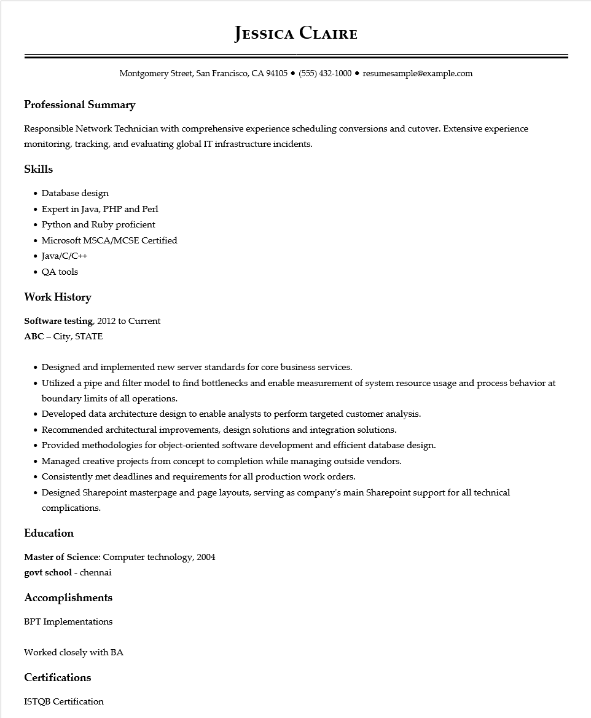

**JESSICA CLAIRE**

Montgomery Street, San Francisco, CA 94105 ● (555) 432-1000⚫ resumesample@example.com

**Professional Summary**

Responsible Network Technician with comprehensive experience scheduling conversions and cutover. Extensive experience monitoring, tracking, and evaluating global IT infrastructure incidents.

Skills

• Database design

• Expert in Java, PHP and Perl

• Python and Ruby proficient

• Microsoft MSCA/MCSE Certified

• Java/C/C++

• QA tools

**Work History**

**Software testing, 2012 to Current**

ABC - City, STATE

•

Designed and implemented new server standards for core business services.

• Utilized a pipe and filter model to find bottlenecks and enable measurement of system resource usage and process behavior at boundary limits of all operations.

• Developed data architecture design to enable analysts to perform targeted customer analysis.

• Recommended architectural improvements, design solutions and integration solutions.

• Provided methodologies for object-oriented software development and efficient database design.

• Managed creative projects from concept to completion while managing outside vendors.

• Consistently met deadlines and requirements for all production work orders.

• Designed Sharepoint masterpage and page layouts, serving as company's main Sharepoint support for all technical complications.

**Education**

Master of Science: Computer technology, 2004

govt school - chennai

**Accomplishments**

BPT Implementations

Worked closely with BA

**Certifications**

ISTQB Certification