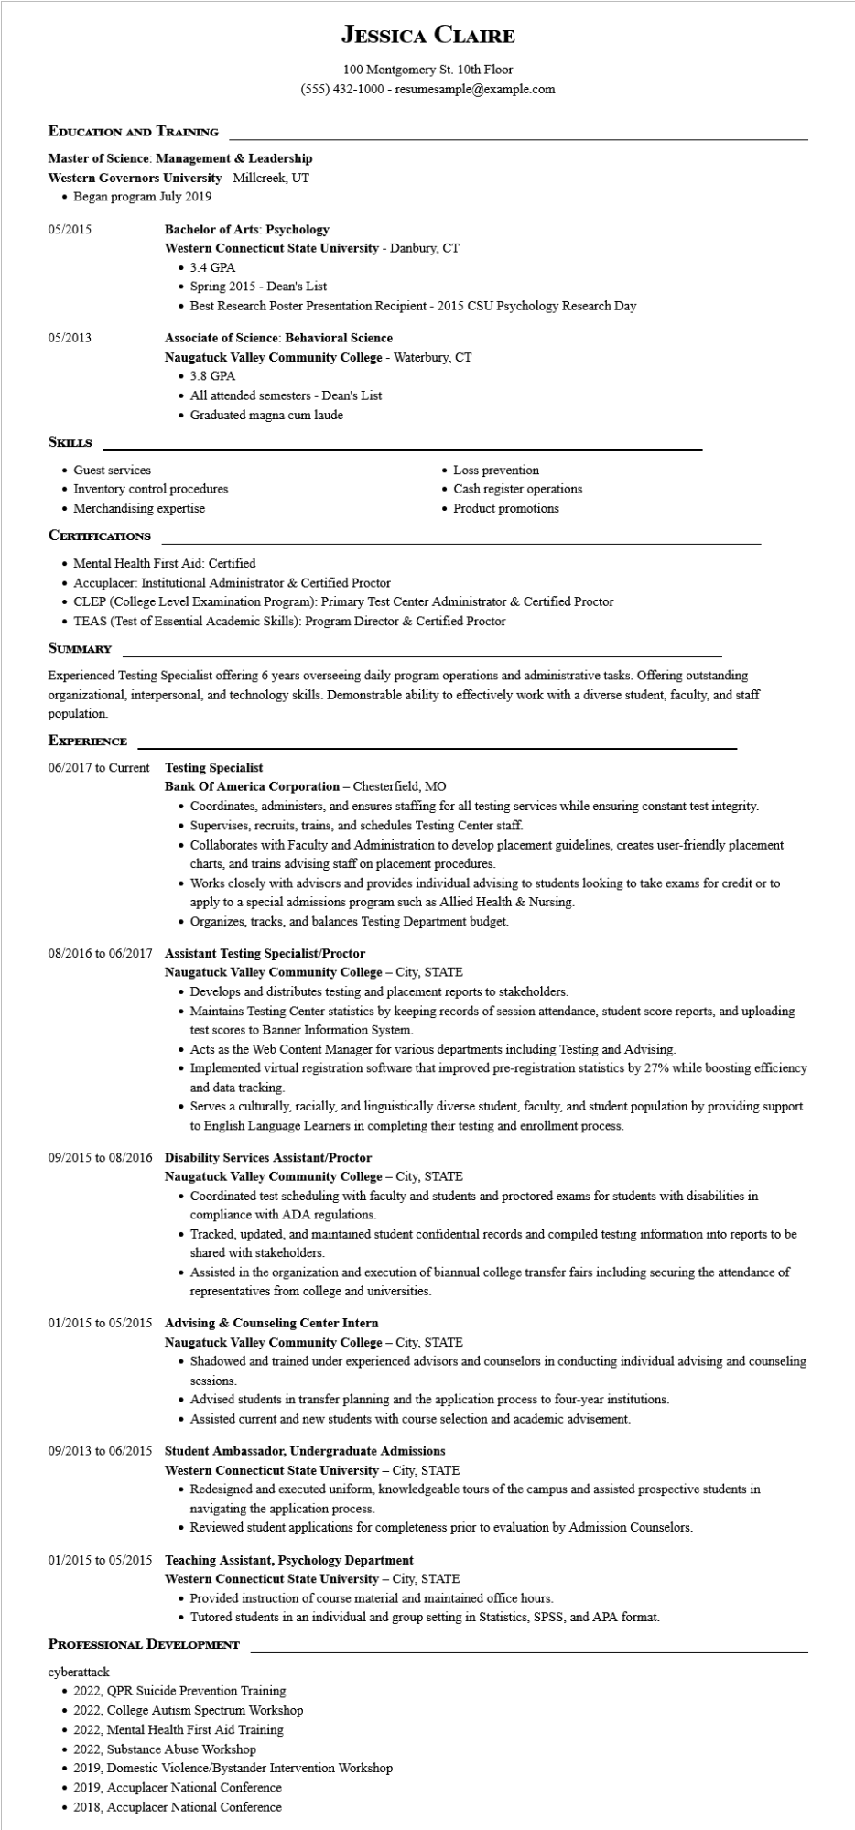

**JESSICA CLAIRE**

100 Montgomery St. 10th Floor

(555) 432-1000 - resumesample@example.com

**EDUCATION AND TRAINING**

**Master of Science: Management & Leadership Western Governors University - Millcreek, UT • Began program July 2019**

05/2015

05/2013

**Bachelor of Arts: Psychology**

**Western Connecticut State University - Danbury, CT**

• 3.4 GPA

• Spring 2015 - Dean's List

• Best Research Poster Presentation Recipient - 2015 CSU Psychology Research Day

**Associate of Science: Behavioral Science**

**Naugatuck Valley Community College - Waterbury, CT**

• 3.8 GPA

• All attended semesters - Dean's List

• Graduated magna cum laude

**SKILLS**

• Guest services

Inventory control procedures

• Merchandising expertise

**CERTIFICATIONS**

• Mental Health First Aid: Certified

• Accuplacer: Institutional Administrator & Certified Proctor

• Loss prevention

• Cash register operations

• Product promotions

• CLEP (College Level Examination Program): Primary Test Center Administrator & Certified Proctor

• TEAS (Test of Essential Academic Skills): Program Director & Certified Proctor

**SUMMARY**

Experienced Testing Specialist offering 6 years overseeing daily program operations and administrative tasks. Offering outstanding organizational, interpersonal, and technology skills. Demonstrable ability to effectively work with a diverse student, faculty, and staff population.

**EXPERIENCE**

**06/2017 to Current Testing Specialist**

Bank Of America Corporation - Chesterfield, MO

• Coordinates, administers, and ensures staffing for all testing services while ensuring constant test integrity.

• Supervises, recruits, trains, and schedules Testing Center staff.

• Collaborates with Faculty and Administration to develop placement guidelines, creates user-friendly placement charts, and trains advising staff on placement procedures.

• Works closely with advisors and provides individual advising to students looking to take exams for credit or to apply to a special admissions program such as Allied Health & Nursing.

• Organizes, tracks, and balances Testing Department budget.

08/2016 to 06/2017 Assistant Testing Specialist/Proctor

**Naugatuck Valley Community College - City, STATE**

• Develops and distributes testing and placement reports to stakeholders.

• Maintains Testing Center statistics by keeping records of session attendance, student score reports, and uploading test scores to Banner Information System.

• Acts as the Web Content Manager for various departments including Testing and Advising.

• Implemented virtual registration software that improved pre-registration statistics by 27% while boosting efficiency and data tracking.

• Serves a culturally, racially, and linguistically diverse student, faculty, and student population by providing support to English Language Learners in completing their testing and enrollment process.

**09/2015 to 08/2016 Disability Services Assistant/Proctor**

**Naugatuck Valley Community College - City, STATE**

• Coordinated test scheduling with faculty and students and proctored exams for students with disabilities in compliance with ADA regulations.

• Tracked, updated, and maintained student confidential records and compiled testing information into reports to be shared with stakeholders.

• Assisted in the organization and execution of biannual college transfer fairs including securing the attendance of representatives from college and universities.

**01/2015 to 05/2015 Advising & Counseling Center Intern**

**Naugatuck Valley Community College - City, STATE**

• Shadowed and trained under experienced advisors and counselors in conducting individual advising and counseling

sessions.

• Advised students in transfer planning and the application process to four-year institutions.

• Assisted current and new students with course selection and academic advisement.

**09/2013 to 06/2015 Student Ambassador, Undergraduate Admissions**

**Western Connecticut State University - City, STATE**

• Redesigned and executed uniform, knowledgeable tours of the campus and assisted prospective students in navigating the application process.

• Reviewed student applications for completeness prior to evaluation by Admission Counselors.

**01/2015 to 05/2015 Teaching Assistant, Psychology Department**

**Western Connecticut State University - City, STATE**

• Provided instruction of course material and maintained office hours.

• Tutored students in an individual and group setting in Statistics, SPSS, and APA format.

**PROFESSIONAL DEVELOPMENT**

cyberattack

• 2022, QPR Suicide Prevention Training

• 2022, College Autism Spectrum Workshop

• 2022, Mental Health First Aid Training

• 2022, Substance Abuse Workshop

• 2019, Domestic Violence/Bystander Intervention Workshop

⚫ 2019, Accuplacer National Conference

⚫ 2018, Accuplacer National Conference