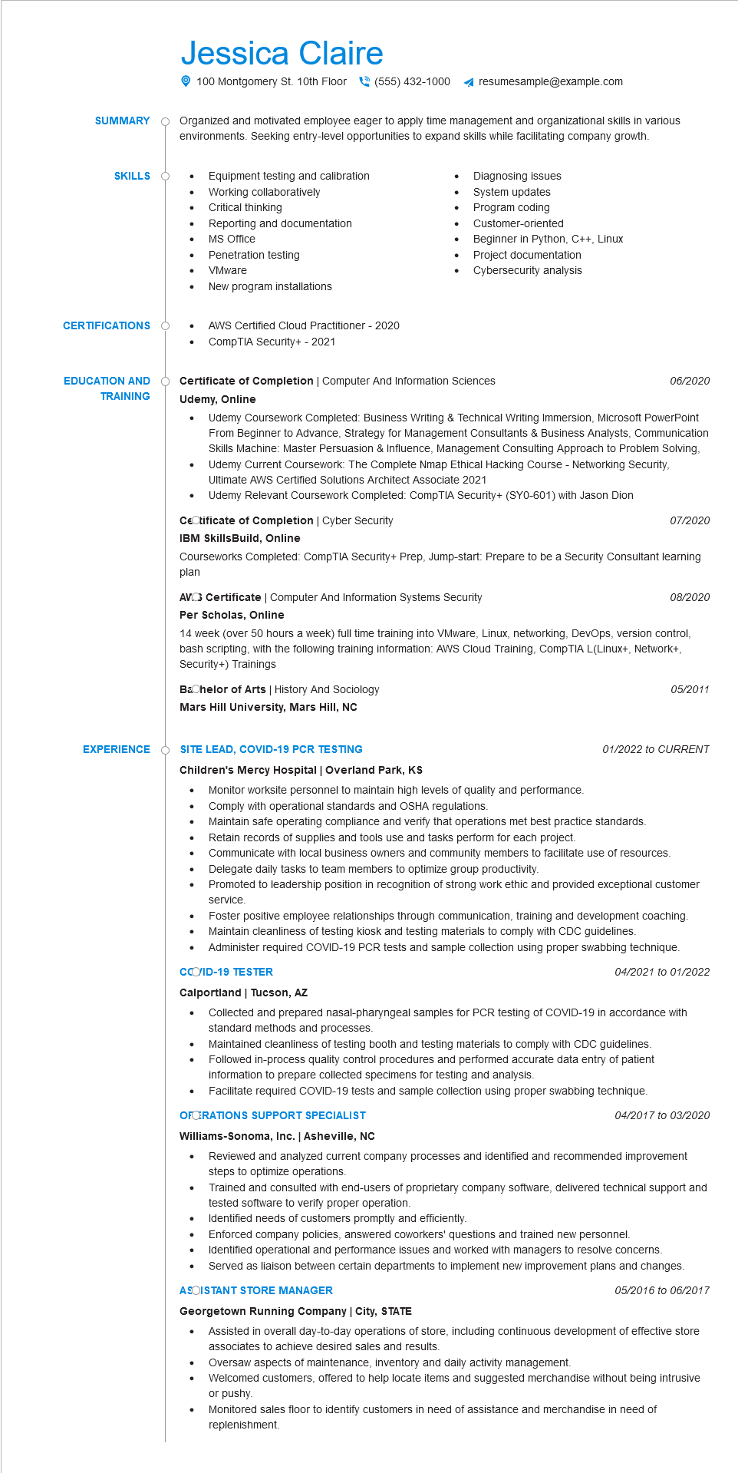

**SUMMARY**

Jessica Claire

100 Montgomery St. 10th Floor (555) 432-1000 ◄ resumesample@example.com

Organized and motivated employee eager to apply time management and organizational skills in various environments. Seeking entry-level opportunities to expand skills while facilitating company growth.

Equipment testing and calibration

**SKILLS O**

•

Working collaboratively

Diagnosing issues

•

System updates

**CERTIFICATIONS**

**EDUCATION AND TRAINING**

• Critical thinking

•

Reporting and documentation

MS Office

Penetration testing

•

VMware

•

New program installations

AWS Certified Cloud Practitioner - 2020

CompTIA Security+ - 2021

Program coding

Customer-oriented

Beginner in Python, C++, Linux

Cybersecurity analysis

•

Project documentation

**Certificate of Completion | Computer And Information Sciences Udemy, Online**

*06/2020*

Udemy Coursework Completed: Business Writing & Technical Writing Immersion, Microsoft PowerPoint From Beginner to Advance, Strategy for Management Consultants Business Analysts, Communication Skills Machine: Master Persuasion & Influence, Management Consulting Approach to Problem Solving, Udemy Current Coursework: The Complete Nmap Ethical Hacking Course - Networking Security, Ultimate AWS Certified Solutions Architect Associate 2021

Udemy Relevant Coursework Completed: CompTIA Security+ (SY0-601) with Jason Dion

CeCtificate of Completion | Cyber Security

**IBM SkillsBuild, Online**

07/2020

Courseworks Completed: CompTIA Security+ Prep, Jump-start: Prepare to be a Security Consultant learning plan

**AVC Certificate | Computer And Information Systems Security Per Scholas, Online**

*08/2020*

14 week (over 50 hours a week) full time training into VMware, Linux, networking, DevOps, version control, bash scripting, with the following training information: AWS Cloud Training, CompTIA L(Linux+, Network+, Security+) Trainings

Bachelor of Arts | History And Sociology

**Mars Hill University, Mars Hill, NC**

*05/2011*

**EXPERIENCE**

**SITE LEAD, COVID-19 PCR TESTING**

**Children's Mercy Hospital | Overland Park, KS**

Monitor worksite personnel to maintain high levels of quality and performance.

•

Comply with operational standards and OSHA regulations.

•

•

*01/2022 to CURRENT*

Maintain safe operating compliance and verify that operations met best practice standards. Retain records of supplies and tools use and tasks perform for each project.

Communicate with local business owners and community members to facilitate use of resources.

Delegate daily tasks to team members to optimize group productivity.

Promoted to leadership position in recognition of strong work ethic and provided exceptional customer service

Foster positive employee relationships through communication, training and development coaching. Maintain cleanliness of testing kiosk and testing materials to comply with CDC guidelines.

•

Administer required COVID-19 PCR tests and sample collection using proper swabbing technique.

04/2021 to 01/2022

**COID-19 TESTER**

**Calportland | Tucson, AZ**

Collected and prepared nasal-pharyngeal samples for PCR testing of COVID-19 in accordance with standard methods and processes.

Maintained cleanliness of testing booth and testing materials to comply with CDC guidelines.

Followed in-process quality control procedures and performed accurate data entry of patient information to prepare collected specimens for testing and analysis.

•

Facilitate required COVID-19 tests and sample collection using proper swabbing technique. OFERATIONS SUPPORT SPECIALIST

04/2017 to 03/2020

**Williams-Sonoma, Inc. | Asheville, NC**

•

Reviewed and analyzed current company processes and identified and recommended improvement steps to optimize operations.

Trained and consulted with end-users of proprietary company software, delivered technical support and tested software to verify proper operation.

Identified needs of customers promptly and efficiently.

Enforced company policies, answered coworkers' questions and trained new personnel.

• Identified operational and performance issues and worked with managers to resolve concerns.

Served as liaison between certain departments to implement new improvement plans and changes. ASOISTANT STORE MANAGER

**Georgetown Running Company | City, STATE**

•

*05/2016 to 06/2017*

Assisted in overall day-to-day operations of store, including continuous development of effective store associates to achieve desired sales and results.

Oversaw aspects of maintenance, inventory and daily activity management.

Welcomed customers, offered to help locate items and suggested merchandise without being intrusive

or pushy.

Monitored sales floor to identify customers in need of assistance and merchandise in need of replenishment.