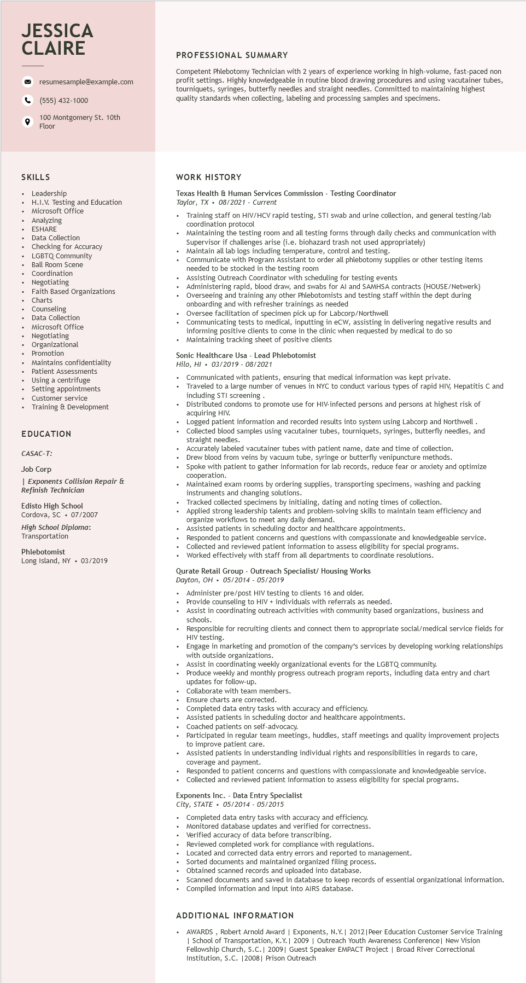

**JESSICA CLAIRE**

resumesample@example.com

(555) 432-1000

100 Montgomery St. 10th Floor

**PROFESSIONAL SUMMARY**

Competent Phlebotomy Technician with 2 years of experience working in high-volume, fast-paced non profit settings. Highly knowledgeable in routine blood drawing procedures and using vacutainer tubes, tourniquets, syringes, butterfly needles and straight needles. Committed to maintaining highest quality standards when collecting, labeling and processing samples and specimens.

**SKILLS**

Leadership

H.I.V. Testing and Education

Microsoft Office

Analyzing

*ESHARE*

Data Collection

Checking for Accuracy

LGBTQ Community

Ball Room Scene

Coordination Negotiating

Faith Based Organizations

Charts

Counseling

Data Collection

Microsoft Office Negotiating

Organiza

Organizational

• Promotion

• Maintains confidentiality

Patient Assessments

• Using a centrifuge

• Setting appointments

• Customer service

• Training & Development

**EDUCATION**

*CASAC-T:*

Job Corp

*| Exponents Collision Repair &*

*Refinish Technician*

Edisto High School

Cordova, SC 07/2007

*High School Diploma:*

Transportation

Phlebotomist

Long Island, NY. 03/2019

**WORK HISTORY**

Texas Health & Human Services Commission - Testing Coordinator

*Taylor, TX. 08/2021 - Current*

• Training staff on HIV/HCV rapid testing, STI swab and urine collection, and general testing/lab coordination protocol

Maintaining the testing room and all testing forms through daily checks and communication with Supervisor if challenges arise (i.e. biohazard trash not used appropriately)

Maintain all lab logs including temperature, control and testing.

Communicate

*with*

Program Assistant to order all phlebotomy supplies or other testing items needed to be stocked in the testing room

• Assisting Outreach Coordinator with scheduling for testing events

Administering rapid, blood draw, and swabs for Al and SAMHSA contracts (HOUSE/Netwerk)

• Overseeing and training any other Phlebotomists and testing staff within the dept during onboarding and with refresher trainings as needed

Oversee facilitation of specimen pick up for Labcorp/Northwell

Communicating tests to medical, inputting in eCW, assisting in delivering negative results and informing positive clients to come in the clinic when requested by medical to do so

• Maintaining tracking sheet of positive clients

Sonic Healthcare Usa - Lead Phlebotomist

*Hilo, HI*

03/2019 - 08/2021

Communicated with patients, ensuring that medical information was kept private.

Traveled to a large number of venues in NYC to conduct various types of rapid HIV, Hepatitis C and including STI screening

Distributed condoms to promote use for HIV-infected persons and persons at highest risk of acquiring HIV.

Logged patient information and recorded results into system using Labcorp and Northwell . Collected blood samples using vacutainer tubes, tourniquets, syringes, butterfly needles, and straight needles.

Accurately labeled vacutainer tubes with patient name, date and time of collection. Drew blood from veins by vacuum tube, syringe or butterfly venipuncture methods. Spoke with patient to gather information for lab records, reduce fear or anxiety and optimize www.peration.

Maintained exam rooms by ordering supplies, transporting specimens, washing and packing instruments and changing solutions.

Tracked collected specimens by initialing, dating and noting times of collection.

• Applied strong leadership talents and problem-solving skills to maintain team efficiency and organize workflows to meet any daily demand.

Assisted patients in scheduling doctor and healthcare appointments.

Responded to patient concerns and questions with compassionate and knowledgeable service. Collected and reviewed patient information to assess eligibility for special programs.

Worked effectively with staff from all departments to coordinate resolutions.

Qurate Retail Group - Outreach Specialist/ Housing Works

*Dayton, OH 05/2014 - 05/2019*

Administer pre/post HIV testing to clients 16 and older.

• Provide counseling to HIV+ individuals with referrals as needed.

Assist in coordinating outreach activities with community based organizations, business and schools.

Responsible for recruiting clients and connect them to appropriate social/medical service fields for HIV

*V testing.*

Engage in marketing and promotion of the company's services by developing working relationships with outside organizations.

גורו

Assist in coordinating weekly organizational events for the LGBTQ community.

Produce weekly and monthly progress outreach program reports, including data entry and chart updates for follow-up.

Collaborate with team members.

Collabo

Lean

Ensure charts are corrected.

Completed data entry tasks with accuracy and efficiency.

Assisted patients in scheduling doctor and healthcare appointments.

Coached patients on self-advocacy.

Participated in regular team meetings, huddles, staff meetings and quality improvement projects to improve patient care.

Assisted patients in understanding individual rights and responsibilities in regards to care,

coverage and payment.

Responded to patient concerns and questions with compassionate and knowledgeable service. Collected and reviewed patient information to assess eligibility for special programs.

Exponents Inc. - Data Entry Specialist

*City, STATE 05/2014 - 05/2015*

Completed data entry tasks with accuracy and efficiency.

Monitored database updates and verified for correctness.

Verified accuracy of data before transcribing.

Reviewed completed work for compliance with regulations.

Sorted documents and maintained organized filing process.

Located and corrected data entry errors and reported to management.

Obtained scanned records and uploaded into database.

Scanned documents and saved in database to keep records of essential organizational information. Compiled information and input into AIRS database.

ADDITIONAL INFORMATION

•

AWARDS, Robert Arnold Award | Exponents, N.Y. | 2012 | Peer Education Customer Service Training | School of Transportation, K.Y. | 2009 | Outreach Youth Awareness Conference| New Vision Fellowship Church, S.C. | 2009 | Guest Speaker EMPACT Project | Broad River Correctional Institution, S.C. | 2008 | Prison Outreach