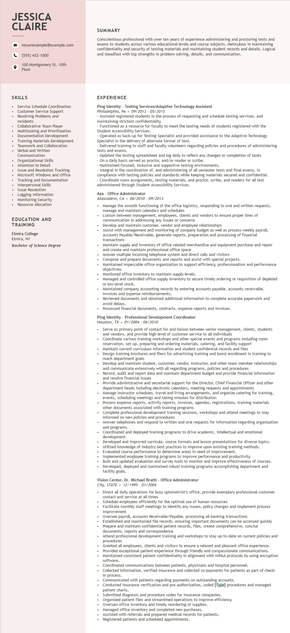

**JESSICA CLAIRE**

resumesample@example.com

(555) 432-1000

100 Montgomery St. 10th Floor

SUMMARY

Conscientious professional with over ten years of experience administering and proctoring tests and exams to students across various educational levels and course subjects. Meticulous in maintaining confidentiality and security of testing materials and maintaining student records and details. Logical and steadfast with top strengths in problem-solving, details, and communication.

SKILLS

Service Schedule Coordination

Customer Service Support Resolving Problems and Incidents

Collaborative Team Player

Multitasking and Prioritization Documentation Development Training Materials Development Teamwork and Collaboration Verbal and written

Communication

Organizational Skills

Attention to Detail

Issue and Resolution Tracking Microsoft Windows and Office Tracking and Documentation Interpersonal Skills

Issue Resolution

• Logging Information

• Monitoring Security

•

Resource Allocation

EDUCATION AND

TRAINING

Elmira College

Elmira, NY

*Bachelor of Science Degree*

**EXPERIENCE**

Ping Identity - Testing Services/Adaptive Technology Assistant Philadelphia, PA 09/2013 - 05/2015

• Assisted registered students in the process of requesting and schedule testing services, and maintaining strictest confidentiality.

• Functioned as a resource for faculty to meet the testing needs of students registered with the Student Accessibility Services.

Operated as as back-up for Testing Specialist and provided assistance to the Adaptive Technology Specialist in the delivery of alternate format of text.

Delivered training to staff and faculty volunteers regarding policies and procedures of administering tests and exams.

Updated the testing spreadsheet and log daily to reflect any changes or completion of tasks On a daily basis served as proctor, and/or reader or scribe.

Maintained focused, inclusive and supportive testing environments.

Integral in the coordination of, and administering of all semester tests and final exams, in compliance with testing policies and standards while keeping materials secured and confidential. Coordinate room assignments, testing materials, and proctor, scribe, and readers for all test administered through Student Accessibility Services.

Aza - Office Administrator

*Atascadero, CA 06/2010- 09/2013*

• Manage the smooth functioning of the office logistics, responding to oral and written requests, manage and maintain calendars and schedules

• Liaison between management, employees, clients and vendors to ensure proper lines of communication in addressing any issues or concerns

• Develop and maintain customer, vendor and employee relationships

•

.

Assist with management and monitoring of company budget as well as process weekly payroll, accoun accounts Payable/Receivable, generate reports, preparation and processing of financial

transactions

Maintain supply and inventory of office related merchandise and equipment purchase and repair and create and maintain professional office space

Answer multiple incoming telephone system and direct calls and visitors

Compose and prepare documents and reports and assist with special projects.

Maintained impeccable office organization to support efficiency, professionalism and performance objectives.

Monitored office inventory to maintain supply levels.

Managed and controlled office supply inventory to secure timely ordering or requisition of depleted or low-level stock.

of tow

Maintained company accounting records by entering accounts payable, accounts receivable, invoices and expense reimbursements.

Reviewed documents and obtained additional information to complete accurate paperwork and avoid delays.

Processed financial documents, contracts, expense reports and invoices.

Ping Identity - Professional Development Coordinator

*Houston, TX 01/2004 - 06/2010*

.

.

Serve as primary point of contact for and liaison between senior management, clients, students and vendors, and provide high level of customer service to all individuals

Coordinate various training workshops and other special events and programs including room reservation, set-up, preparing and ordering materials, catering, and facility support Maintain current curriculum information and student confidential records and files

Design training brochures and fliers for advertising training and boost enrollment in training to reach department goals

• Develop and maintain student, customer, vendor, instructor, and other team member relationships and communicate extensively with all regarding programs, policies and procedures

a

Record, audit and report data and maintain department budget and provide financial information and resolve financial issues

Provide administrative and secretarial support for the Director, Chief Financial Officer and other department heads including electronic calendars, meeting requests and appointments

Manage instructor schedules, travel and living arrangements, and organize catering for training, events, scheduling meetings and taking minutes for distribution

Process expense reports, activity reports, invoices, agendas, registrations, training materials other documents associated with training programs

Complete professional development training sessions, workshops and attend meetings to stay informed on new policies and procedures

Answer telephones and respond to written and oral requests for information regarding organization and programs.

Coordinated and deployed training programs to drive academic, intellectual and emotional development.

Developed and improved curricula, course formats and lesson presentations for diverse topics. Utilized

I knowledge of industry best practices to improve upon existing training methods.

• Evaluated course performance to determine areas in need of improvement.

• Implemented employee training programs to improve performance and productivity.

• Built and updated evaluation and survey tools to monitor and improve effectiveness of courses.

• Developed, deployed and maintained robust training programs accomplishing department and facility goals.

Vision Center, Dr. Michael Bratti - Office Administrator

*City, STATE 12/1995 - 01/2004*

Direct all daily operations for busy optometrist's office, provide exemplary professional customer contact and service at all times

Schedule employees efficiently for the optimal use of human resources

Facilitate monthly staff meetings to identify any issues, policy changes and implement process improvement

Oversee payroll, accounts Receivable/Payable, processing all banking transactions Established and maintained file records, ensuring important documents can be accessed quickly Prepare and maintain confidential patient records, files, create comprehensive, concise documents, reports and correspondence

Attend professional development training and workshops to stay up-to-date on current policies and procedures

Greeted all employees, clients and visitors to ensure relaxed and pleasant office experience.

Provided exceptional patient experience through friendly and compassionate communications. Maintained consistent patient confidentiality in alignment with HIPAA protocols by using encryption software.

Coordinated communications between patients, physicians and hospital personnel.

Conected Collected information, verified insurance and collected co-payments for patients as part of check- in process.

Communicated with patients regarding payments on outstanding accounts.

Conducted insurance verification and pre-authorization, coded [Type] procedures and managed patient charts.

Submitted diagnosis and procedure codes for insurance companies.

Organized patient files and streamlined operations to improve efficiency.

Oversaw office inventory and timely reordering of supplies.

Managed office inventory and completed new purchases.

Assisted with referrals and prepared medical records for patients.

Registered patients and scheduled appointments.