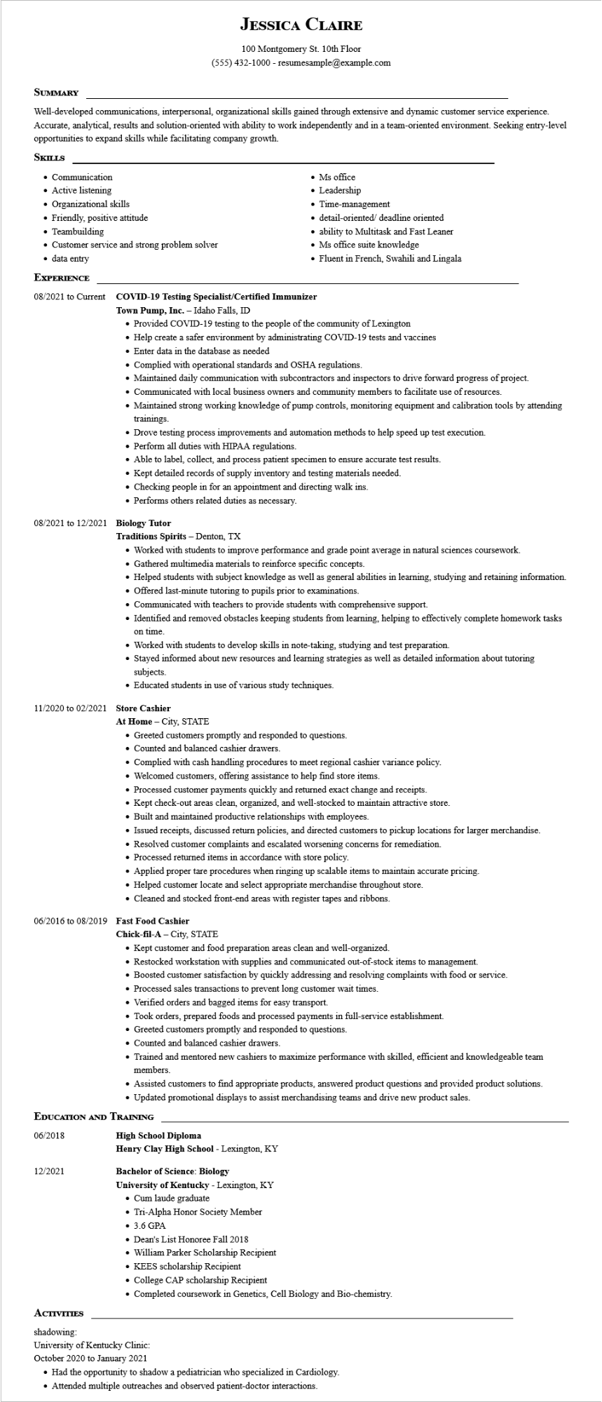

**JESSICA CLAIRE**

100 Montgomery St. 10th Floor

(555) 432-1000 - resumesample@example.com

**SUMMARY**

Well-developed communications, interpersonal, organizational skills gained through extensive and dynamic customer service experience. Accurate, analytical, results and solution-oriented with ability to work independently and in a team-oriented environment. Seeking entry-level opportunities to expand skills while facilitating company growth.

**SKILLS**

• Communication

• Active listening

• Organizational skills

• Friendly, positive attitude

• Teambuilding

• Customer service and strong problem solver

• data entry

**EXPERIENCE**

08/2021 to Current

• Ms office

• Leadership

• Time-management

⚫ detail-oriented/ deadline oriented

• ability to Multitask and Fast Leaner

• Ms office suite knowledge

• Fluent in French, Swahili and Lingala

**COVID-19 Testing Specialist/Certified Immunizer**

Town Pump, Inc. - Idaho Falls, ID

• Provided COVID-19 testing to the people of the community of Lexington

• Help create a safer environment by administrating COVID-19 tests and vaccines

• Enter data in the database as needed

• Complied with operational standards and OSHA regulations.

• Maintained daily communication with subcontractors and inspectors to drive forward progress of project.

• Communicated with local business owners and community members to facilitate use of resources.

• Maintained strong working knowledge of pump controls, monitoring equipment and calibration tools by attending trainings.

• Drove testing process improvements and automation methods to help speed up test execution.

• Perform all duties with HIPAA regulations.

• Able to label, collect, and process patient specimen to ensure accurate test results.

• Kept detailed records of supply inventory and testing materials needed.

• Checking people in for an appointment and directing walk ins.

• Performs others related duties as necessary.

08/2021 to 12/2021 Biology Tutor

Traditions Spirits - Denton, TX

• Worked with students to improve performance and grade point average in natural sciences coursework.

• Gathered multimedia materials to reinforce specific concepts.

• Helped students with subject knowledge as well as general abilities in learning, studying and retaining information.

• Offered last-minute tutoring to pupils prior to examinations.

• Communicated with teachers to provide students with comprehensive support.

• Identified and removed obstacles keeping students from learning, helping to effectively complete homework tasks

**on time.**

• Worked with students to develop skills in note-taking, studying and test preparation.

• Stayed informed about new resources and learning strategies as well as detailed information about tutoring subjects.

• Educated students in use of various study techniques.

11/2020 to 02/2021 Store Cashier

At Home - City, STATE

• Greeted customers promptly and responded to questions.

• Counted and balanced cashier drawers.

• Complied with cash handling procedures to meet regional cashier variance policy.

• Welcomed customers, offering assistance to help find store items.

• Processed customer payments quickly and returned exact change and receipts.

• Kept check-out areas clean, organized, and well-stocked to maintain attractive store.

• Built and maintained productive relationships with employees.

• Issued receipts, discussed return policies, and directed customers to pickup locations for larger merchandise.

• Resolved customer complaints and escalated worsening concerns for remediation.

• Processed returned items in accordance with store policy.

• Applied proper tare procedures when ringing up scalable items to maintain accurate pricing.

• Helped customer locate and select appropriate merchandise throughout store.

• Cleaned and stocked front-end areas with register tapes and ribbons.

**06/2016 to 08/2019 Fast Food Cashier**

**Chick-fil-A - City, STATE**

• Kept customer and food preparation areas clean and well-organized.

• Restocked workstation with supplies and communicated out-of-stock items to management.

• Boosted customer satisfaction by quickly addressing and resolving complaints with food or service.

• Processed sales transactions to prevent long customer wait times.

• Verified orders and bagged items for easy transport.

• Took orders, prepared foods and processed payments in full-service establishment.

• Greeted customers promptly and responded to questions.

• Counted and balanced cashier drawers.

• Trained and mentored new cashiers to maximize performance with skilled, efficient and knowledgeable team members.

• Assisted customers to find appropriate products, answered product questions and provided product solutions.

• Updated promotional displays to assist merchandising teams and drive new product sales.

**EDUCATION AND TRAINING**

06/2018

**High School Diploma**

Henry Clay High School - Lexington, KY

12/2021

**Bachelor of Science: Biology**

**ACTIVITIES**

shadowing:

**University of Kentucky - Lexington, KY**

• Cum laude graduate

• Tri-Alpha Honor Society Member

• 3.6 GPA

• Dean's List Honoree Fall 2018

• William Parker Scholarship Recipient

• KEES scholarship Recipient

College CAP scholarship Recipient

• Completed coursework in Genetics, Cell Biology and Bio-chemistry.

University of Kentucky Clinic:

October 2020 to January 2021

• Had the opportunity to shadow a pediatrician who specialized in Cardiology.

• Attended multiple outreaches and observed patient-doctor interactions.