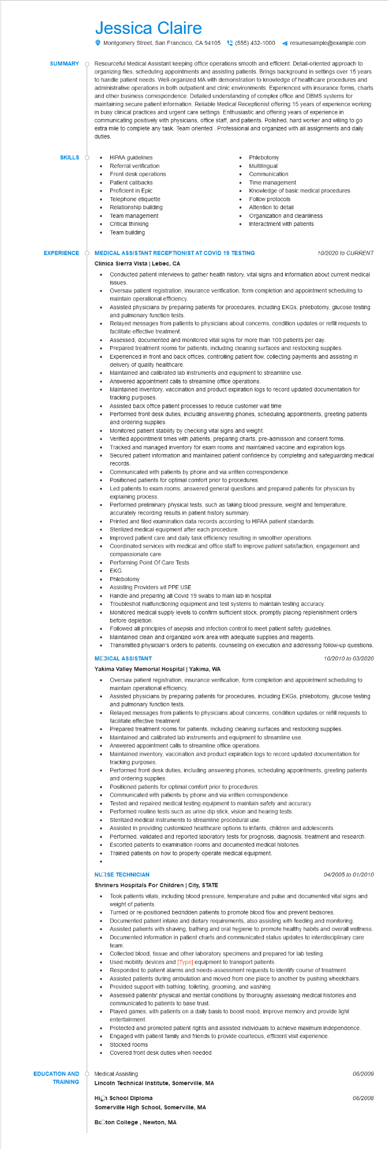

**SUMMARY**

Jessica Claire

Montgomery Street, San Francisco, CA 94105(555) 432-1000

resumesample@example.com

Resourceful Medical Assistant keeping office operations smooth and efficient. Detail-oriented approach to organizing files, scheduling appointments and assisting patients. Brings background in settings over 15 years to handle patient needs. Well-organized MA with demonstration to knowledge of healthcare procedures and administrative operations in both outpatient and clinic environments. Experienced with insurance forms, charts and other business correspondence. Detailed understanding of complex office and DBMS systems for maintaining secure patient information. Reliable Medical Receptionist offering 15 years of experience working in busy clinical practices and urgent care settings. Enthusiastic and offering years of experience in communicating positively with physicians, office staff, and patients. Polished, hard worker and willing to go extra mile to complete any task. Team oriented. Professional and organized with all assignments and daily duties.

**SKILLS O**

•

**EXPERIENCE**

•

HIPAA guidelines

• Referral verification

Patient callbacks Proficient in Epic

•

Phlebotomy Multilingual

Front desk operations

•

•

Telephone etiquette

Relationship building

Team management

Critical thinking

Team building

Communication

Time management

Knowledge of basic medical procedures

•

Follow protocols

Attention to detail

Organization and cleanliness

Interactment with patients

**MEDICAL ASSISTANT RECEPTIONIST AT COVID 19 TESTING**

**Clinica Sierra Vista | Lebec, CA**

•

·

•

•

*10/2020 to CURRENT*

Conducted patient interviews to gather health history, vital signs and information about current medical issues.

Oversaw patient registration, insurance verification, form completion and appointment scheduling to maintain operational efficiency.

Assisted physicians by preparing patients for procedures, including EKGs, phlebotomy, glucose testing and pulmonary function tests.

Relayed messages from patients to physicians about concerns, condition updates or refill requests to facilitate effective treatment.

Assessed, documented and monitored vital signs for more than 100 patients per day.

Prepared treatment rooms for patients, including cleaning surfaces and restocking supplies.

Experienced in front and back offices, controlling patient flow, collecting payments and assisting in delivery of quality healthcare.

Maintained and calibrated lab instruments and equipment to streamline use.

Answered appointment calls to streamline office operations.

Maintained inventory, vaccination and product expiration logs to record updated documentation for tracking purposes.

•

Assisted back office patient processes to reduce customer wait time

•

Performed front desk duties, including answering phones, scheduling appointments, greeting patients and ordering supplies.

Monitored patient stability by checking vital signs and weight.

• Verified appointment times with patients, preparing charts, pre-admission and consent forms.

• Tracked and managed inventory for exam rooms and maintained vaccine and expiration logs.

• Secured patient information and maintained patient confidence by completing and safeguarding medical records.

•

•

Communicated with patients by phone and via written correspondence.

Positioned patients for optimal comfort prior to procedures.

Led patients to exam rooms, answered general questions and prepared patients for physician by explaining process.

Performed preliminary physical tests, such as taking blood pressure, weight and temperature,

accurately recording results in patient history summary.

Printed and filed examination data records according to HIPAA patient standards.

•

Sterilized medical equipment after each procedure.

Improved patient care and daily task efficiency resulting in smoother operations.

•

Coordinated services with medical and office staff to improve patient satisfaction, engagement and compassionate care.

Performing Point Of Care Tests

•

EKG

Phlebotomy

•

Assisting Providers wit PPE USE

Handle and preparing all Covid 19 swabs to main lab in hospital

Troubleshot malfunctioning equipment and test systems to maintain testing accuracy.

Monitored medical supply levels to confirm sufficient stock, promptly placing replenishment orders

before depletion.

Followed all principles of asepsis and infection control to meet patient safety guidelines.

• Maintained clean and organized work area with adequate supplies and reagents.

• Transmitted physician's orders to patients, counseling on execution and addressing follow-up questions.

**MODICAL ASSISTANT**

**Yakima Valley Memorial Hospital | Yakima, WA**

10/2010 to 03/2020

Oversaw patient registration, insurance verification, form completion and appointment scheduling to maintain operational efficiency.

Assisted physicians by preparing patients for procedures, including EKGs, phlebotomy, glucose testing and pulmonary function tests.

.

Relayed messages from patients to physicians about concerns, condition updates or refill requests to facilitate effective treatment.

....

Prepared treatment rooms for patients, including cleaning surfaces and restocking supplies. Maintained and calibrated lab instruments and equipment to streamline use.

Answered appointment calls to streamline office operations.

Maintained inventory, vaccination and product expiration logs to record updated documentation for tracking purposes.

Performed front desk duties, including answering phones, scheduling appointments, greeting patients and ordering supplies.

Positioned patients for optimal comfort prior to procedures.

•

Communicated with patients by phone and via written correspondence.

•

Tested and repaired medical testing equipment to maintain safety and accuracy.

Performed routine tests such as urine dip stick, vision and hearing tests.

•

Sterilized medical instruments to streamline procedural use.

Assisted in providing customized healthcare options to infants, children and adolescents.

Performed, validated and reported laboratory tests for prognosis, diagnosis, treatment and research. Escorted patients to examination rooms and documented medical histories.

Trained patients on how to properly operate medical equipment.

**NLOSE TECHNICIAN**

**Shriners Hospitals For Children | City, STATE**

......

04/2005 to 01/2010

Took patients vitals, including blood pressure, temperature and pulse and documented vital signs and weight of patients.

Turned or re-positioned bedridden patients to promote blood flow and prevent bedsores. Documented patient intake and dietary requirements, also assisting with feeding and monitoring.

· Assisted patients with shaving, bathing and oral hygiene to promote healthy habits and overall wellness. Documented information in patient charts and communicated status updates to interdisciplinary care team.

•

Collected blood, tissue and other laboratory specimens and prepared for lab testing.

Used mobility devices and [Type] equipment to transport patients.

Responded to patient alarms and needs-assessment requests to identify course of treatment.

Assisted patients during ambulation and moved from one place to another by pushing wheelchairs. Provided support with bathing, toileting, grooming, and washing.

Assessed patients' physical and mental conditions by thoroughly assessing medical histories and communicated to patients to base trust.

•

Played games, with patients on a daily basis to boost mood, improve memory and provide light entertainment.

•

Protected and promoted patient rights and assisted individuals to achieve maximum independence. Engaged with patient family and friends to provide courteous, efficient visit experience.

Stocked rooms

Covered front desk duties when needed

**EDUCATION AND TRAINING**

Medical Assisting

**Lincoln Technical Institute, Somerville, MA**

**High School Diploma**

**Somerville High School, Somerville, MA**

**BcOton College, Newton, MA**

06/2009

*06/2008*