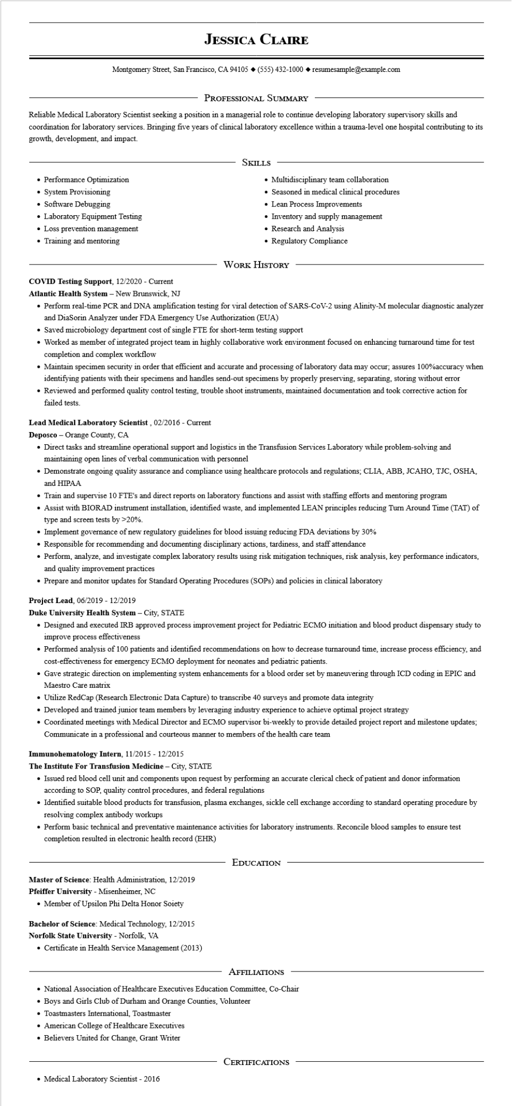

**JESSICA CLAIRE**

Montgomery Street, San Francisco, CA 94105 ♦ (555) 432-1000 ◆ resumesample@example.com

PROFESSIONAL SUMMARY

Reliable Medical Laboratory Scientist seeking a position in a managerial role to continue developing laboratory supervisory skills and coordination for laboratory services. Bringing five years of clinical laboratory excellence within a trauma-level one hospital contributing to its growth, development, and impact.

• Performance Optimization

• System Provisioning

• Software Debugging

• Laboratory Equipment Testing

• Loss prevention management

• Training and mentoring

SKILLS

• Multidisciplinary team collaboration

• Seasoned in medical clinical procedures

• Lean Process Improvements

• Inventory and supply management

• Research and Analysis

• Regulatory Compliance.

WORK HISTORY

**COVID Testing Support, 12/2020 - Current**

**Atlantic Health System - New Brunswick, NJ**

• Perform real-time PCR and DNA amplification testing for viral detection of SARS-CoV-2 using Alinity-M molecular diagnostic analyzer and DiaSorin Analyzer under FDA Emergency Use Authorization (EUA)

• Saved microbiology department cost of single FTE for short-term testing support

• Worked as member of integrated project team in highly collaborative work environment focused on enhancing turnaround time for test completion and complex workflow

• Maintain specimen security in order that efficient and accurate and processing of laboratory data may occur; assures 100% accuracy when identifying patients with their specimens and handles send-out specimens by properly preserving, separating, storing without error

• Reviewed and performed quality control testing, trouble shoot instruments, maintained documentation and took corrective action for failed tests.

**Lead Medical Laboratory Scientist, 02/2016 - Current**

Deposco - Orange County, CA

• Direct tasks and streamline operational support and logistics in the Transfusion Services Laboratory while problem-solving and maintaining open lines of verbal communication with personnel

• Demonstrate ongoing quality assurance and compliance using healthcare protocols and regulations; CLIA, ABB, JCAHO, TJC, OSHA, and HIPAA

• Train and supervise 10 FTE's and direct reports on laboratory functions and assist with staffing efforts and mentoring program

• Assist with BIORAD instrument installation, identified waste, and implemented LEAN principles reducing Turn Around Time (TAT) of type and screen tests by >20%.

• Implement governance of new regulatory guidelines for blood issuing reducing FDA deviations by 30%

• Responsible for recommending and documenting disciplinary actions, tardiness, and staff attendance

• Perform, analyze, and investigate complex laboratory results using risk mitigation techniques, risk analysis, key performance indicators, and quality improvement practices

• Prepare and monitor updates for Standard Operating Procedures (SOPs) and policies in clinical laboratory

Project Lead, 06/2019 - 12/2019

**Duke University Health System - City, STATE**

• Designed and executed IRB approved process improvement project for Pediatric ECMO initiation and blood product dispensary study to improve process effectiveness

• Performed analysis of 100 patients and identified recommendations on how to decrease turnaround time, increase process efficiency, and cost-effectiveness for emergency ECMO deployment for neonates and pediatric patients.

• Gave strategic direction on implementing system enhancements for a blood order set by maneuvering through ICD coding in EPIC and Maestro Care matrix

• Utilize RedCap (Research Electronic Data Capture) to transcribe 40 surveys and promote data integrity

• Developed and trained junior team members by leveraging industry experience to achieve optimal project strategy

• Coordinated meetings with Medical Director and ECMO supervisor bi-weekly to provide detailed project report and milestone updates; Communicate in a professional and courteous manner to members of the health care team

**Immunohematology Intern, 11/2015 - 12/2015**

**The Institute For Transfusion Medicine - City, STATE**

• Issued red blood cell unit and components upon request by performing an accurate clerical check of patient and donor information according to SOP, quality control procedures, and federal regulations

• Identified suitable blood products for transfusion, plasma exchanges, sickle cell exchange according to standard operating procedure by resolving complex antibody workups

• Perform basic technical and preventative maintenance activities for laboratory instruments. Reconcile blood samples to ensure test completion resulted in electronic health record (EHR)

**Master of Science: Health Administration, 12/2019**

Pfeiffer University - Misenheimer, NC

• Member of Upsilon Phi Delta Honor Soiety

**Bachelor of Science: Medical Technology, 12/2015 Norfolk State University - Norfolk, VA**

• Certificate in Health Service Management (2013)

EDUCATION

AFFILIATIONS

• National Association of Healthcare Executives Education Committee, Co-Chair

Boys and Girls Club of Durham and Orange Counties, Volunteer

• Toastmasters International, Toastmaster

• American College of Healthcare Executives

• Believers United for Change, Grant Writer

• Medical Laboratory Scientist - 2016

CERTIFICATIONS