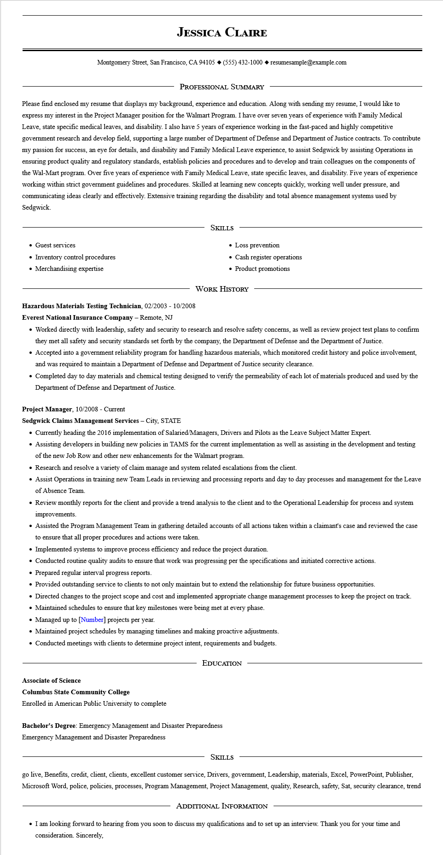

**JESSICA CLAIRE**

Montgomery Street, San Francisco, CA 94105 ♦ (555) 432-1000 resumesample@example.com

PROFESSIONAL SUMMARY

Please find enclosed my resume that displays my background, experience and education. Along with sending my resume, I would like to express my interest in the Project Manager position for the Walmart Program. I have over seven years of experience with Family Medical Leave, state specific medical leaves, and disability. I also have 5 years of experience working in the fast-paced and highly competitive government research and develop field, supporting a large number of Department of Defense and Department of Justice contracts. To contribute my passion for success, an eye for details, and disability and Family Medical Leave experience, to assist Sedgwick by assisting Operations in ensuring product quality and regulatory standards, establish policies and procedures and to develop and train colleagues on the components of the Wal-Mart program. Over five years of experience with Family Medical Leave, state specific leaves, and disability. Five years of experience working within strict government guidelines and procedures. Skilled at learning new concepts quickly, working well under pressure, and communicating ideas clearly and effectively. Extensive training regarding the disability and total absence management systems used by Sedgwick.

• Guest services

• Inventory control procedures

• Merchandising expertise

SKILLS

• Loss prevention

• Cash register operations

• Product promotions

**Hazardous Materials Testing Technician, 02/2003 - 10/2008**

**Everest National Insurance Company - Remote, NJ**

WORK HISTORY

• Worked directly with leadership, safety and security to research and resolve safety concerns, as well as review project test plans to confirm they met all safety and security standards set forth by the company, the Department of Defense and the Department of Justice.

• Accepted into a government reliability program for handling hazardous materials, which monitored credit history and police involvement,

and was required to maintain a Department of Defense and Department of Justice security clearance.

• Completed day to day materials and chemical testing designed to verify the permeability of each lot of materials produced and used by the Department of Defense and Department of Justice.

Project Manager, 10/2008 - Current

**Sedgwick Claims Management Services - City, STATE**

• Currently heading the 2016 implementation of Salaried/Managers, Drivers and Pilots as the Leave Subject Matter Expert.

• Assisting developers in building new policies in TAMS for the current implementation as well as assisting in the development and testing of the new Job Row and other new enhancements for the Walmart program.

• Research and resolve a variety of claim manage and system related escalations from the client.

• Assist Operations in training new Team Leads in reviewing and processing reports and day to day processes and management for the Leave of Absence Team.

• Review monthly reports for the client and provide a trend analysis to the client and to the Operational Leadership for process and system improvements.

• Assisted the Program Management Team in gathering detailed accounts of all actions taken within a claimant's case and reviewed the case to ensure that all proper procedures and actions were taken.

• Implemented systems to improve process efficiency and reduce the project duration.

• Conducted routine quality audits to ensure that work was progressing per the specifications and initiated corrective actions.

• Prepared regular interval progress reports.

• Provided outstanding service to clients to not only maintain but to extend the relationship for future business opportunities.

• Directed changes to the project scope and cost and implemented appropriate change management processes to keep the project on track.

• Maintained schedules to ensure that key milestones were being met at every phase.

• Managed up to [Number] projects per year.

• Maintained project schedules by managing timelines and making proactive adjustments.

• Conducted meetings with clients to determine project intent, requirements and budgets.

**Associate of Science**

**Columbus State Community College**

EDUCATION

Enrolled in American Public University to complete

Bachelor's Degree: Emergency Management and Disaster Preparedness

Emergency Management and Disaster Preparedness

SKILLS

go live, Benefits, credit, client, clients, excellent customer service, Drivers, government, Leadership, materials, Excel, PowerPoint, Publisher, Microsoft Word, police, policies, processes, Program Management, Project Management, quality, Research, safety, Sat, security clearance, trend

ADDITIONAL INFORMATION

⚫ I am looking forward to hearing from you soon to discuss my qualifications and to set up an interview. Thank you for your time and consideration. Sincerely,