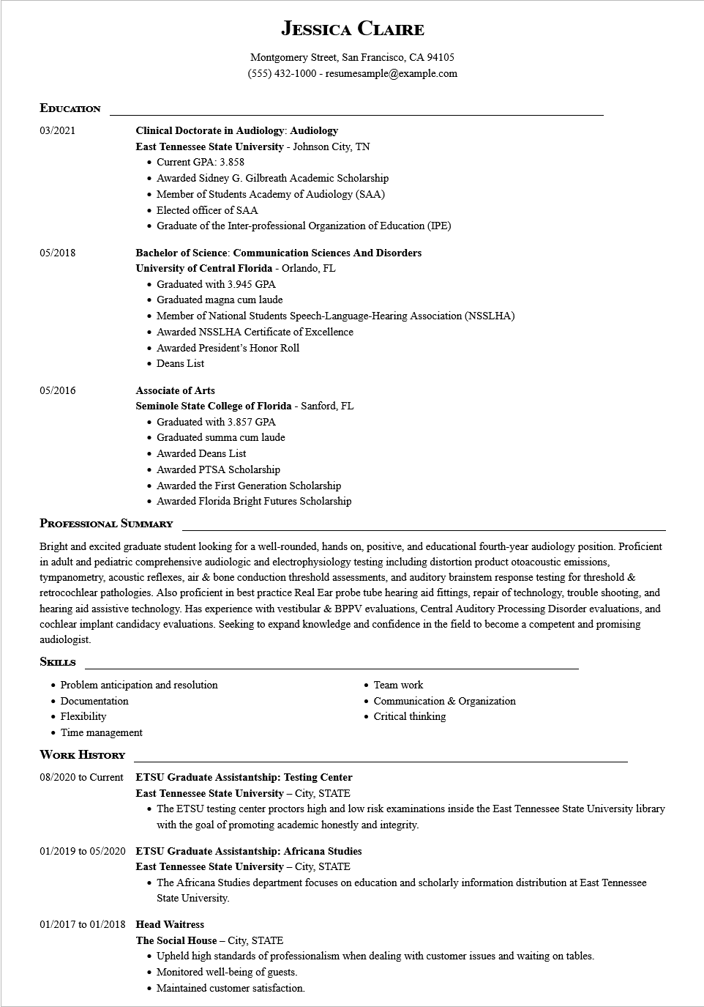

**JESSICA CLAIRE**

Montgomery Street, San Francisco, CA 94105 (555) 432-1000 - resumesample@example.com

**EDUCATION**

03/2021

05/2018

05/2016

**Clinical Doctorate in Audiology: Audiology East Tennessee State University - Johnson City, TN • Current GPA: 3.858**

• Awarded Sidney G. Gilbreath Academic Scholarship

• Member of Students Academy of Audiology (SAA)

• Elected officer of SAA

• Graduate of the Inter-professional Organization of Education (IPE)

**Bachelor of Science: Communication Sciences And Disorders**

**University of Central Florida - Orlando, FL**

• Graduated with 3.945 GPA

• Graduated magna cum laude

• Member of National Students Speech-Language-Hearing Association (NSSLHA)

• Awarded NSSLHA Certificate of Excellence

• Awarded President's Honor Roll

• Deans List

**Associate of Arts**

**Seminole State College of Florida - Sanford, FL**

• Graduated with 3.857 GPA

• Graduated summa cum laude

• Awarded Deans List

• Awarded PTSA Scholarship

• Awarded the First Generation Scholarship

• Awarded Florida Bright Futures Scholarship

**PROFESSIONAL SUMMARY**

Bright and excited graduate student looking for a well-rounded, hands on, positive, and educational fourth-year audiology position. Proficient in adult and pediatric comprehensive audiologic and electrophysiology testing including distortion product otoacoustic emissions, tympanometry, acoustic reflexes, air & bone conduction threshold assessments, and auditory brainstem response testing for threshold & retrocochlear pathologies. Also proficient in best practice Real Ear probe tube hearing aid fittings, repair of technology, trouble shooting, and hearing aid assistive technology. Has experience with vestibular & BPPV evaluations, Central Auditory Processing Disorder evaluations, and cochlear implant candidacy evaluations. Seeking to expand knowledge and confidence in the field to become a competent and promising audiologist.

**SKILLS**

• Problem anticipation and resolution

Team work

• Documentation

• Flexibility

• Time management

**WORK HISTORY**

**08/2020 to Current ETSU Graduate Assistantship: Testing Center East Tennessee State University - City, STATE**

• Communication & Organization • Critical thinking

The ETSU testing center proctors high and low risk examinations inside the East Tennessee State University library with the goal of promoting academic honestly and integrity.

**01/2019 to 05/2020 ETSU Graduate Assistantship: Africana Studies**

**East Tennessee State University - City, STATE**

• The Africana Studies department focuses on education and scholarly information distribution at East Tennessee State University.

**01/2017 to 01/2018 Head Waitress**

The Social House - City, STATE

• Upheld high standards of professionalism when dealing with customer issues and waiting on tables.

• Monitored well-being of guests.

Maintained customer satisfaction.