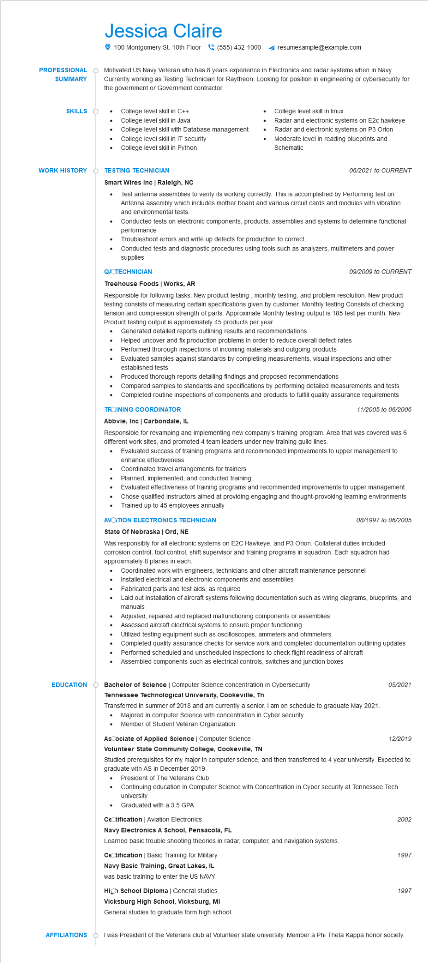

**PROFESSIONAL**

**SUMMARY**

**SKILLS**

Jessica Claire

100 Montgomery St. 10th Floor (555) 432-1000

resumesample@example.com

Motivated US Navy Veteran who has 8 years experience in Electronics and radar systems when in Navy. Currently working as Testing Technician for Raytheon. Looking for position in engineering or cybersecurity for the government or Government contractor.

College level skill in C++

College level skill in Java

• College level skill with Database management College level skill in IT security

• College level skill in Python

College level skill in linux

Radar and electronic systems on E2c hawkeye

Radar and electronic systems on P3 Orion Moderate level in reading blueprints and Schematic

**WORK HISTORY**

**TESTING TECHNICIAN**

**Smart Wires Inc | Raleigh, NC**

•

*06/2021 to CURRENT*

Test antenna assemblies to verify its working correctly. This is accomplished by Performing test on Antenna assembly which includes mother board and various circuit cards and modules with vibration and environmental tests.

Conducted tests on electronic components, products, assemblies and systems to determine functional performance

Troubleshoot errors and write up defects for production to correct.

• Conducted tests and diagnostic procedures using tools such as analyzers, multimeters and power supplies

**Q/OTECHNICIAN**

Treehouse Foods | Works, AR

*09/2009 to CURRENT*

Responsible for following tasks: New product testing, monthly testing, and problem resolution. New product testing consists of measuring certain specifications given by customer. Monthly testing Consists of checking tension and compression strength of parts. Approximate Monthly testing output is 185 test per month. New Product testing output is approximately 45 products per year.

Generated detailed reports outlining results and recommendations

•

•

Helped uncover and fix production problems in order to reduce overall defect rates

•

Performed thorough inspections of incoming materials and outgoing products

Evaluated samples against standards by completing measurements, visual inspections and other established tests

•

Produced thorough reports detailing findings and proposed recommendations

Completed routine inspections of components and products to fulfill quality assurance requirements TROINING COORDINATOR

•

Compared samples to standards and specifications by performing detailed measurements and tests

*11/2005 to 06/2006*

**Abbvie, Inc | Carbondale, IL**

Responsible for revamping and implementing new company's training program. Area that was covered was 6 different work sites, and promoted 4 team leaders under new training guild lines.

•

Evaluated success of training programs and recommended improvements to upper management to enhance effectiveness

•

Coordinated travel arrangements for trainers

Planned, implemented, and conducted training

Evaluated effectiveness of training programs and recommended improvements to upper management

•

Chose qualified instructors aimed at providing engaging and thought-provoking learning environments Trained up to 45 employees annually

**AVOTION ELECTRONICS TECHNICIAN**

*08/1997 to 06/2005*

**State Of Nebraska | Ord, NE**

Was responsibly for all electronic systems on E2C Hawkeye, and P3 Orion. Collateral duties included corrosion control, tool control, shift supervisor and training programs in squadron. Each squadron had approximately 8 planes in each.

•

Coordinated work with engineers, technicians and other aircraft maintenance personnel Installed electrical and electronic components and assemblies

Fabricated parts and test aids, as required

Laid out installation of aircraft systems following documentation such as wiring diagrams, blueprints, and manuals

Adjusted, repaired and replaced malfunctioning components or assemblies

•

Assessed aircraft electrical systems to ensure proper functioning

Utilized testing equipment such as oscilloscopes, ammeters and ohmmeters

•

Completed quality assurance checks for service work and completed documentation outlining updates Performed scheduled and unscheduled inspections to check flight readiness of aircraft

•

Assembled components such as electrical controls, switches and junction boxes

**EDUCATION**

Bachelor of Science | Computer Science concentration in Cybersecurity

**Tennessee Technological University, Cookeville, Tn**

Transferred in summer of 2018 and am currently a senior. I am on schedule to graduate May 2021.

·

Majored in computer Science with concentration in Cyber security

Member of Student Veteran Organization

**AsCociate of Applied Science | Computer Science**

**Volunteer State Community College, Cookeville, TN**

05/2021

12/2019

Studied prerequisites for my major in computer science, and then transferred to 4 year university. Expected to graduate with AS in December 2019

President of The Veterans Club

Continuing education in Computer Science with Concentration in Cyber security at Tennessee Tech university

Graduated with a 3.5 GPA

CeCtification | Aviation Electronics

2002

**Navy Electronics A School, Pensacola, FL**

Learned basic trouble shooting theories in radar, computer, and navigation systems.

CeCtification | Basic Training for Military

1997

**Navy Basic Training, Great Lakes, IL**

was basic training to enter the US NAVY

**High School Diploma | General studies Vicksburg High School, Vicksburg, MI General studies to graduate form high school.**

1997

**AFFILIATIONS**

I was President of the Veterans club at Volunteer state university. Member a Phi Theta Kappa honor society.