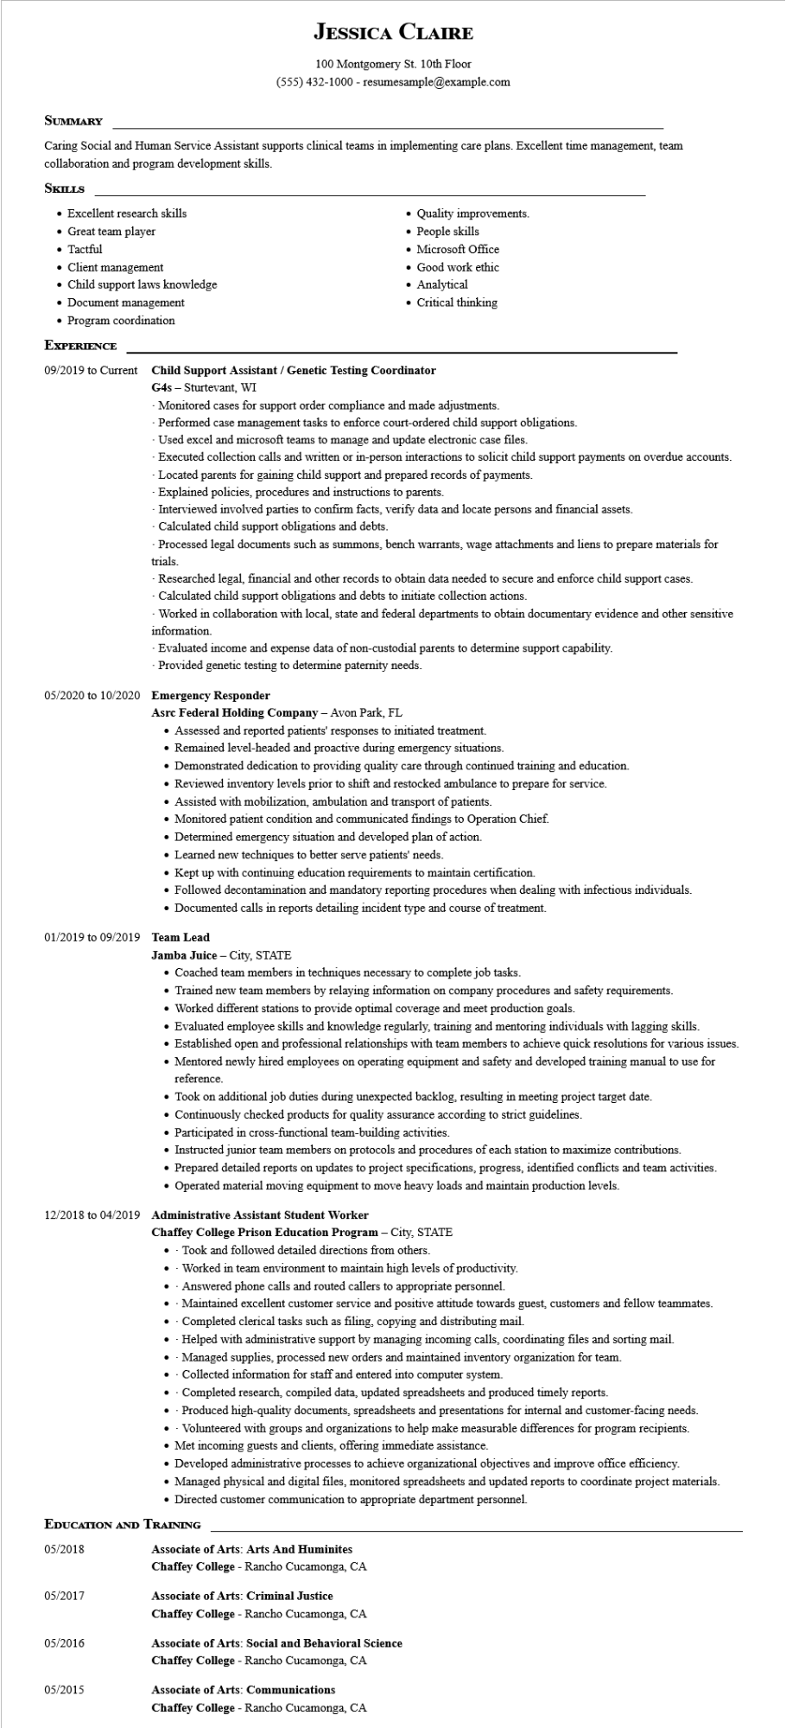

**JESSICA CLAIRE**

100 Montgomery St. 10th Floor

(555) 432-1000 - resumesample@example.com

**SUMMARY**

Caring Social and Human Service Assistant supports clinical teams in implementing care plans. Excellent time management, team collaboration and program development skills.

**SKILLS**

• Excellent research skills

• Great team player

• Tactful

• Client management

• Child support laws knowledge

• Document management

• Program coordination

**EXPERIENCE**

• Quality improvements.

•

People skills

• Microsoft Office

• Analytical

• Good work ethic

• Critical thinking

**09/2019 to Current Child Support Assistant / Genetic Testing Coordinator**

G4s - Sturtevant, WI

-Monitored cases for support order compliance and made adjustments.

Performed case management tasks to enforce court-ordered child support obligations.

-Used excel and microsoft teams to manage and update electronic case files.

-Executed collection calls and written or in-person interactions to solicit child support payments on overdue accounts.

- Located parents for gaining child support and prepared records of payments.

- Explained policies, procedures and instructions to parents.

Interviewed involved parties to confirm facts, verify data and locate persons and financial assets.

Calculated child support obligations and debts.

-Processed legal documents such as summons, bench warrants, wage attachments and liens to prepare materials for trials.

- Researched legal, financial and other records to obtain data needed to secure and enforce child support cases. Calculated child support obligations and debts to initiate collection actions.

Worked in collaboration with local, state and federal departments to obtain documentary evidence and other sensitive information.

Evaluated income and expense data of non-custodial parents to determine support capability.

-Provided genetic testing to determine paternity needs.

05/2020 to 10/2020 Emergency Responder

**Asrc Federal Holding Company - Avon Park, FL**

• Assessed and reported patients' responses to initiated treatment.

• Remained level-headed and proactive during emergency situations.

• Demonstrated dedication to providing quality care through continued training and education.

• Reviewed inventory levels prior to shift and restocked ambulance to prepare for service.

• Assisted with mobilization, ambulation and transport of patients.

• Monitored patient condition and communicated findings to Operation Chief.

• Determined emergency situation and developed plan of action.

• Learned new techniques to better serve patients' needs.

• Kept up with continuing education requirements to maintain certification.

• Followed decontamination and mandatory reporting procedures when dealing with infectious individuals.

• Documented calls in reports detailing incident type and course of treatment.

01/2019 to 09/2019 Team Lead

**Jamba Juice - City, STATE**

• Coached team members in techniques necessary to complete job tasks.

• Trained new team members by relaying information on company procedures and safety requirements.

• Worked different stations to provide optimal coverage and meet production goals.

• Evaluated employee skills and knowledge regularly, training and mentoring individuals with lagging skills.

• Established open and professional relationships with team members to achieve quick resolutions for various issues.

• Mentored newly hired employees on operating equipment and safety and developed training manual to use for reference.

• Took on additional job duties during unexpected backlog, resulting in meeting project target date.

• Continuously checked products for quality assurance according to strict guidelines.

• Participated in cross-functional team-building activities.

• Instructed junior team members on protocols and procedures of each station to maximize contributions.

• Prepared detailed reports on updates to project specifications, progress, identified conflicts and team activities.

• Operated material moving equipment to move heavy loads and maintain production levels.

**12/2018 to 04/2019 Administrative Assistant Student Worker**

Chaffey College Prison Education Program - City, STATE

· Took and followed detailed directions from others.

Worked in team environment to maintain high levels of productivity.

• Answered phone calls and routed callers to appropriate personnel.

•

·

Maintained excellent customer service and positive attitude towards guest, customers and fellow teammates. Completed clerical tasks such as filing, copying and distributing mail.

⚫ - Helped with administrative support by managing incoming calls, coordinating files and sorting mail.

•

Managed supplies, processed new orders and maintained inventory organization for team.

•

Collected information for staff and entered into computer system.

Completed research, compiled data, updated spreadsheets and produced timely reports.

•

Produced high-quality documents, spreadsheets and presentations for internal and customer-facing needs.

Volunteered with groups and organizations to help make measurable differences for program recipients.

• Met incoming guests and clients, offering immediate assistance.

• Developed administrative processes to achieve organizational objectives and improve office efficiency.

• Managed physical and digital files, monitored spreadsheets and updated reports to coordinate project materials.

• Directed customer communication to appropriate department personnel.

EDUCATION AND TRAINING

05/2018

**Associate of Arts: Arts And Huminites**

Chaffey College - Rancho Cucamonga, CA

05/2017

**Associate of Arts: Criminal Justice**

Chaffey College - Rancho Cucamonga, CA

05/2016

Associate of Arts: Social and Behavioral Science Chaffey College - Rancho Cucamonga, CA

05/2015

**Associate of Arts: Communications**

Chaffey College - Rancho Cucamonga, CA