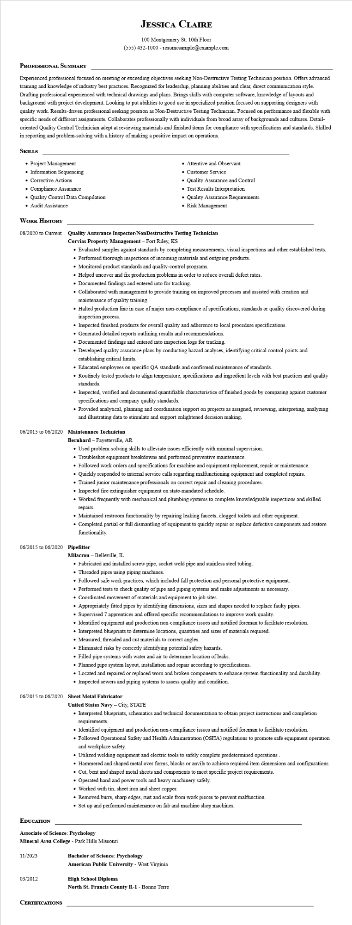

**JESSICA CLAIRE**

100 Montgomery St. 10th Floor (555) 432-1000 - resumesample@example.com

**PROFESSIONAL SUMMARY**

Experienced professional focused on meeting or exceeding objectives seeking Non-Destructive Testing Technician position. Offers advanced training and knowledge of industry best practices. Recognized for leadership, planning abilities and clear, direct communication style. Drafting professional experienced with technical drawings and plans. Brings skills with computer software, knowledge of layouts and background with project development. Looking to put abilities to good use in specialized position focused on supporting designers with quality work. Results-driven professional seeking position as Non-Destructive Testing Technician. Focused on performance and flexible with specific needs of different assignments. Collaborates professionally with individuals from broad array of backgrounds and cultures. Detail- oriented Quality Control Technician adept at reviewing materials and finished items for compliance with specifications and standards. Skilled in reporting and problem-solving with a history of making a positive impact on operations.

**SKILLS**

• Project Management

• Information Sequencing

• Corrective Actions

• Compliance Assurance

• Quality Control Data Compilation

• Audit Assistance

**WORK HISTORY**

• Attentive and Observant

• Customer Service

• Quality Assurance and Control

• Test Results Interpretation

• Quality Assurance Requirements

• Risk Management

**08/2020 to Current Quality Assurance Inspector/Non Destructive Testing Technician Corvias Property Management - Fort Riley, KS**

• Evaluated samples against standards by completing measurements, visual inspections and other established tests.

• Performed thorough inspections of incoming materials and outgoing products.

• Monitored product standards and quality-control programs.

• Helped uncover and fix production problems in order to reduce overall defect rates.

• Documented findings and entered into for tracking.

• Collaborated with management to provide training on improved processes and assisted with creation and maintenance of quality training.

• Halted production line in case of major non-compliance of specifications, standards or quality discovered during inspection process.

• Inspected finished products for overall quality and adherence to local procedure specifications.

• Generated detailed reports outlining results and recommendations.

• Documented findings and entered into inspection logs for tracking.

• Developed quality assurance plans by conducting hazard analyses, identifying critical control points and establishing critical limits.

• Educated employees on specific QA standards and confirmed maintenance of standards.

• Routinely tested products to align temperature, specifications and ingredient levels with best practices and quality standards.

• Inspected, verified and documented quantifiable characteristics of finished goods by comparing against customer specifications and company quality standards.

• Provided analytical, planning and coordination support on projects as assigned, reviewing, interpreting, analyzing and illustrating data to stimulate and support enlightened decision making.

**06/2015 to 06/2020 Maintenance Technician**

Bernhard - Fayetteville, AR

• Used problem-solving skills to alleviate issues efficiently with minimal supervision.

• Troubleshot equipment breakdowns and performed preventive maintenance.

• Followed work orders and specifications for machine and equipment replacement, repair or maintenance.

• Quickly responded to internal service calls regarding malfunctioning equipment and completed repairs.

• Trained junior maintenance professionals on correct repair and cleaning procedures.

• Inspected fire extinguisher equipment on state-mandated schedule.

• Worked frequently with mechanical and plumbing systems to complete knowledgeable inspections and skilled repairs.

• Maintained restroom functionality by repairing leaking faucets, clogged toilets and other equipment.

• Completed partial or full dismantling of equipment to quickly repair or replace defective components and restore functionality.

06/2015 to 06/2020 Pipefitter

Milacron - Belleville, IL

• Fabricated and installed screw pipe, socket weld pipe and stainless steel tubing.

• Threaded pipes using piping machines.

• Followed safe work practices, which included fall protection and personal protective equipment.

• Performed tests to check quality of pipe and piping systems and make adjustments as necessary.

• Coordinated movement of materials and equipment to job sites.

• Appropriately fitted pipes by identifying dimensions, sizes and shapes needed to replace faulty pipes.

• Supervised 7 apprentices and offered specific recommendations to improve work quality.

• Identified equipment and production non-compliance issues and notified foreman to facilitate resolution.

• Interpreted blueprints to determine locations, quantities and sizes of materials required.

• Measured, threaded and cut materials to correct angles.

• Eliminated risks by correctly identifying potential safety hazards.

• Filled pipe systems with water and air to determine location of leaks.

• Planned pipe system layout, installation and repair according to specifications.

• Located and repaired or replaced worn and broken components to enhance system functionality and durability.

• Inspected sewers and piping systems to assess quality and condition.

**06/2015 to 06/2020 Sheet Metal Fabricator**

**United States Navy - City, STATE**

• Interpreted blueprints, schematics and technical documentation to obtain project instructions and completion requirements.

• Identified equipment and production non-compliance issues and notified foreman to facilitate resolution.

• Followed Operational Safety and Health Administration (OSHA) regulations to promote safe equipment operation and workplace safety.

• Utilized welding equipment and electric tools to safely complete predetermined operations

• Hammered and shaped metal over forms, blocks or anvils to achieve required item dimensions and configurations.

• Cut, bent and shaped metal sheets and components to meet specific project requirements.

• Operated hand and power tools and heavy machinery safely.

• Worked with tin, sheet iron and sheet copper.

• Removed burrs, sharp edges, rust and scale from work pieces to prevent malfunction.

• Set up and performed maintenance on fab and machine shop machines.

**EDUCATION**

**Associate of Science: Psychology**

Mineral Area College - Park Hills Missouri

11/2023

**Bachelor of Science: Psychology**

**American Public University - West Virginia**

03/2012

**High School Diploma**

**North St. Francis County R-1 - Bonne Terre**

**CERTIFICATIONS**