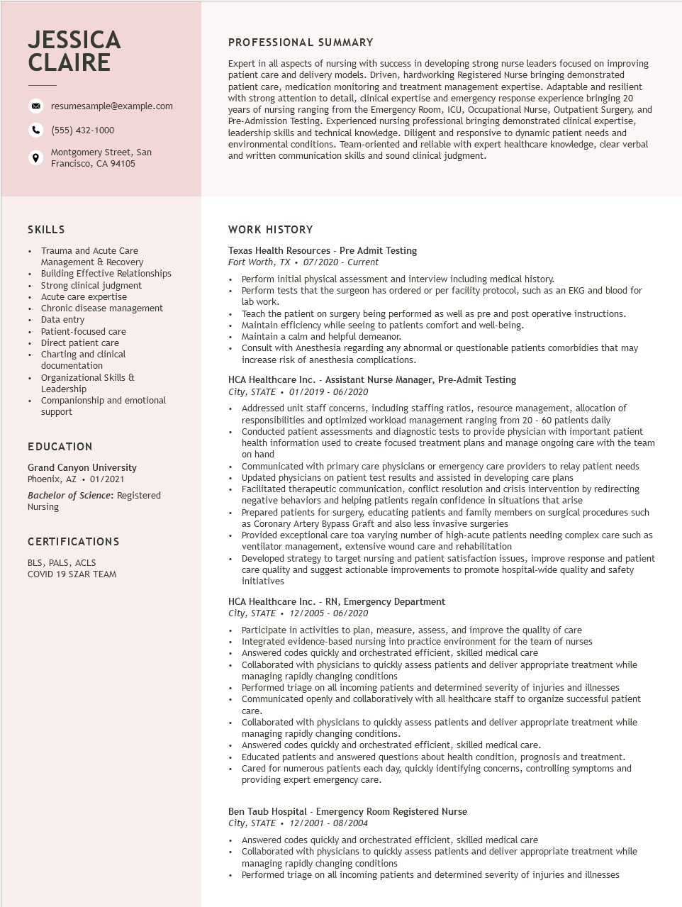

**JESSICA CLAIRE**

resumesample@example.com

(555) 432-1000

Montgomery Street, San Francisco, CA 94105

PROFESSIONAL SUMMARY

Expert in all aspects of nursing with success in developing strong nurse leaders focused on improving patient care and delivery models. Driven, hardworking Registered Nurse bringing demonstrated patient care, medication monitoring and treatment management expertise. Adaptable and resilient with strong attention to detail, clinical expertise and emergency response experience bringing 20 years of nursing ranging from the Emergency Room, ICU, Occupational Nurse, Outpatient Surgery, and Pre-Admission Testing. Experienced nursing professional bringing demonstrated clinical expertise, leadership skills and technical knowledge. Diligent and responsive to dynamic patient needs and environmental conditions. Team-oriented and reliable with expert healthcare knowledge, clear verbal and written communication skills and sound clinical judgment.

SKILLS

•

Trauma and Acute Care

•

+

Management & Recovery

Building Effective Relationships

Strong clinical judgment

Chronic disease management

•

Acute care expertise

•

•

Data entry

Direct patient care

•

•

Patient-focused care

Charting and clinical

documentation

Organizational Skills & Leadership

Companionship and emotional

support

EDUCATION

Grand Canyon University Phoenix, AZ. 01/2021

Bachelor of Science: Registered Nursing

CERTIFICATIONS

BLS, PALS, ACLS

COVID 19 SZAR TEAM

**WORK HISTORY**

Texas Health Resources - Pre Admit Testing

Fort Worth, TX⚫ 07/2020 - Current

• Perform initial physical assessment and interview including medical history.

• Perform tests that the surgeon has ordered or per facility protocol, such as an EKG and blood for lab work.

•

Teach the patient on surgery being performed as well as pre and post operative instructions. • Maintain efficiency while seeing to patients comfort and well-being.

• Maintain a calm and helpful demeanor.

• Consult with Anesthesia regarding any abnormal or questionable patients comorbidies that may increase risk of anesthesia complications.

HCA Healthcare Inc. - Assistant Nurse Manager, Pre-Admit Testing City, STATE⚫ 01/2019 - 06/2020

• Addressed unit staff concerns, including staffing ratios, resource management, allocation of responsibilities and optimized workload management ranging from 20 - 60 patients daily

• Conducted patient assessments and diagnostic tests to provide physician with important patient health information used to create focused treatment plans and manage ongoing care with the team on hand

• Communicated with primary care physicians or emergency care providers to relay patient needs Updated physicians on patient test results and assisted in developing care plans

Facilitated therapeutic communication, conflict resolution and crisis intervention by redirecting negative behaviors and helping patients regain confidence in situations that arise

Prepared patients for surgery, educating patients and family members on surgical procedures such as Coronary Artery Bypass Graft and also less invasive surgeries

Provided exceptional care toa varying number of high-acute patients needing complex care such as ventilator management, extensive wound care and rehabilitation

• Developed strategy to target nursing and patient satisfaction issues, improve response and patient care quality and suggest actionable improvements to promote hospital-wide quality and safety initiatives

HCA Healthcare Inc. - RN, Emergency Department

*City, STATE⚫ 12/2005 - 06/2020*

Participate in activities to plan, measure, assess, and improve the quality of care Integrated evidence-based nursing into practice environment for the team of nurses

Answered codes quickly and orchestrated efficient, skilled medical care

• Collaborated with physicians to quickly assess patients and deliver appropriate treatment while managing rapidly changing conditions

• Performed triage on all incoming patients and determined severity of injuries and illnesses

• Communicated openly and collaboratively with all healthcare staff to organize successful patient

•

care.

Collaborated with physicians to quickly assess patients and deliver appropriate treatment while managing rapidly changing conditions.

• Answered codes quickly and orchestrated efficient, skilled medical care.

Educated patients and answered questions about health condition, prognosis and treatment. Cared for numerous patients each day, quickly identifying concerns, controlling symptoms and providing expert emergency care.

Ben Taub Hospital - Emergency Room Registered Nurse

*City, STATE 12/2001 - 08/2004*

• Answered codes quickly and orchestrated efficient, skilled medical care

• Collaborated with physicians to quickly assess patients and deliver appropriate treatment while managing rapidly changing conditions

• Performed triage on all incoming patients and determined severity of injuries and illnesses