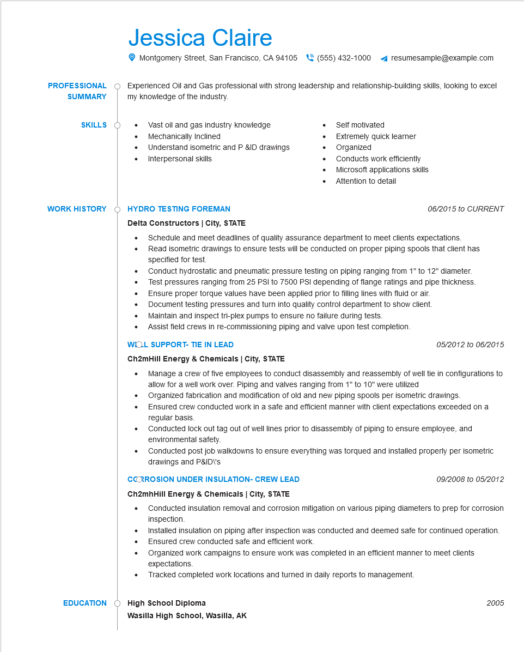

**PROFESSIONAL**

**SUMMARY**

**SKILLS**

Jessica Claire

Montgomery Street, San Francisco, CA 94105

(555) 432-1000

resumesample@example.com

Experienced Oil and Gas professional with strong leadership and relationship-building skills, looking to excel my knowledge of the industry.

Vast oil and gas industry knowledge

Self motivated

• Mechanically Inclined

Extremely quick learner

Understand isometric and P &ID drawings Interpersonal skills

•

Organized

Conducts work efficiently

**WORK HISTORY**

**HYDRO TESTING FOREMAN**

**Delta Constructors | City, STATE**

Microsoft applications skills Attention to detail

*06/2015 to CURRENT*

• Schedule and meet deadlines of quality assurance department to meet clients expectations. Read isometric drawings to ensure tests will be conducted on proper piping spools that client has specified for test.

Conduct hydrostatic and pneumatic pressure testing on piping ranging from 1" to 12" diameter. Test pressures ranging from 25 PSI to 7500 PSI depending of flange ratings and pipe thickness. • Ensure proper torque values have been applied prior to filling lines with fluid or air. Document testing pressures and turn into quality control department to show client. Maintain and inspect tri-plex pumps to ensure no failure during tests.

Assist field crews in re-commissioning piping and valve upon test completion.

**WOL SUPPORT- TIE IN LEAD**

**Ch2mHill Energy & Chemicals | City, STATE**

*05/2012 to 06/2015*

Manage a crew of five employees to conduct disassembly and reassembly of well tie in configurations to allow for a well work over. Piping and valves ranging from 1" to 10" were utilized

Organized fabrication and modification of old and new piping spools per isometric drawings.

• Ensured crew conducted work in a safe and efficient manner with client expectations exceeded on a regular basis.

Conducted lock out tag out of well lines prior to disassembly of piping to ensure employee, and environmental safety.

• Conducted post job walkdowns to ensure everything was torqued and installed properly per isometric drawings and P&ID\'s

**CCORROSION UNDER INSULATION-CREW LEAD**

**Ch2mhHill Energy & Chemicals | City, STATE**

*09/2008 to 05/2012*

Conducted insulation removal and corrosion mitigation on various piping diameters to prep for corrosion inspection.

Installed insulation on piping after inspection was conducted and deemed safe for continued operation. • Ensured crew conducted safe and efficient work.

•

Organized work campaigns to ensure work was completed in an efficient manner to meet clients expectations.

Tracked completed work locations and turned in daily reports to management.

**EDUCATION**

**High School Diploma**

**Wasilla High School, Wasilla, AK**

2005