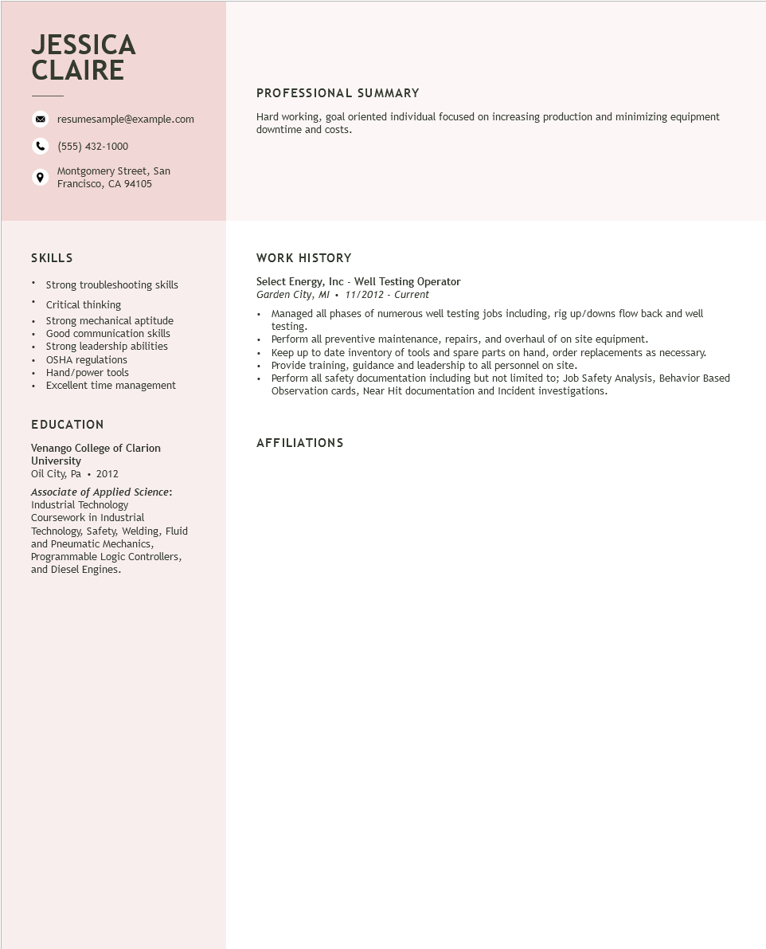

**JESSICA CLAIRE**

resumesample@example.com

(555) 432-1000

Montgomery Street, San Francisco, CA 94105

PROFESSIONAL SUMMARY

Hard working, goal oriented individual focused on increasing production and minimizing equipment downtime and costs.

SKILLS

• Strong troubleshooting skills

+

Critical thinking

·

•

•

Strong mechanical aptitude

Good communication skills

Strong leadership abilities

OSHA regulations

Hand/power tools

Excellent time management

EDUCATION

Venango College of Clarion University

Oil City, Pa⚫ 2012

Associate of Applied Science:

Industrial Technology

Coursework in Industrial

Technology, Safety, Welding, Fluid and Pneumatic Mechanics, Programmable Logic Controllers, and Diesel Engines.

WORK HISTORY

Select Energy, Inc - Well Testing Operator

Garden City, MI. 11/2012 - Current

• Managed all phases of numerous well testing jobs including, rig up/downs flow back and well testing.

• Perform all preventive maintenance, repairs, and overhaul of on site equipment.

• Keep up to date inventory of tools and spare parts on hand, order replacements as necessary. Provide training, guidance and leadership to all personnel on site.

Perform all safety documentation including but not limited to; Job Safety Analysis, Behavior Based Observation cards, Near Hit documentation and Incident investigations.

**AFFILIATIONS**