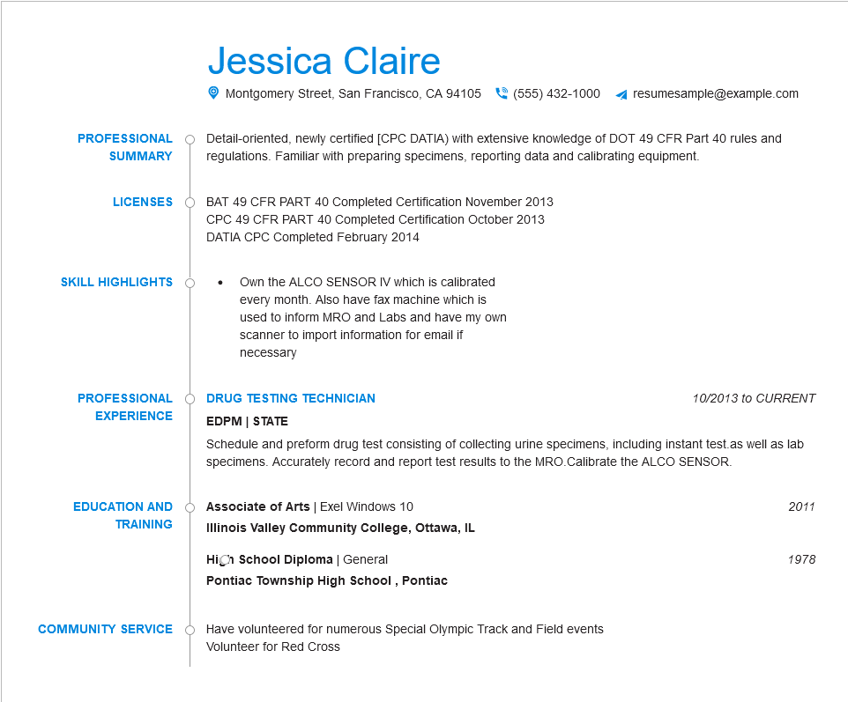

**PROFESSIONAL**

**SUMMARY**

**LICENSES**

**SKILL HIGHLIGHTS**

Jessica Claire

Montgomery Street, San Francisco, CA 94105

(555) 432-1000

resumesample@example.com

Detail-oriented, newly certified [CPC DATIA) with extensive knowledge of DOT 49 CFR Part 40 rules and regulations. Familiar with preparing specimens, reporting data and calibrating equipment.

BAT 49 CFR PART 40 Completed Certification November 2013 CPC 49 CFR PART 40 Completed Certification October 2013 DATIA CPC Completed February 2014

Own the ALCO SENSOR IV which is calibrated

every month. Also have fax machine which is used to inform MRO and Labs and have my own scanner to import information for email if

necessary

**PROFESSIONAL EXPERIENCE**

**DRUG TESTING TECHNICIAN**

**EDPM | STATE**

*10/2013 to CURRENT*

Schedule and preform drug test consisting of collecting urine specimens, including instant test.as well as lab specimens. Accurately record and report test results to the MRO.Calibrate the ALCO SENSOR.

**EDUCATION AND**

**TRAINING**

Associate of Arts | Exel Windows 10

**Illinois Valley Community College, Ottawa, IL**

**High School Diploma | General**

**Pontiac Township High School, Pontiac**

**COMMUNITY SERVICE**

Have volunteered for numerous Special Olympic Track and Field events Volunteer for Red Cross

*2011*

1978