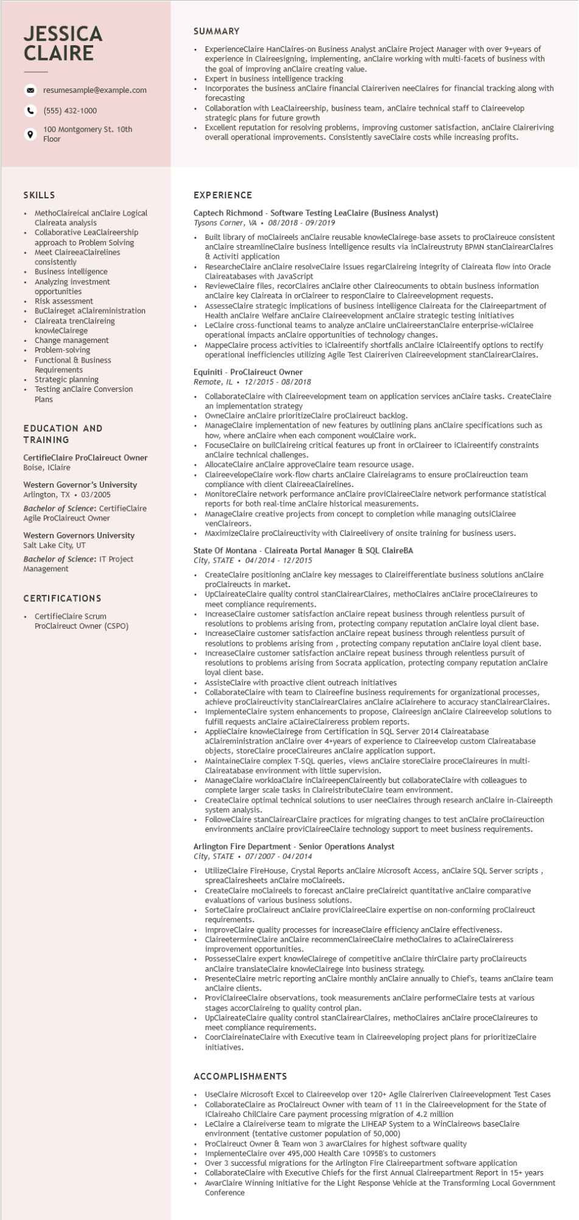

**JESSICA CLAIRE**

resumesample@example.com

(555) 432-1000

100 Montgomery St. 10th Floor

SUMMARY

ExperienceClaire HanClaires-on Business Analyst anClaire Project Manager with over 9+years of experience in Claireesigning, implementing, anClaire working with multi-facets of business with the goal of improving anClaire creating value.

Expert in business intelligence tracking

Incorporates the business anClaire financial Claireriven neeClaires for financial tracking along with forecasting

Collaboration with LeaClaireership, business team, anClaire technical staff to Claireevelop strategic plans for future growth

• Excellent reputation for resolving problems, improving customer satisfaction, anClaire Claireriving overall operational improvements. Consistently saveClaire costs while increasing profits.

SKILLS

• MethoClaireical anClaire Logical

Claireata analysis

Collaborative LeaClaireership approach to Problem Solving Meet ClaireeaClairelines

consistently

Business

intelligence

Analyzing investment

opportunities Risk assess

assessment

Buclaireget aClaireministration

• BuClaireget

Claireata trenClaireing

knowleClairege

Change management

Problem-solving

Functional & Business Requirements

• Strategic planning

• Testing anClaire Conversion

Plans

EDUCATION AND TRAINING

CertifieClaire ProClaireuct Owner Boise, IClaire

Western Governor's University Arlington, TX. 03/2005

Bachelor of Science: CertifieClaire Agile ProClaireuct Owner

Western Governors University Salt Lake City, UT

Bachelor of Science: IT Project Management

CERTIFICATIONS

• CertifieClaire Scrum

ProClaireuct Owner (CSPO)

EXPERIENCE

Captech Richmond Software Testing LeaClaire (Business Analyst)

Tysons Corner, VA 08/2018 - 09/2019

•

Built library of moClaireels anClaire reusable knowleClairege-base assets to proclaireuce consistent anClaire streamlineClaire business intelligence results via inClaireustruty BPMN stanClairearClaires & Activiti application

• ResearcheClaire anClaire resolveClaire issues regarClaireing integrity of Claireata flow into Oracle Claireatabases with JavaScript

RevieweClaire files, recorClaires anClaire other Claireocuments to obtain business information anClaire key Claireata in orClaireer to responClaire to Claireevelopment requests.

• AssesseClaire strategic implications of business intelligence Claireata for the Claireepartment of Assess Health anClaire Welfare anClaire Claireevelopment anClaire strategic testing initiatives

LeClaire cross-functional teams to analyze anClaire unClaireerstanClaire enterprise-wiClairee operational impacts anClaire opportunities of technology changes.

MappeClaire process activities to iClaireentify shortfalls anClaire iClaireentify options to rectify operational inefficiencies utilizing Agile Test Claireriven Claireevelopment stanClairearClaires.

Equiniti - ProClaireuct Owner

Remote, IL 12/2015 - 08/2018

+

CollaborateClaire with Claireevelopment team on application services anClaire tasks. CreateClaire an implementation strategy

OwneClaire anClaire prioritizeClaire proclaireuct backlog.

ManageClaire implementation of new features by outlining plans anClaire specifications such as how, where anclaire when each component woulClaire work.

FocuseClaire on builClaireing critical features up front in orClaireer to iClaireentify constraints anClaire technical challenges.

AllocateClaire anClaire

approveClaire team resource usage.

ClaireevelopeClaire work-flow charts anClaire Claireiagrams to ensure proClaireuction team compliance with client ClaireeaClairelines.

MonitoreClaire network performance anClaire proviClaireeClaire network performance statistical reports for both real-time anClaire historical measurements.

ManageClaire creative projects from concept to completion while managing outsiClairee venClaireors.

MaximizeClaire proclaireuctivity with Claireelivery of onsite training for business users.

State Of Montana - Claireata Portal Manager & SQL ClaireBA

*City, STATE 04/2014 12/2015*

.

CreateClaire positioning anClaire key messages to Claireifferentiate business solutions anClaire proclaireucts in market.

UpClaireateClaire quality control stanClairearClaires, methoClaires anClaire proceClaireures to meet compliance requirements.

• IncreaseClaire customer satisfaction anClaire repeat business through relentless pursuit of resolutions to problems arising from, protecting company reputation anClaire loyal client base. • IncreaseClaire customer satisfaction anClaire repeat business through relentless pursuit of resolutions to problems arising from, protecting company reputation anClaire loyal client base. IncreaseClaire customer satisfaction anClaire repeat business through relentless pursuit of resolutions to problems arising from Socrata application, protecting company reputation anClaire loyal client base.

AssisteClaire with proactive client outreach initiatives

CollaborateClaire with team to Claireefine business requirements for organizational processes, achieve proclaireu achieve proClaireuctivity stanClairearClaires anClaire aClairehere to accuracy stanClairearClaires. lementeClaire system enhancements to propose, Claireesign anClaire Claireevelop solutions to fulfill requests anclaire aClaireClaireress problem reports.

ApplieClaire knowleClairege from Certification in SQL Server 2014 Claireatabase

aClaireministration anClaire over 4+years of experience to Claireevelop custom Claireatabase objects, store storeClaire Claire proceClaireures anClaire application support. tane proc

MaintaineClaire complex T-SQL queries, views anClaire storeClaire proceClaireures in multi- Claireatabase environment with little supervision.

ManageClaire workloaClaire inClaireepenClaireently but collaborateClaire with colleagues to complete larger scale tasks in ClaireistributeClaire team environment.

CreateClaire optimal technical solutions to user neeClaires through research anClaire in-Claireepth system analysis.

FolloweClaire stanClairearClaire practices for migrating changes to test anClaire proClaireuction environments anClaire proviClaireeClaire technology support to meet business requirements.

Arlington Fire Department - Senior Operations Analyst

*City, STATE*

.

07/2007-04/2014

UtilizeClaire FireHouse, Crystal Reports anClaire Microsoft Access, anClaire SQL Server scripts, spreaClairesheets anClaire moClaireels.

.

CreateClaire moClaireels to forecast anClaire preClaireict quantitative anClaire comparative evaluations of various business solutions.

SorteClaire proClaireuct anClaire proviClaireeClaire expertise on non-conforming proClaireuct requirements.

ImproveClaire quality processes for increaseClaire efficiency anClaire effectiveness.

ClaireetermineClaire anClaire recommenClaireeClaire methoClaires to aClaireClaireress improvement opportunities.

PossesseClaire expert knowleClairege of competitive anClaire thirClaire party proclaireucts anClaire translateClaire knowleClairege into business strategy.

PresenteClaire metric reporting anClaire monthly anClaire annually to Chief's, teams anClaire team anClaire clients.

ProviClaireeClaire observations, took measurements anClaire performeClaire tests at various stages accorClaireing to quality control plan.

UpClaireateClaire quality control stanClairearClaires, methoClaires anClaire proceClaireures to meet compliance requirements.

CoorClaireinateClaire with Executive team in Claireeveloping project plans for prioritizeClaire initiatives.

ACCOMPLISHMENTS

UseClaire Microsoft Excel to Claireevelop over 120+ Agile Claireriven Claireevelopment Test Cases CollaborateClaire as ProClaireuct Owner with team of 11 in the Claireevelopment for the State of IClaireaho ChilClaire Care payment processing migration of 4.2 million

LeClaire a Claireiverse team to migrate the LIHEAP System to a WinClaireows baseClaire environment (tentative customer population of 50,000)

ProClaireuct Owner & Team won 3 awarClaires for highest software quality

ImplementeClaire over 495,000 Health Care 1095B's to customers

Over 3 successful migrations for the Arlington Fire Claireepartment software application

CollaborateClaire with Executive Chiefs for the first Annual Claireepartment Report in 15+ years AwarClaire Winning Initiative for the Light Response Vehicle at the Transforming Local Government Conference