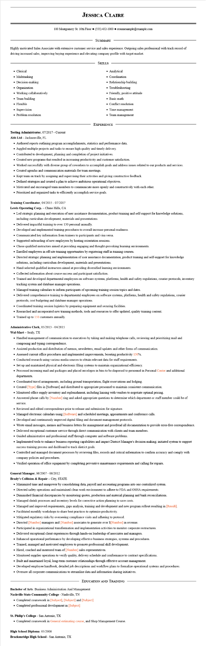

**JESSICA CLAIRE**

100 Montgomery St. 10th Floor (555) 432-1000◆ resumesample@example.com

SUMMARY

Highly motivated Sales Associate with extensive customer service and sales experience. Outgoing sales professional with track record of driving increased sales, improving buying experience and elevating company profile with target market.

• Clerical

SKILLS

• Analytical

• Multitasking

• Decision-making

• Organization

• Working collaboratively

• Team building

• Flexible

• Supervision

• Problem resolution

• Coordination

• Relationship building

• Troubleshooting

• Friendly, positive attitude

• Basic math

• Conflict resolution

• Time management

• Team management

EXPERIENCE

**Testing Administrator, 07/2017 - Current**

Abb Ltd - Jacksonville, FL

• Authored reports outlining program accomplishments, statistics and performance data.

• Juggled multiple projects and tasks to ensure high quality and timely delivery.

• Contributed to development, planning and completion of project initiatives.

• Created new programs that resulted in increasing productivity and customer satisfaction.

• Worked successfully with diverse group of coworkers to accomplish goals and address issues related to our products and services.

• Created agendas and communication materials for team meetings.

• Kept team on track by assigning and supervising their activities and giving constructive feedback.

• Defined strategies and created a plan to achieve ambitious operational objectives.

• Motivated and encouraged team members to communicate more openly and constructively with each other.

• Prioritized and organized tasks to efficiently accomplish service goals.

Training Coordinator, 04/2015 - 07/2017

**Lewis Operating Corp. - Chino Hills, CA**

• Led strategic planning and execution of user assistance documentation, product training and self-support for knowledge solutions, including curriculum development, materials and presentations.

• Delivered impactful training to over 130 personal annually.

• Developed and implemented training procedures to overall increase personal readiness.

• Communicated key information from trainers to participants and visa versa.

• Supported onboarding of new employees by hosting orientation sessions.

• Chose qualified instructors aimed at providing engaging and thought-provoking learning environments.

• Enrolled employees in off-site training opportunities by registering staff in training courses.

• Directed strategic planning and implementation of user assistance documentation, product training and self-support for knowledge solutions, including curriculum development, materials and presentations.

• Hand-selected qualified instructors aimed at providing diversified learning environments.

• Collected information about course success and participant satisfaction.

• Trained and developed departmental employees on software systems, platforms, health and safety regulations, courier protocols, inventory tracking system and database manager operations.

• Managed training calendars to inform participants of upcoming training session topics and dates.

• Delivered comprehensive training to departmental employees on software systems, platforms, health and safety regulations, courier protocols, cost budgeting and database manager operations.

• Coordinated training session logistics by preparing equipment and securing facilities.

• Researched and incorporated new training methods, tools and resources to offer updated, quality training content.

• Trained up to 150 customers annually.

Administrative Clerk, 05/2013 - 04/2015

Wal-Mart - Sealy, TX

• Handled management of communication to executives by taking and making telephone calls, reviewing and prioritizing mail and composing and typing correspondence.

• Assisted production and distribution of memos, newsletters, email updates and other forms of communication.

• Assessed current office procedures and implemented improvements, boosting productivity 150%.

• Conducted research using various media sources to obtain relevant data for staff requirements.

• Set up and maintained physical and electronic filing systems to maintain organizational efficiency.

• Processed incoming mail and packages and placed envelopes in bins to be dispersed to personnel in Personal Center and additional departments.

• Coordinated travel arrangements, including ground transportation, flight reservations and lodging.

• Created [Type] files in [Software] and distributed to appropriate personnel to maintain consistent communication.

• Monitored office supply inventory and replenishment, including liaising with vendors to negotiate optimal pricing.

• Answered phone calls by [Number] ring and asked appropriate questions to determine which department or staff member could be of service.

• Reviewed and edited correspondence prior to release and submission for signature.

• Managed electronic calendars using [Software] and scheduled meetings, appointments and conference calls.

• Developed and continuously improved digital filing and document management protocols.

• Wrote email messages, memos and business letters for management and proofread all documentation to provide error-free correspondence.

• Delivered exceptional customer service through direct communication with clients and team members.

• Guided administrative and professional staff through computer and software problems.

• Implemented tools to enhance business reporting capabilities and impact District Manager's decision making; initiated system to support success training process and dashboard to track district goals.

• Controlled and managed document processes by reviewing files, records and critical information to confirm accuracy and comply with company policies and procedures.

• Verified operation of office equipment by completing preventive maintenance requirements and calling for repairs.

General Manager, 06/2007 - 06/2012

**Brady's Collision & Repair - City, STATE**

• Maximized time and manpower by consolidating data, payroll and accounting programs into one centralized system.

• Directed safety operations and maintained clean work environment to adhere to FDA and OSHA requirements.

• Diminished financial discrepancies by monitoring quotes, production and material planning and bank reconciliations.

• Managed shrink processes and inventory levels for corrective action planning to save costs.

• Managed and improved requirements, gaps analysis, training and development and new program rollout resulting in [Result].

• Facilitated monthly workshops to share best practices to optimize productivity.

• Mitigated regulatory risks by overseeing compliance visits and adhering to protocol.

• Directed [Number] managers and [Number] associates to generate over $[Number] in revenue.

• Participated in organizational transformation and implementation activities to monitor corporate restructures.

• Delivered exceptional client experiences through hands-on leadership of associates and managers.

• Enhanced operational performance by developing effective business strategies, systems and procedures.

• Trained, managed and motivated employees to promote professional skill development.

• Hired, coached and mentored team of [Number] sales representatives.

• Monitored supplier operations to verify quality, delivery schedule and conformance to contract specifications.

• Built and maintained loyal, long-term customer relationships through effective account management.

• Developed employee handbook, detailed job descriptions and workflow plans to formalize operational systems and procedures.

• Oversaw all corporate communications to streamline data and information sharing initiatives.

EDUCATION AND TRAINING

Bachelor of Arts: Business Administration And Management

**Nashville State Community College - Nashville, TN**

• Completed coursework in [Subject], [Subject] and [Subject]

• Completed professional development in [Subject]

**St. Philip's College - San Antonio, TX**

• Completed coursework in General estimating course, and Shop Management Course.

**High School Diploma: 05/2006**

**Brackenridge High School - San Antonio, TX**