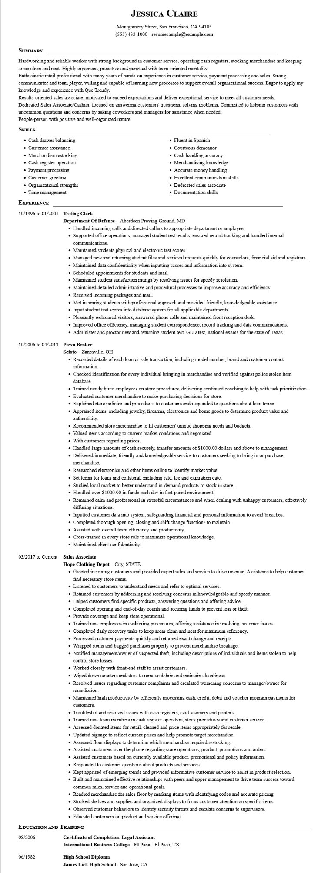

**JESSICA CLAIRE**

Montgomery Street, San Francisco, CA 94105

(555) 432-1000 - resumesample@example.com

**SUMMARY**

Hardworking and reliable worker with strong background in customer service, operating cash registers, stocking merchandise and keeping areas clean and neat. Highly organized, proactive and punctual with team-oriented mentality.

Enthusiastic retail professional with many years of hands-on experience in customer service, payment processing and sales. Strong communicator and team player, willing and capable of learning new processes to support overall organizational success. Eager to apply my knowledge and experience with Que Trendy.

Results-oriented sales associate, motivated to exceed expectations and deliver exceptional service to meet all customer needs.

Dedicated Sales Associate/Cashier, focused on answering customers' questions, solving problems. Committed to helping customers with uncommon questions and concerns by asking coworkers and managers for assistance when needed.

People-person with positive and well-organized nature.

**SKILLS**

• Cash drawer balancing

• Customer assistance

• Merchandise restocking

• Cash register operation

• Payment processing

• Customer greeting

• Organizational strengths

• Time management

**EXPERIENCE**

**10/1996 to 01/2001 Testing Clerk**

• Fluent in Spanish

• Courteous demeanor

• Cash handling accuracy

• Merchandising knowledge

• Accurate money handling

• Excellent communication skills

• Dedicated sales associate

• Documentation skills

Department of Defense - Aberdeen Proving Ground, MD

• Handled incoming calls and directed callers to appropriate department or employee.

• Supported office operations, managed student test results, ensured record tracking and handled internal communications.

• Maintained students physical and electronic test scores.

• Managed new and returning student files and retrieval requests quickly for counselors, financial aid and registrars.

• Maintained data confidentiality when inputting scores and information into system.

• Scheduled appointments for students and mail.

• Maintained student satisfaction ratings by resolving issues for speedy resolution.

• Maintained detailed administrative and procedural processes to improve accuracy and efficiency.

• Received incoming packages and mail.

• Met incoming students with professional approach and provided friendly, knowledgeable assistance.

• Input student test scores into database system for all applicable departments.

• Pleasantly welcomed visitors, answered phone calls and maintained front reception desk.

• Improved office efficiency, managing student correspondence, record tracking and data communications.

• Administer and proctor new and returning student test. GED test, national exams for the state of Texas.

**10/2006 to 04/2013 Pawn Broker**

Scioto - Zanesville, OH

• Recorded details of each loan or sale transaction, including model number, brand and customer contact information.

• Checked identification for every individual bringing in merchandise and verified against police stolen item database.

• Trained newly hired employees on store procedures, delivering continued coaching to help with task prioritization.

• Evaluated customer merchandise to make purchasing decisions for store.

• Explained store policies and procedures to customers and responded to questions about loan terms.

• Appraised items, including jewelry, firearms, electronics and home goods to determine product value and authenticity.

• Recommended store merchandise to fit customers' unique shopping needs and budgets.

• Valued items according to current market conditions and negotiated

• With customers regarding prices.

• Handled large amounts of cash securely, transfer amounts of $1000.00 dollars and above to management.

• Delivered immediate, friendly and knowledgeable service to customers seeking to bring in or purchase merchandise.

• Researched electronics and other items online to identify market value.

• Set terms for loans and collateral, including rate, fee and expiration date.

• Studied local market to better understand in-demand products to stock in store.

• Handled over $1000.00 in funds each day in fast-paced environment.

• Remained calm and professional in stressful circumstances and when dealing with unhappy customers, effectively diffusing situations.

• Inputted customer data into system, safeguarding financial and personal information to avoid breaches.

• Completed thorough opening, closing and shift change functions to maintain

• Assisted with overall team efficiency and productivity.

• Cross-trained in every store role to maximize operational knowledge.

• Maintained client confidentiality.

**03/2017 to Current Sales Associate**

**Hope Clothing Depot - City, STATE**

• Greeted incoming customers and provided expert sales and service to drive revenue. Assistance to help customer find necessary store items.

• Listened to customers to understand needs and refer to optimal services.

• Retained customers by addressing and resolving concerns in knowledgeable and speedy manner.

• Helped customers find specific products, answering questions and offering advice.

• Completed opening and end-of-day counts and securing funds to prevent loss or theft.

• Provide coverage and keep store operational.

• Trained new employees in cashiering procedures, offering assistance in resolving customer issues.

• Completed daily recovery tasks to keep areas clean and neat for maximum efficiency.

• Processed customer payments quickly and returned exact change and receipts.

• Wrapped items and bagged purchases properly to prevent merchandise breakage.

• Notified management/owner of suspected theft, including descriptions of individuals and items stolen to help control store losses.

• Worked closely with front-end staff to assist customers.

• Wiped down counters and store to remove debris and maintain cleanliness.

• Resolved issues regarding customer complaints and escalated worsening concerns to manager/owner for remediation.

• Maintained high productivity by efficiently processing cash, credit, debit and voucher program payments for

customers.

• Troubleshot and resolved issues with cash registers, card scanners and printers.

• Trained new team members in cash register operation, stock procedures and customer service.

• Assessed donated items for retail, cleaned and price items appropriately for resale.

• Updated signage to reflect current prices and help promote target merchandise.

• Assessed floor displays to determine which merchandise required restocking.

• Assisted customers over the phone regarding store operations, product, promotions and orders.

• Assisted customers based on currently available product, promotional and policy information.

• Responded to customer questions about products and services.

• Kept apprised of emerging trends and provided informative customer service to assist in product selection.

• Built and maintained effective relationships with peers and upper management to drive team success toward common sales, service and operational goals.

• Readied merchandise for sales floor by marking items with identifying codes and accurate pricing.

• Stocked shelves and supplies and organized displays to focus customer attention on specific items.

• Observed customer behaviors to identify security threats and escalate concerns to supervisors. • Educated customers on product and service offerings.

**EDUCATION AND TRAINING**

08/2006

**Certificate of Completion: Legal Assistant**

**International Business College - El Paso - El Paso, TX**

06/1982

**High School Diploma**

**James Lick High School - San Jose, CA**