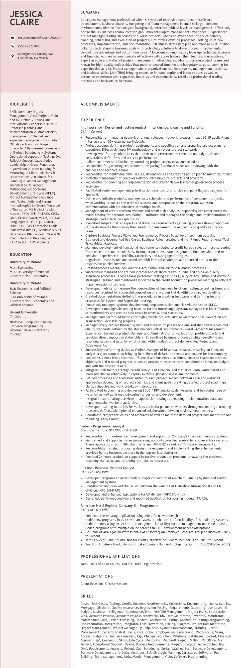

**JESSICA CLAIRE**

9

resumesample@example.com

(555) 432-1000

Montgomery Street, San Francisco, CA 94105

SUMMARY

Sr. project management professional with 18+ years of extensive experience in Software Development, Business analysis, Budgeting and Team management in small to large, complex environments. Diverse Technological background. Interface with all levels of management. Effectively bridge the IT/Business communication gap. Relevant Project Management Experience * Experienced project manager leading all phases of diverse projects: Hands on experience in service delivery, planning, scheduling and execution of projects. Optimizing existing processes, setting up of of new processes, implementation, and documentation. * Business strategist; plan and manage multi-million dollar projects aligning business goals with technology solutions to drive process improvements, competitive advantage and bottom-line gains. * Excellent communicator; leverage technical, business and financial acumen to communicate effectively with stake holders, their teams and executives. * Expert in agile and waterfall project management methodologies. Able to manage project teams and known for high-quality deliverables that meet or exceed timeline and budgetary targets. Looking for opportunities as a Sr. Project Manager where organizations can leverage my management, technical and business skills. [Job Title] bringing expertise in listed equity and index options as well as extensive experience with regulatory inquiries and examinations, retail and professional trading practices and back-office functions.

HIGHLIGHTS

Skills Summary Project Management✓ MS Project, Visio and MS Office ✓ Strong and motivational Leadership skills ✓ Strategic planning and implementation ✓ Time/priority management ✓ Budget and expense management ✓ On-site/ Off shore Transition Project

Lifecycle✓

Requirements Analysis

✓ Project Scheduling ✓ Systems Operational support✓ Testing/QA/ Support Value-Added

Rollout/

Leadership ✓ Cross-Functional Supervision✓ Team Building & Mentoring✓ Client Relations & Presentations ✓ Business & IT

Planning✓ Vendor Management

Technical Skills Project Methodologies: Software Development Life Cycle (SDLC), Project Man Project Management ment Advance certificate, Agile and Scrum methodologies Software/Tools: MS office suite, MS Project, Visio, Access, TSO/ISPF, FILEAID, CICS,

QMF, CHANGEMAN, VSAM, IDCAMS Languages & OS: SQL, COBOL, UNIX, SAS- SAS Enterprise Guide Platforms: IBM PC, Windows 97/NT Databases: DB2, Access, Oracle 9i Credit Decision Rule Engine: STRATA (CGI AMS Product)

**EDUCATION**

University of Mumbai

M.A: Economics

M.A: University of Mumbai Concentration: Economics

University of Mumbai

B.A: Economics and Political Science

B.A: University of Mumbai Concentration: Economics and Political Science

DePaul University Chicago, IL

Diploma: Computer Science/ Software Programming Diploma: DePaul University, Chicago

**ACCOMPLISHMENTS**

**EXPERIENCE**

Imt Insurance - Design and Testing Analyst - Interchange, Clearing and Funding 01/1 Current

.

Responsible for managing network bi-annual releases. Network releases impact 10-15 applications internally and 100+ external participants

Project scoping, defining project requirements and specification and preparing project plans for execution. Effectively apply PM methodology and enforces project standards

• Develop WBS for key subprojects that have to be performed on time and on budget, develop deliverables definitions and activity performance

Deliver customer satisfaction by controlling project scope, cost, and schedule

Responsible for gathering requirements, preparing functional specs and reviewing with the business and technical teams

business

Responsible for identifying risks, issues, dependencies and creating action plan to minimize impact Portfolio management of Discover Network Infrastructure projects and programs

Responsible for planning and implementation of Discover Network internal governance process activities

Facilitated senior management prioritization sessions to prioritize company flagship projects for approval.

Define and initiate projects, manage cost, schedule, and performance of component projects, while working to ensure the ultimate success and acceptance of the program. Maintain communication with stakeholders at multiple levels.

Management of credit decision systems and credit risk analytics, supporting consumer credit risk model testing for accounts acquisition. - Initiated and managed the design and implementation of strategic credit decision capabilities

Identified subject-matter experts and drive the requirements gathering process through approval of the documents that convey their needs to management, developers, and quality assurance team.

Capture Business Process Flows and Reengineered Process to achieve maximum outputs. Gathered and documented Use Cases, Business Rules, created and maintained Requirements/Test Traceability Matrices.

Managed development of functional requirements related to credit bureau selection, pre-screening, fraud check, product stipulations, income stipulations, rate assignment, final decision, and re- decision. Experience in Portfolio, Collections and Mortgage strategies.

Negotiated install issues and schedules with internal customers and reported status to the sponsible parties involved

Created process manual documenting Acquisition and Portfolio business processes Successfully managed and trained internal and offshore teams in India and China on quality assurance processes. These teams performed testing assuring Quality of Acquisition and Portfolio strategies Trained strategies. Trained and mentored associates in the credit acquisition processes leading to efficient implementation of projects

of

Developed metrics to measure Developed metrics to measure the complexities of business functions, estimate testing time, and resources required for successful completion of any given install within the project deadline.

Created documentations defining the procedures in creating test cases and defining testing processes sfor r System and Regression testing.

Proactively managed systems development, implementation and risk via the use of SDLC. Developed a manageable testing baseline for the Interchange System. Managed the identification

of requirements and created test cases to cover all test scenarios. on require

Managed and performed testing for highly visible projects such as Merchant Loss Prevention and Transaction Level Pricing projects.

Managed every project through system and integration phases and ensured that deliverables met quality standards defined by the stockholder's initial requirements Overall Project Management Experience: Served as project Manager and Administrator on various high profile projects and provided direct support to stakeholders. Streamlined business processes while identifying and resolving issues and gaps for on time and within budget project delivery. Key Projects and Achievements:

Successfully performing duties as Project Manager of bi-annual releases, ensuring on-time, on- budget project completion bringing in millions of dollars in revenue and volume for the company. Led teams across broad technical, financial and business disciplines. Focused teams on business objectives and tracked progress to ensure project milestones were completed on time, on budget and with the desired results.

Mitigated risk factors through careful analysis of financial and statistical data. Anticipated and managed change effectively in rapidly evolving global business environments.

mana

Defined processes and tools best suited to each project. Moved between agile and waterfall

approaches depending on project specifics and client goals, creating detailed project road maps, plans, schedules dules and work breakdown structures.

Participated in planning and delivering SDLC / RFP sessions, deliverables and templates. Use of waterfall as well agile methodologies for design and development.

Integral in coordinating activities in application testing, developing implementation plans and implementation weekend activities.

• Developed training materials for various projects; partnered with QA throughout testing / tracking

.

to assess defects. Championed enhanced collaboration between business departments.

Coordinate project activities and resources as well as maintain detailed project documentation and reporting. Early Career

Fedex - Programmer Analyst

Edwardsville, IL 05/1998 - 04/2000

• Responsible for maintenance, development and support of Company's financial inventory system.

• Maintained and supported order processing, accounts payable/receivable, and inventory systems. These applications ran in IBM Mainframe and MVS/DB2 as well as TANDEM environments. Responsibility included, proposing design, development and implementing the enhancements provided by the business partners in the appropriate platforms.

Provided 24 hours production support to resolve production problems, analyzing the problem, resolving the issue, and rerunning the jobs as necessary.

Luk Inc - Business Systems Analyst

01/1997 - 05/1998

• Developed programs to accommodate major conversion of Merchant Banking System and Credit Management System

Coordinated and resolved the issues between the vendors of Household International and UK

division. (HFC BANK-UK)

Developed and enhanced applications for UK division (HFC BANK- UK).

• Designed, performed analysis and modified application for scoring module (TRIAD).

American Hotel Register Company IL - Programmer

01/1996-01/1997

Enhanced the existing application using Micro focus workbench

Coded new programs in VS COBOL and VSAM to enhance the functionality of the existing systems Coded reports using DYLACORE (report generation utility) for the management on request basis. Coded programs with multiple online screens in CICS environment Recent Affiliations Co-Chair of APAD (Asian Professionals At Discover) An Employee Resource group at Discover. (2012 to Present)

Tamil Folks of Lake County- Not for Profit Organization - Board Member (April 2010 to Present) Board of Trustee - Hindu Mandir of Lake County - Non-Profit Organization, IL (Aug 2010-Dec 2012)

PROFESSIONAL AFFILIATIONS

Tamil Folks of Lake County- Not for Profit Organization

PRESENTATIONS

Client Relations & Presentations

**SKILLS**

Cases, Test Cases, Testing, Credit, Business Requirements, Collections, Documenting, Loans, Metrics, Mortgage, Offshore, Quality Assurance, Regression Testing, Requirements Gathering, Use Cases, Bi, Budget, Business Intelligence, Governance, Pmo, Portfolio Management, Project Plans, Satisfaction, Wbs, Accounts Payable, Accounts Payable/receivable, Db2, Ibm Mainframe, Inventory, Mainframe, Maintenance, Mvs, Order Processing, Tandem, Application Testing, Application Testing/programming, Documentation, Integration, Integrator, Loss Prevention, Pricing, Progress, Project Documentation, Project Management, Project Manager, Qa, Rfp, Sdlc, Systems Development, Training, Credit Management, Systems Analyst, Basis, Cics, Cobol, Employee Resource Group, Micro Focus, Vsam, Access, Budgeting, Business Analysis, Cgi, Changeman, Client Relations, Databases, Exceed, Financial Acumen, Ispf, Leadership Skills, Life Cycle, Mentoring, Microsoft Project, Million, Ms Office, Ms Project, Operational Support, Oracle, Process Improvements, Project Lifecycle, Project Scheduling, Qmf, Requirements Analysis, Rollout, Sas, Scheduling, Serial Attached Scsi, Software Development, Software Development Life Cycle, Solutions, Sql, Strategic Planning, Structured Software, Team Building, Team Management, Unix, Vendor Management, Visio, Software Programming