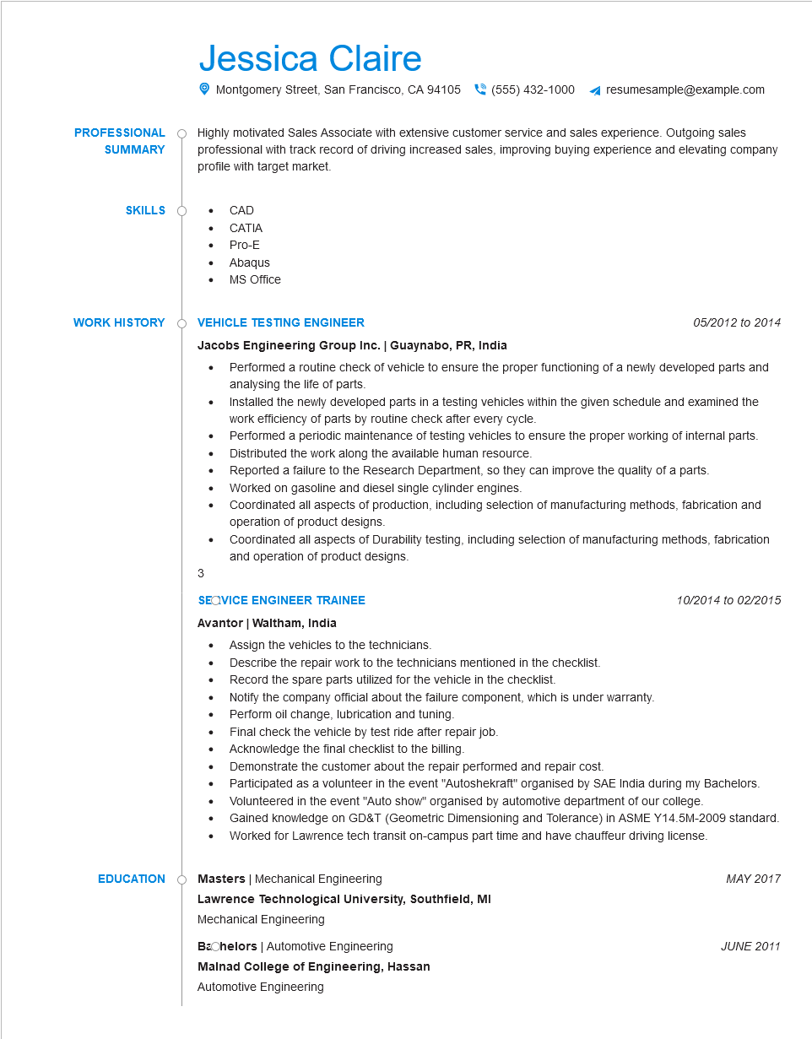

**PROFESSIONAL SUMMARY**

Jessica Claire

Montgomery Street, San Francisco, CA 94105

(555) 432-1000

resumesample@example.com

Highly motivated Sales Associate with extensive customer service and sales experience. Outgoing sales professional with track record of driving increased sales, improving buying experience and elevating company profile with target market.

**SKILLS**

• CAD

• CATIA

**WORK HISTORY**

• Pro-E

Abaqus

• MS Office

**VEHICLE TESTING ENGINEER**

**Jacobs Engineering Group Inc. | Guaynabo, PR, India**

3

*05/2012 to 2014*

• Performed a routine check of vehicle to ensure the proper functioning of a newly developed parts and analysing the life of parts.

Installed the newly developed parts in a testing vehicles within the given schedule and examined the work efficiency of parts by routine check after every cycle.

Performed a periodic maintenance of testing vehicles to ensure the proper working of internal parts.

•

Distributed the work along the available human resource.

•

Reported a failure to the Research Department, so they can improve the quality of a parts.

Worked on gasoline and diesel single cylinder engines.

•

Coordinated all aspects of production, including selection of manufacturing methods, fabrication and operation of product designs.

Coordinated all aspects of Durability testing, including selection of manufacturing methods, fabrication and operation of product designs.

**SEOVICE ENGINEER TRAINEE**

**Avantor | Waltham, India**

• Assign the vehicles to the technicians.

• Describe the repair work to the technicians mentioned in the checklist.

Record the spare parts utilized for the vehicle in the checklist.

Notify the company official about the failure component, which is under warranty.

•

•

Perform oil change, lubrication and tuning.

Final check the vehicle by test ride after repair job.

10/2014 to 02/2015

Acknowledge the final checklist to the billing.

Demonstrate the customer about the repair performed and repair cost.

• Participated as a volunteer in the event "Autoshekraft" organised by SAE India during my Bachelors. Volunteered in the event "Auto show" organised by automotive department of our college.

Gained knowledge on GD&T (Geometric Dimensioning and Tolerance) in ASME Y14.5M-2009 standard. Worked for Lawrence tech transit on-campus part time and have chauffeur driving license.

**EDUCATION**

Masters | Mechanical Engineering

**Lawrence Technological University, Southfield, MI**

Mechanical Engineering

Bachelors | Automotive Engineering

**Malnad College of Engineering, Hassan**

Automotive Engineering

MAY 2017

*JUNE 2011*