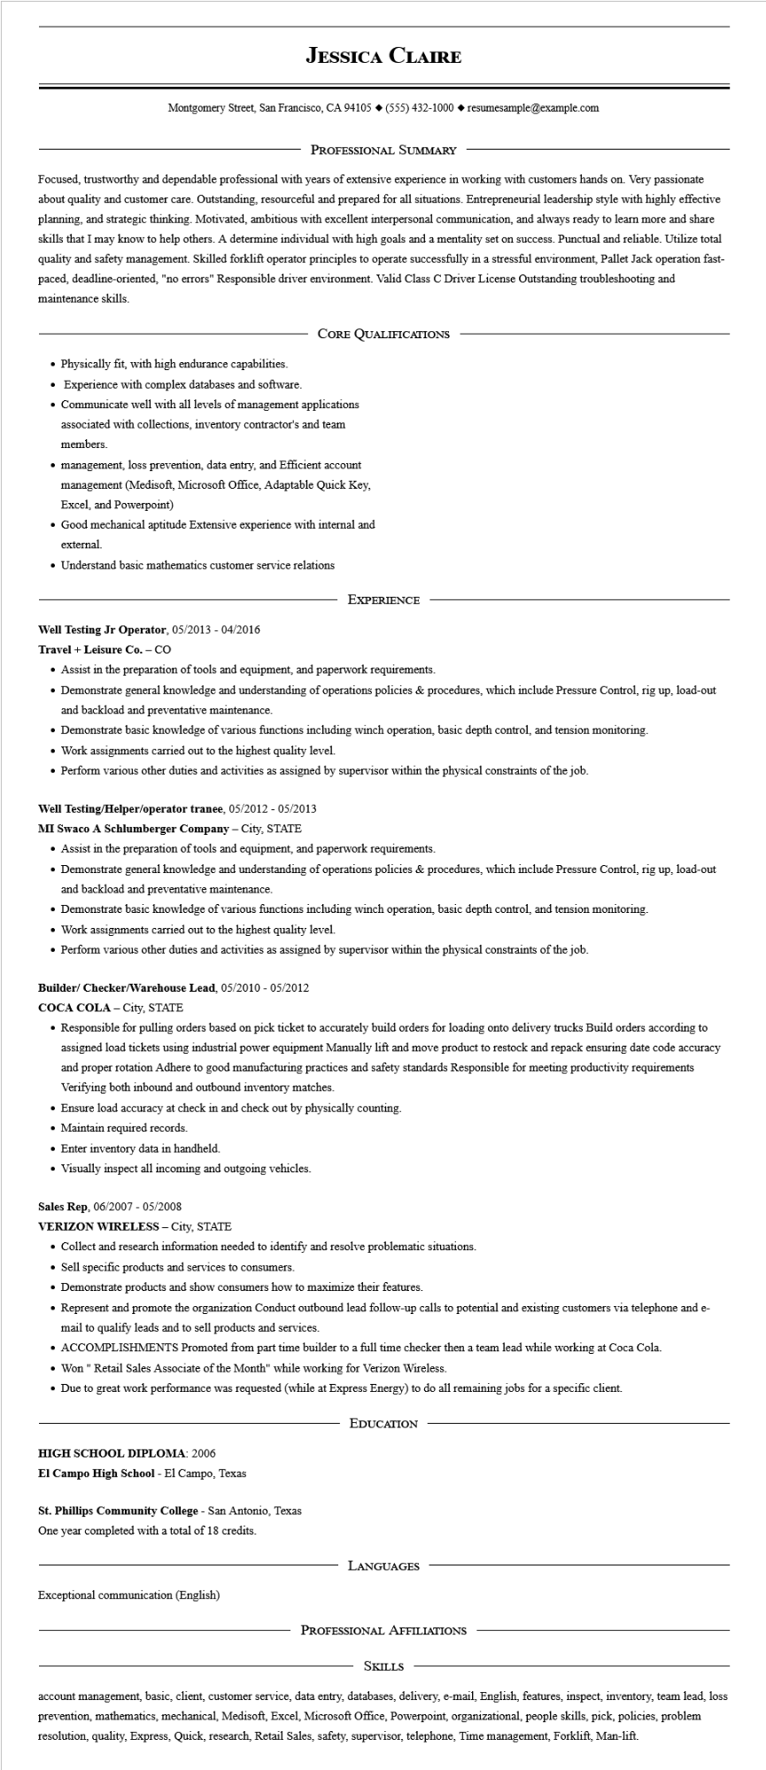

**JESSICA CLAIRE**

Montgomery Street, San Francisco, CA 94105 ♦ (555) 432-1000 resumesample@example.com

PROFESSIONAL SUMMARY

Focused, trustworthy and dependable professional with years of extensive experience in working with customers hands on. Very passionate about quality and customer care. Outstanding, resourceful and prepared for all situations. Entrepreneurial leadership style with highly effective planning, and strategic thinking. Motivated, ambitious with excellent interpersonal communication, and always ready to learn more and share skills that I may know to help others. A determine individual with high goals and a mentality set on success. Punctual and reliable. Utilize total quality and safety management. Skilled forklift operator principles to operate successfully in a stressful environment, Pallet Jack operation fast- paced, deadline-oriented, "no errors" Responsible driver environment. Valid Class C Driver License Outstanding troubleshooting and maintenance skills.

CORE QUALIFICATIONS

• Physically fit, with high endurance capabilities.

• Experience with complex databases and software.

• Communicate well with all levels of management applications associated with collections, inventory contractor's and team members.

• management, loss prevention, data entry, and Efficient account management (Medisoft, Microsoft Office, Adaptable Quick Key, Excel, and Powerpoint)

• Good mechanical aptitude Extensive experience with internal and external.

• Understand basic mathematics customer service relations

EXPERIENCE

**Well Testing Jr Operator, 05/2013 - 04/2016**

**Travel + Leisure Co. - CO**

• Assist in the preparation of tools and equipment, and paperwork requirements.

• Demonstrate general knowledge and understanding of operations policies & procedures, which include Pressure Control, rig up, load-out and backload and preventative maintenance.

• Demonstrate basic knowledge of various functions including winch operation, basic depth control, and tension monitoring.

• Work assignments carried out to the highest quality level.

• Perform various other duties and activities as assigned by supervisor within the physical constraints of the job.

**Well Testing/Helper/operator tranee, 05/2012 - 05/2013**

**MI Swaco A Schlumberger Company - City, STATE**

• Assist in the preparation of tools and equipment, and paperwork requirements.

• Demonstrate general knowledge and understanding of operations policies & procedures, which include Pressure Control, rig up, load-out and backload and preventative maintenance.

• Demonstrate basic knowledge of various functions including winch operation, basic depth control, and tension monitoring.

• Work assignments carried out to the highest quality level.

• Perform various other duties and activities as assigned by supervisor within the physical constraints of the job.

**Builder/ Checker/Warehouse Lead, 05/2010- 05/2012**

**COCA COLA - City, STATE**

• Responsible for pulling orders based on pick ticket to accurately build orders for loading onto delivery trucks Build orders according to assigned load tickets using industrial power equipment Manually lift and move product to restock and repack ensuring date code accuracy and proper rotation Adhere to good manufacturing practices and safety standards Responsible for meeting productivity requirements Verifying both inbound and outbound inventory matches.

• Ensure load accuracy at check in and check out by physically counting.

• Maintain required records.

• Enter inventory data in handheld.

• Visually inspect all incoming and outgoing vehicles.

Sales Rep, 06/2007 - 05/2008

**VERIZON WIRELESS - City, STATE**

• Collect and research information needed to identify and resolve problematic situations.

• Sell specific products and services to consumers.

• Demonstrate products and show consumers how to maximize their features.

• Represent and promote the organization Conduct outbound lead follow-up calls to potential and existing customers via telephone and e- mail to qualify leads and to sell products and services.

• ACCOMPLISHMENTS Promoted from part time builder to a full time checker then a team lead while working at Coca Cola.

• Won " Retail Sales Associate of the Month" while working for Verizon Wireless.

• Due to great work performance was requested (while at Express Energy) to do all remaining jobs for a specific client.

**HIGH SCHOOL DIPLOMA: 2006**

**El Campo High School - El Campo, Texas**

**St. Phillips Community College - San Antonio, Texas**

One year completed with a total of 18 credits.

EDUCATION

LANGUAGES

Exceptional communication (English)

PROFESSIONAL AFFILIATIONS

SKILLS

account management, basic, client, customer service, data entry, databases, delivery, e-mail, English, features, inspect, inventory, team lead, loss prevention, mathematics, mechanical, Medisoft, Excel, Microsoft Office, Powerpoint, organizational, people skills, pick, policies, problem resolution, quality, Express, Quick, research, Retail Sales, safety, supervisor, telephone, Time management, Forklift, Man-lift.