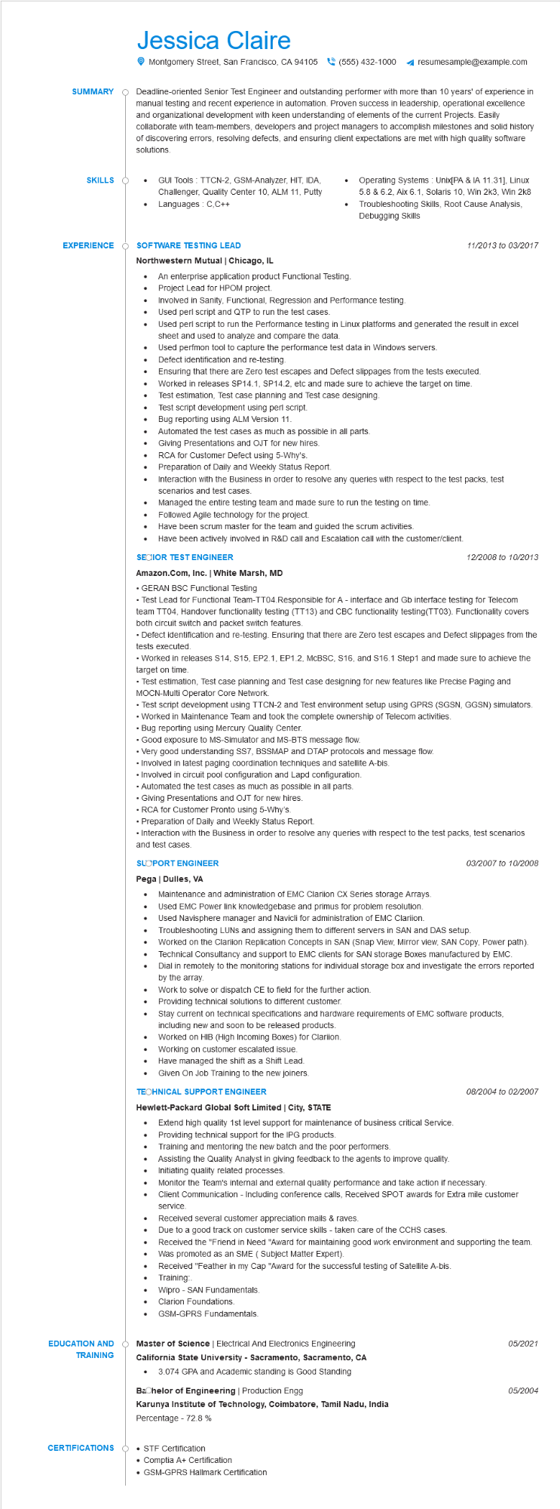

**SUMMARY**

Jessica Claire

Montgomery Street, San Francisco, CA 94105 (555) 432-1000

resumesample@example.com

Deadline-oriented Senior Test Engineer and outstanding performer with more than 10 years' of experience in manual testing and recent experience in automation. Proven success in leadership, operational excellence and organizational development with keen understanding of elements of the current Projects. Easily collaborate with team-members, developers and project managers to accomplish milestones and solid history of discovering errors, resolving defects, and ensuring client expectations are met with high quality software solutions.

**SKILLS O**

GUI Tools: TTCN-2, GSM-Analyzer, HIT, IDA, Challenger, Quality Center 10, ALM 11, Putty Languages: C,C++

**EXPERIENCE**

**SOFTWARE TESTING LEAD**

•

Operating Systems: Unix[PA & IA 11.31], Linux 5.8 & 6.2, Aix 6.1, Solaris 10, Win 2k3, Win 2k8 Troubleshooting Skills, Root Cause Analysis, Debugging Skills

11/2013 to 03/2017

**Northwestern Mutual | Chicago, IL**

•

•

•

An enterprise application product Functional Testing.

Project Lead for HPOM project.

Involved in Sanity, Functional, Regression and Performance testing.

Used perl script and QTP to run the test cases.

Used perl script to run the Performance testing in Linux platforms and generated the result in excel

sheet and used to analyze and compare the data.

Used perfmon tool to capture the performance test data in Windows servers.

Defect identification and re-testing.

Ensuring that there are Zero test escapes and Defect slippages from the tests executed.

Worked in releases SP14.1, SP14.2, etc and made sure to achieve the target on time.

•

•

Test estimation, Test case planning and Test case designing.

Test script development using perl script.

Bug reporting using ALM Version 11.

Automated the test cases as much as possible in all parts.

Giving Presentations and OJT for new hires.

RCA for Customer Defect using 5-Why's.

Preparation of Daily and Weekly Status Report.

Interaction with the Business in order to resolve any queries with respect to the test packs, test scenarios and test cases.

Managed the entire testing team and made sure to run the testing on time.

•

Followed Agile technology for the project.

Have been scrum master for the team and guided the scrum activities.

• Have been actively involved in R&D call and Escalation call with the customer/client.

**SECIOR TEST ENGINEER**

**Amazon.com, Inc. | White Marsh, MD**

• GERAN BSC Functional Testing

12/2008 to 10/2013

• Test Lead for Functional Team-TT04.Responsible for A - interface and Gb interface testing for Telecom team TT04, Handover functionality testing (TT13) and CBC functionality testing(TT03). Functionality covers both circuit switch and packet switch features.

• Defect identification and re-testing. Ensuring that there are Zero test escapes and Defect slippages from the tests executed.

• Worked in releases S14, $15, EP2.1, EP1.2, MCBSC, S16, and S16.1 Step1 and made sure to achieve the target on time.

• Test estimation, Test case planning and Test case designing for new features like Precise Paging and MOCN-Multi Operator Core Network.

• Test script development using TTCN-2 and Test environment setup using GPRS (SGSN, GGSN) simulators.

• Worked in Maintenance Team and took the complete ownership of Telecom activities.

• Bug reporting using Mercury Quality Center.

• Good exposure to MS-Simulator and MS-BTS message flow.

• Very good understanding SS7, BSSMAP and DTAP protocols and message flow.

• Involved in latest paging coordination techniques and satellite A-bis.

• Involved in circuit pool configuration and Lapd configuration.

• Automated the test cases as much as possible in all parts.

• Giving Presentations and OJT for new hires.

• RCA for Customer Pronto using 5-Why's.

• Preparation of Daily and Weekly Status Report.

• Interaction with the Business in order to resolve any queries with respect to the test packs, test scenarios and test cases.

**SLOPORT ENGINEER**

*03/2007 to 10/2008*

**Pega | Dulles, VA**

•

•

Maintenance and administration of EMC Clariion CX Series storage Arrays. Used EMC Power link knowledgebase and primus for problem resolution.

Used Navisphere manager and Navicli for administration of EMC Clariion.

Troubleshooting LUNS and assigning them to different servers in SAN and DAS setup. Worked on the Clariion Replication Concepts in SAN (Snap View, Mirror view, SAN Copy, Power path). Technical Consultancy and support to EMC clients for SAN Storage Boxes manufactured by EMC.

Dial in remotely to the monitoring stations for individual storage box and investigate the errors reported by the array.

Work to solve or dispatch CE to field for the further action.

Providing technical solutions to different customer.

Stay current on technical specifications and hardware requirements of EMC software products,

including new and soon to be released products.

Worked on HIB (High Incoming Boxes) for Clariion.

• Working on customer escalated issue.

•

Have managed the shift as a Shift Lead.

Given On Job Training to the new joiners.

**TECHNICAL SUPPORT ENGINEER**

**Hewlett-Packard Global Soft Limited | City, STATE**

08/2004 to 02/2007

•

Extend high quality 1st level support for maintenance of business critical Service.

•

Providing technical support for the IPG products.

Training and mentoring the new batch and the poor performers.

Assisting the Quality Analyst in giving feedback to the agents to improve quality.

Initiating quality related processes.

•

Monitor the Team's internal and external quality performance and take action if necessary.

Client Communication - Including conference calls, Received SPOT awards for Extra mile customer service.

•

Received several customer appreciation mails & raves.

Due to a good track on customer service skills - taken care of the CCHS cases.

Received the "Friend in Need "Award for maintaining good work environment and supporting the team. Was promoted as an SME (Subject Matter Expert).

•

Received "Feather in my Cap "Award for the successful testing of Satellite A-bis.

Training:

Wipro - SAN Fundamentals.

Clarion Foundations.

GSM-GPRS Fundamentals.

**EDUCATION AND TRAINING**

Master of Science | Electrical And Electronics Engineering

05/2021

**California State University - Sacramento, Sacramento, CA**

• 3.074 GPA and Academic standing is Good Standing

**Bachelor of Engineering | Production Engg**

05/2004

**Karunya Institute of Technology, Coimbatore, Tamil Nadu, India Percentage - 72.8%**

**CERTIFICATIONS**

O

• STF Certification

• Comptia A+ Certification

• GSM-GPRS Hallmark Certification