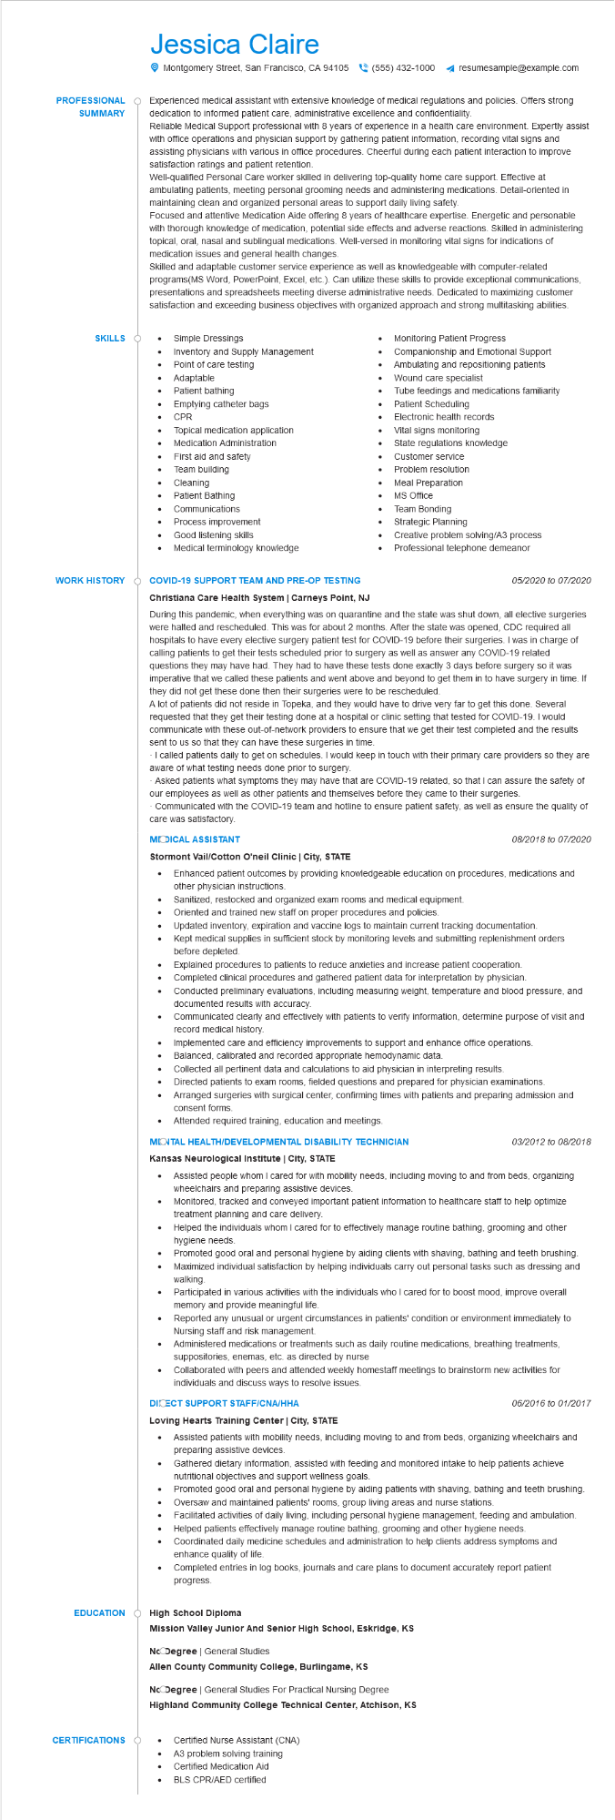

**PROFESSIONAL**

**SUMMARY**

Jessica Claire

Montgomery Street, San Francisco, CA 94105(555) 432-1000 ◄ resumesample@example.com

Experienced medical assistant with extensive knowledge of medical regulations and policies. Offers strong dedication to informed patient care, administrative excellence and confidentiality.

Reliable Medical Support professional with 8 years of experience in a health care environment. Expertly assist with office operations and physician support by gathering patient information, recording vital signs and assisting physicians with various in office procedures. Cheerful during each patient interaction to improve satisfaction ratings and patient retention.

Well-qualified Personal Care worker skilled in delivering top-quality home care support. Effective at ambulating patients, meeting personal grooming needs and administering medications. Detail-oriented in maintaining clean and organized personal areas to support daily living safety.

Focused and attentive Medication Aide offering 8 years of healthcare expertise. Energetic and personable with thorough knowledge of medication, potential side effects and adverse reactions. Skilled in administering topical, oral, nasal and sublingual medications. Well-versed in monitoring vital signs for indications of medication issues and general health changes.

Skilled and adaptable customer service experience as well as knowledgeable with computer-related programs (MS Word, PowerPoint, Excel, etc.). Can utilize these skills to provide exceptional communications, presentations and spreadsheets meeting diverse administrative needs. Dedicated to maximizing customer satisfaction and exceeding business objectives with organized approach and strong multitasking abilities.

**SKILLS**

Simple Dressings

Inventory and Supply Management Point of care testing

Adaptable

Patient bathing

Emptying catheter bags

CPR

Topical medication application Medication Administration

Monitoring Patient Progress Companionship and Emotional Support Ambulating and repositioning patients Wound care specialist

Tube feedings and medications familiarity Patient Scheduling

Electronic health records

EE

First aid and safety Team building

Cleaning

Patient Bathing Communications Process improvement Good listening skills

Medical terminology knowledge

Vital signs monitoring State regulations knowledge Customer service

Problem resolution Meal Preparation

MS Office

Team Bonding

Strategic Planning

Creative problem solving/A3 process Professional telephone demeanor

**WORK HISTORY**

**EDUCATION**

*05/2020 to 07/2020*

COVID-19 SUPPORT TEAM AND PRE-OP TESTING Christiana Care Health System | Carneys Point, NJ During this pandemic, when everything was on quarantine and the state was shut down, all elective surgeries were halted and rescheduled. This was for about 2 months. After the state was opened, CDC required all hospitals to have every elective surgery patient test for COVID-19 before their surgeries. I was in charge of calling patients to get their tests scheduled prior to surgery as well as answer any COVID-19 related questions they may have had. They had to have these tests done exactly 3 days before surgery so it was imperative that we called these patients and went above and beyond to get them in to have surgery in time. If they did not get these done then their surgeries were to be rescheduled.

A lot of patients did not reside in Topeka, and they would have to drive very far to get this done. Several requested that they get their testing done at a hospital or clinic setting that tested for COVID-19. I would communicate with these out-of-network providers to ensure that we get their test completed and the results sent to us so that they can have these surgeries in time.

. I called patients daily to get on schedules. I would keep in touch with their primary care providers so they are aware of what testing needs done prior to surgery.

Asked patients what symptoms they may have that are COVID-19 related, so that I can assure the safety of our employees as well as other patients and themselves before they came to their surgeries. Communicated with the COVID-19 team and hotline to ensure patient safety, as well as ensure the quality of care was satisfactory.

**MODICAL ASSISTANT**

**Stormont Vail/Cotton O'neil Clinic | City, STATE**

•

*08/2018 to 07/2020*

Enhanced patient outcomes by providing knowledgeable education on procedures, medications and other physician instructions.

Sanitized, restocked and organized exam rooms and medical equipment.

•

Oriented and trained new staff on proper procedures and policies.

Updated inventory, expiration and vaccine logs to maintain current tracking documentation.

Kept medical supplies in sufficient stock by monitoring levels and submitting replenishment orders before depleted.

Explained procedures to patients to reduce anxieties and increase patient cooperation.

•

Completed clinical procedures and gathered patient data for interpretation by physician.

Conducted preliminary evaluations, including measuring weight, temperature and blood pressure, and documented results with accuracy.

Communicated clearly and effectively with patients to verify information, determine purpose of visit and record medical history.

Implemented care and efficiency improvements to support and enhance office operations.

•

Balanced, calibrated and recorded appropriate hemodynamic data.

Collected all pertinent data and calculations to aid physician in interpreting results.

•

Directed patients to exam rooms, fielded questions and prepared for physician examinations.

• Arranged surgeries with surgical center, confirming times with patients and preparing admission and consent forms.

Attended required training, education and meetings.

**MONTAL HEALTH/DEVELOPMENTAL DISABILITY TECHNICIAN**

**Kansas Neurological Institute | City, STATE**

*03/2012 to 08/2018*

Assisted people whom I cared for with mobility needs, including moving to and from beds, organizing wheelchairs and preparing assistive devices.

•

Monitored, tracked and conveyed important patient information to healthcare staff to help optimize treatment planning and care delivery.

Helped the individuals whom I cared for to effectively manage routine bathing, grooming and other hygiene needs.

Promoted good oral and personal hygiene by aiding clients with shaving, bathing and teeth brushing. Maximized individual satisfaction by helping individuals carry out personal tasks such as dressing and walking

Participated in various activities with the individuals who I cared for to boost mood, improve overall memory and provide meaningful life.

Reported any unusual or urgent circumstances in patients' condition or environment immediately to Nursing staff and risk management.

Administered medications or treatments such as daily routine medications, breathing treatments, suppositories, enemas, etc. as directed by nurse

Collaborated with peers and attended weekly homestaff meetings to brainstorm new activities for individuals and discuss ways to resolve issues.

**DICECT SUPPORT STAFF/CNA/HHA**

*06/2016 to 01/2017*

**Loving Hearts Training Center | City, STATE**

Assisted patients with mobility needs, including moving to and from beds, organizing wheelchairs and preparing assistive devices.

Gathered dietary information, assisted with feeding and monitored intake to help patients achieve nutritional objectives and support wellness goals.

•

Promoted good oral and personal hygiene by aiding patients with shaving, bathing and teeth brushing. Oversaw and maintained patients' rooms, group living areas and nurse stations.

Facilitated activities of daily living, including personal hygiene management, feeding and ambulation. Helped patients effectively manage routine bathing, grooming and other hygiene needs. Coordinated daily medicine schedules and administration to help clients address symptoms and enhance quality of life.

Completed entries in log books, journals and care plans to document accurately report patient progress.

**High School Diploma**

**Mission Valley Junior And Senior High School, Eskridge, KS**

Nc Degree | General Studies

**Allen County Community College, Burlingame, KS**

Nc Degree | General Studies For Practical Nursing Degree

**Highland Community College Technical Center, Atchison, KS**

**CERTIFICATIONS**

•

•

Certified Nurse Assistant (CNA)

A3 problem solving training

Certified Medication Aid

BLS CPR/AED certified