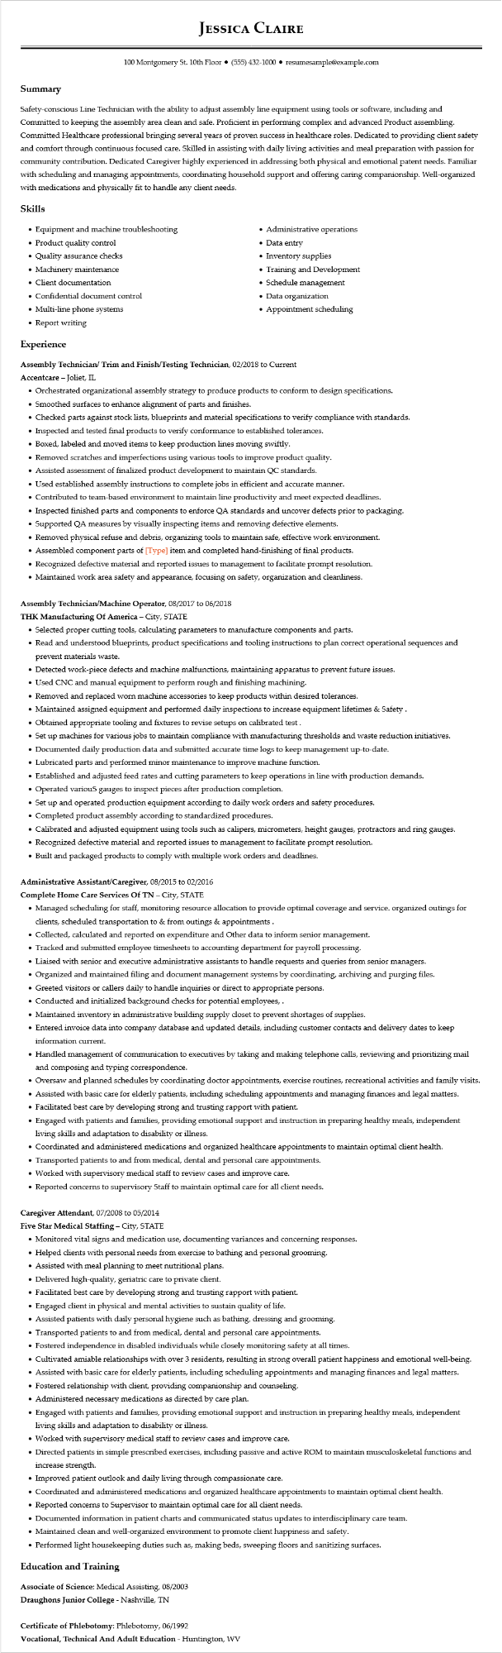

**JESSICA CLAIRE**

100 Montgomery St. 10th Floor (555) 432-1000⚫ resumesample@example.com

**Summary**

Safety-conscious Line Technician with the ability to adjust assembly line equipment using tools or software, including and Committed to keeping the assembly area clean and safe. Proficient in performing complex and advanced Product assembling. Committed Healthcare professional bringing several years of proven success in healthcare roles. Dedicated to providing client safety and comfort through continuous focused care. Skilled in assisting with daily living activities and meal preparation with passion for community contribution. Dedicated Caregiver highly experienced in addressing both physical and emotional patent needs. Familiar with scheduling and managing appointments, coordinating household support and offering caring companionship. Well-organized with medications and physically fit to handle any client needs.

Skills

• Equipment and machine troubleshooting

• Product quality control

• Quality assurance checks

• Machinery maintenance

• Client documentation

• Confidential document control

• Multi-line phone systems

• Report writing

**Experience**

• Administrative operations

• Data entry

• Inventory supplies

•

Training and Development

• Schedule management

• Data organization

• Appointment scheduling

**Assembly Technician/ Trim and Finish/Testing Technician, 02/2018 to Current Accentcare - Joliet, IL**

• Orchestrated organizational assembly strategy to produce products to conform to design specifications.

• Smoothed surfaces to enhance alignment of parts and finishes.

• Checked parts against stock lists, blueprints and material specifications to verify compliance with standards.

• Inspected and tested final products to verify conformance to established tolerances.

• Boxed, labeled and moved items to keep production lines moving swiftly.

• Removed scratches and imperfections using various tools to improve product quality.

• Assisted assessment of finalized product development to maintain QC standards.

• Used established assembly instructions to complete jobs in efficient and accurate manner.

• Contributed to team-based environment to maintain line productivity and meet expected deadlines.

• Inspected finished parts and components to enforce QA standards and uncover defects prior to packaging.

• Supported QA measures by visually inspecting items and removing defective elements.

• Removed physical refuse and debris, organizing tools to maintain safe, effective work environment.

• Assembled component parts of [Type] item and completed hand-finishing of final products.

• Recognized defective material and reported issues to management to facilitate prompt resolution.

• Maintained work area safety and appearance, focusing on safety, organization and cleanliness.

**Assembly Technician/Machine Operator, 08/2017 to 06/2018**

**THK Manufacturing Of America - City, STATE**

• Selected proper cutting tools, calculating parameters to manufacture components and parts.

• Read and understood blueprints, product specifications and tooling instructions to plan correct operational sequences and prevent materials waste.

• Detected work-piece defects and machine malfunctions, maintaining apparatus to prevent future issues.

• Used CNC and manual equipment to perform rough and finishing machining.

• Removed and replaced worn machine accessories to keep products within desired tolerances.

• Maintained assigned equipment and performed daily inspections to increase equipment lifetimes & Safety.

• Obtained appropriate tooling and fixtures to revise setups on calibrated test.

• Set up machines for various jobs to maintain compliance with manufacturing thresholds and waste reduction initiatives.

• Documented daily production data and submitted accurate time logs to keep management up-to-date.

• Lubricated parts and performed minor maintenance to improve machine function.

• Established and adjusted feed rates and cutting parameters to keep operations in line with production demands.

• Operated various gauges to inspect pieces after production completion.

• Set up and operated production equipment according to daily work orders and safety procedures.

• Completed product assembly according to standardized procedures.

• Calibrated and adjusted equipment using tools such as calipers, micrometers, height gauges, protractors and ring gauges.

• Recognized defective material and reported issues to management to facilitate prompt resolution.

• Built and packaged products to comply with multiple work orders and deadlines.

**Administrative Assistant/Caregiver, 08/2015 to 02/2016**

**Complete Home Care Services Of TN - City, STATE**

• Managed scheduling for staff, monitoring resource allocation to provide optimal coverage and service. organized outings for clients, scheduled transportation to & from outings & appointments.

• Collected, calculated and reported on expenditure and Other data to inform senior management.

• Tracked and submitted employee timesheets to accounting department for payroll processing.

• Liaised with senior and executive administrative assistants to handle requests and queries from senior managers.

• Organized and maintained filing and document management systems by coordinating, archiving and purging files.

• Greeted visitors or callers daily to handle inquiries or direct to appropriate persons.

• Conducted and initialized background checks for potential employees,.

• Maintained inventory in administrative building supply closet to prevent shortages of supplies.

• Entered invoice data into company database and updated details, including customer contacts and delivery dates to keep information current.

• Handled management of communication to executives by taking and making telephone calls, reviewing and prioritizing mail and composing and typing correspondence.

• Oversaw and planned schedules by coordinating doctor appointments, exercise routines, recreational activities and family visits. • Assisted with basic care for elderly patients, including scheduling appointments and managing finances and legal matters.

• Facilitated best care by developing strong and trusting rapport with patient.

• Engaged with patients and families, providing emotional support and instruction in preparing healthy meals, independent living skills and adaptation to disability or illness.

• Coordinated and administered medications and organized healthcare appointments to maintain optimal client health.

• Transported patients to and from medical, dental and personal care appointments.

• Worked with supervisory medical staff to review cases and improve care.

• Reported concerns to supervisory Staff to maintain optimal care for all client needs.

**Caregiver Attendant, 07/2008 to 05/2014**

**Five Star Medical Staffing - City, STATE**

• Monitored vital signs and medication use, documenting variances and concerning responses.

• Helped clients with personal needs from exercise to bathing and personal grooming.

• Assisted with meal planning to meet nutritional plans.

• Delivered high-quality, geriatric care to private client.

• Facilitated best care by developing strong and trusting rapport with patient.

• Engaged client in physical and mental activities to sustain quality of life.

• Assisted patients with daily personal hygiene such as bathing, dressing and grooming.

• Transported patients to and from medical, dental and personal care appointments.

• Fostered independence in disabled individuals while closely monitoring safety at all times.

• Cultivated amiable relationships with over 3 residents, resulting in strong overall patient happiness and emotional well-being.

• Assisted with basic care for elderly patients, including scheduling appointments and managing finances and legal matters.

• Fostered relationship with client, providing companionship and counseling.

• Administered necessary medications as directed by care plan.

• Engaged with patients and families, providing emotional support and instruction in preparing healthy meals, independent living skills and adaptation to disability or illness.

• Worked with supervisory medical staff to review cases and improve care.

• Directed patients in simple prescribed exercises, including passive and active ROM to maintain musculoskeletal functions and increase strength.

• Improved patient outlook and daily living through compassionate care.

• Coordinated and administered medications and organized healthcare appointments to maintain optimal client health.

• Reported concerns to Supervisor to maintain optimal care for all client needs.

• Documented information in patient charts and communicated status updates to interdisciplinary care team.

• Maintained clean and well-organized environment to promote client happiness and safety.

• Performed light housekeeping duties such as, making beds, sweeping floors and sanitizing surfaces.

**Education and Training**

Associate of Science: Medical Assisting, 08/2003

**Draughons Junior College - Nashville, TN**

**Certificate of Phlebotomy: Phlebotomy, 06/1992**

**Vocational, Technical And Adult Education - Huntington, WV**