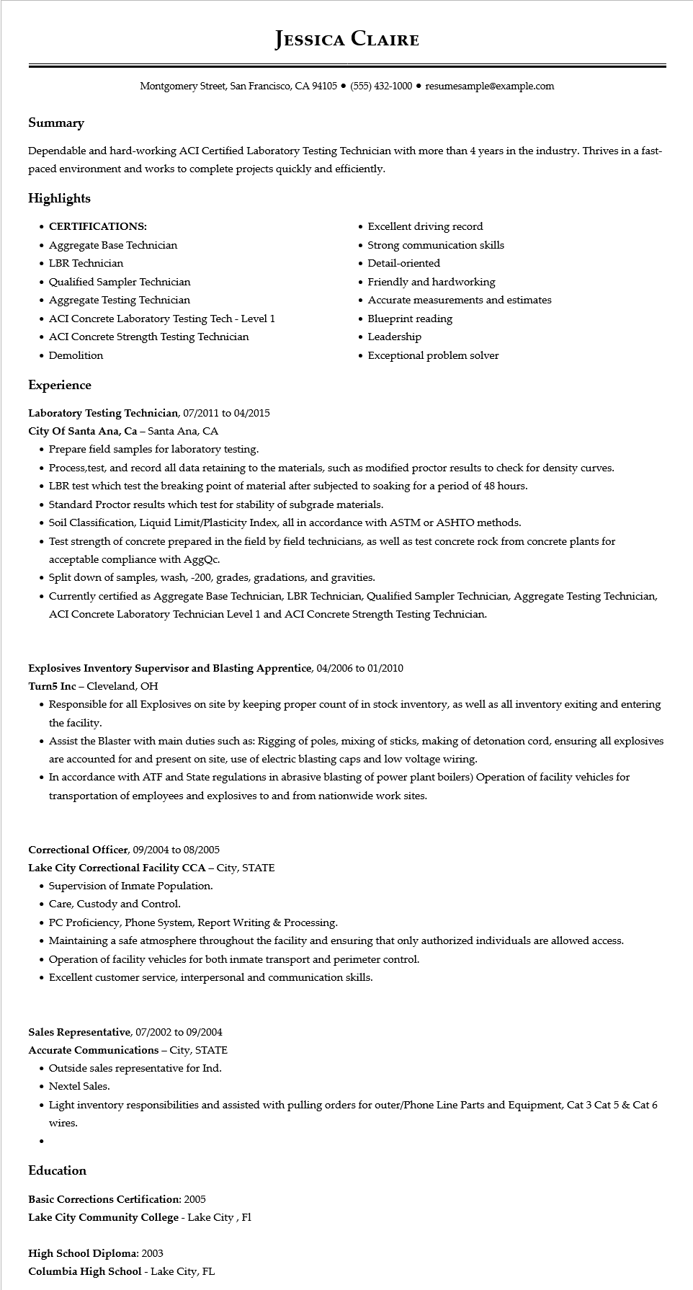

**JESSICA CLAIRE**

Montgomery Street, San Francisco, CA 94105⚫ (555) 432-1000⚫ resumesample@example.com

Summary

Dependable and hard-working ACI Certified Laboratory Testing Technician with more than 4 years in the industry. Thrives in a fast- paced environment and works to complete projects quickly and efficiently.

**Highlights**

**• CERTIFICATIONS:**

• Aggregate Base Technician

• LBR Technician

• Qualified Sampler Technician

• Aggregate Testing Technician

• ACI Concrete Laboratory Testing Tech - Level 1

• ACI Concrete Strength Testing Technician • Demolition

**Experience**

**Laboratory Testing Technician, 07/2011 to 04/2015**

City of Santa Ana, Ca - Santa Ana, CA

• Prepare field samples for laboratory testing.

• Excellent driving record

• Strong communication skills

• Detail-oriented

• Friendly and hardworking

• Accurate measurements and estimates

• Blueprint reading

• Leadership

• Exceptional problem solver

• Process,test, and record all data retaining to the materials, such as modified proctor results to check for density curves.

• LBR test which test the breaking point of material after subjected to soaking for a period of 48 hours.

• Standard Proctor results which test for stability of subgrade materials.

• Soil Classification, Liquid Limit/Plasticity Index, all in accordance with ASTM or ASHTO methods.

• Test strength of concrete prepared in the field by field technicians, as well as test concrete rock from concrete plants for acceptable compliance with AggQc.

• Split down of samples, wash, -200, grades, gradations, and gravities.

• Currently certified as Aggregate Base Technician, LBR Technician, Qualified Sampler Technician, Aggregate Testing Technician, ACI Concrete Laboratory Technician Level 1 and ACI Concrete Strength Testing Technician.

**Explosives Inventory Supervisor and Blasting Apprentice, 04/2006 to 01/2010**

Turn5 Inc - Cleveland, OH

• Responsible for all Explosives on site by keeping proper count of in stock inventory, as well as all inventory exiting and entering the facility.

• Assist the Blaster with main duties such as: Rigging of poles, mixing of sticks, making of detonation cord, ensuring all explosives are accounted for and present on site, use of electric blasting caps and low voltage wiring.

• In accordance with ATF and State regulations in abrasive blasting of power plant boilers) Operation of facility vehicles for transportation of employees and explosives to and from nationwide work sites.

**Correctional Officer, 09/2004 to 08/2005**

**Lake City Correctional Facility CCA - City, STATE**

• Supervision of Inmate Population.

• Care, Custody and Control.

• PC Proficiency, Phone System, Report Writing & Processing.

• Maintaining a safe atmosphere throughout the facility and ensuring that only authorized individuals are allowed access.

• Operation of facility vehicles for both inmate transport and perimeter control.

• Excellent customer service, interpersonal and communication skills.

**Sales Representative, 07/2002 to 09/2004 Accurate Communications - City, STATE**

• Outside sales representative for Ind.

• Nextel Sales.

• Light inventory responsibilities and assisted with pulling orders for outer/Phone Line Parts and Equipment, Cat 3 Cat 5 & Cat 6

wires.

**Education**

**Basic Corrections Certification: 2005**

**Lake City Community College - Lake City, Fl**

**High School Diploma: 2003**

Columbia High School - Lake City, FL