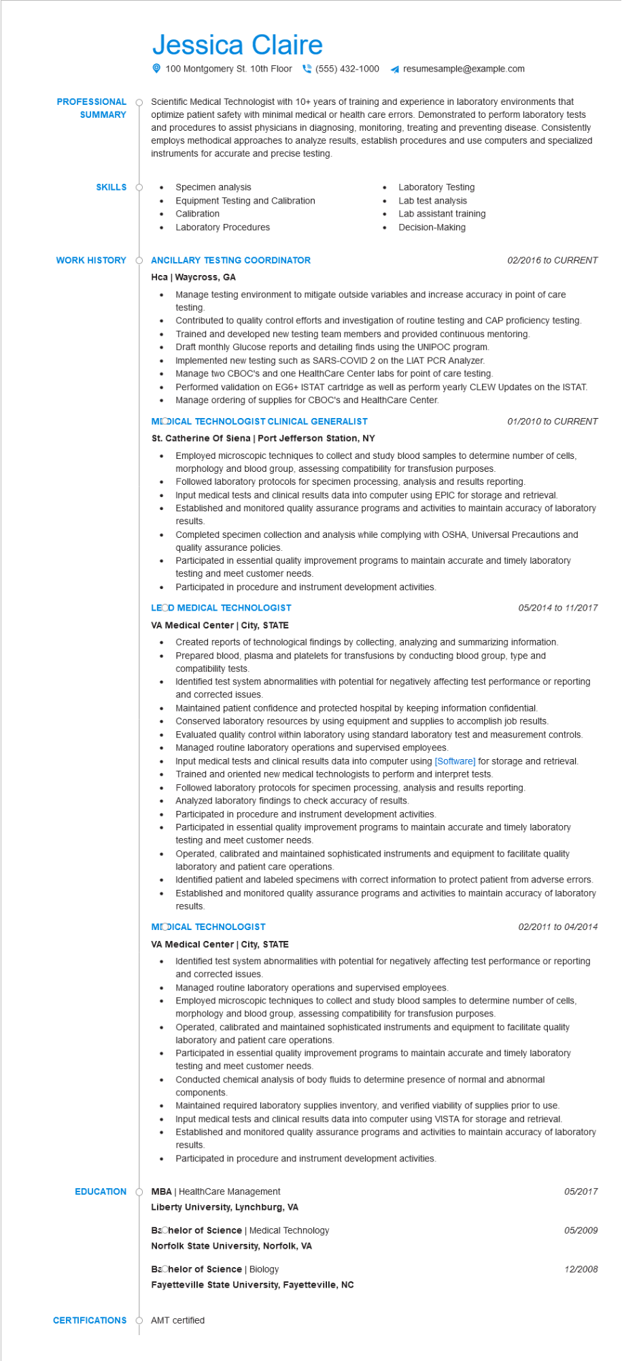

**PROFESSIONAL**

**SUMMARY**

Jessica Claire

100 Montgomery St. 10th Floor (555) 432-1000 ◄ resumesample@example.com

Scientific Medical Technologist with 10+ years of training and experience in laboratory environments that optimize patient safety with minimal medical or health care errors. Demonstrated to perform laboratory tests and procedures to assist physicians in diagnosing, monitoring, treating and preventing disease. Consistently employs methodical approaches to analyze results, establish procedures and use computers and specialized instruments for accurate and precise testing.

**SKILLS**

•

Specimen analysis

Equipment Testing and Calibration

Laboratory Testing

Lab test analysis

• Calibration

•

Laboratory Procedures

•

Lab assistant training Decision-Making

**WORK HISTORY**

**Ò ANCILLARY TESTING COORDINATOR**

*02/2016 to CURRENT*

Hca | Waycross, GA

·

Manage testing environment to mitigate outside variables and increase accuracy in point of care testing.

Contributed to quality control efforts and investigation of routine testing and CAP proficiency testing. Trained and developed new testing team members and provided continuous mentoring.

Draft monthly Glucose reports and detailing finds using the UNIPOC program.

Implemented new testing such as SARS-COVID 2 on the LIAT PCR Analyzer.

Manage two CBOC's and one HealthCare Center labs for point of care testing.

Performed validation on EG6+ ISTAT cartridge as well as perform yearly CLEW Updates on the ISTAT.

· Manage ordering of supplies for CBOC's and HealthCare Center.

**MODICAL TECHNOLOGIST CLINICAL GENERALIST**

**St. Catherine of Siena | Port Jefferson Station, NY**

01/2010 to CURRENT

. Employed microscopic techniques to collect and study blood samples to determine number of cells, morphology and blood group, assessing compatibility for transfusion purposes.

•

•

Followed laboratory protocols for specimen processing, analysis and results reporting.

Input medical tests and clinical results data into computer using EPIC for storage and retrieval.

Established and monitored quality assurance programs and activities to maintain accuracy of laboratory results.

Completed specimen collection and analysis while complying with OSHA, Universal Precautions and quality assurance policies.

Participated in essential quality improvement programs to maintain accurate and timely laboratory testing and meet customer needs.

Participated in procedure and instrument development activities.

**LEOD MEDICAL TECHNOLOGIST**

**VA Medical Center | City, STATE**

•

•

05/2014 to 11/2017

Created reports of technological findings by collecting, analyzing and summarizing information.

Prepared blood, plasma and platelets for transfusions by conducting blood group, type and compatibility tests.

Identified test system abnormalities with potential for negatively affecting test performance or reporting and corrected issues.

Maintained patient confidence and protected hospital by keeping information confidential.

•

Conserved laboratory resources by using equipment and supplies to accomplish job results.

Evaluated quality control within laboratory using standard laboratory test and measurement controls. Managed routine laboratory operations and supervised employees.

Input medical tests and clinical results data into computer using [Software] for storage and retrieval. Trained and oriented new medical technologists to perform and interpret tests.

Followed laboratory protocols for specimen processing, analysis and results reporting.

Analyzed laboratory findings to check accuracy of results.

•

Participated in procedure and instrument development activities.

•

Participated in essential quality improvement programs to maintain accurate and timely laboratory testing and meet customer needs.

Operated, calibrated and maintained sophisticated instruments and equipment to facilitate quality laboratory and patient care operations.

•

Identified patient and labeled specimens with correct information to protect patient from adverse errors. Established and monitored quality assurance programs and activities to maintain accuracy of laboratory results.

**MODICAL TECHNOLOGIST**

**VA Medical Center | City, STATE**

•

*02/2011 to 04/2014*

Identified test system abnormalities with potential for negatively affecting test performance or reporting and corrected issues.

• Managed routine laboratory operations and supervised employees.

Employed microscopic techniques to collect and study blood samples to determine number of cells, morphology and blood group, assessing compatibility for transfusion purposes.

Operated, calibrated and maintained sophisticated instruments and equipment to facilitate quality laboratory and patient care operations.

•

Participated in essential quality improvement programs to maintain accurate and timely laboratory testing and meet customer needs.

Conducted chemical analysis of body fluids to determine presence of normal and abnormal components.

•

•

Maintained required laboratory supplies inventory, and verified viability of supplies prior to use. Input medical tests and clinical results data into computer using VISTA for storage and retrieval. Established and monitored quality assurance programs and activities to maintain accuracy of laboratory

results.

Participated in procedure and instrument development activities.

EDUCATION OMBA | HealthCare Management

*05/2017*

**Liberty University, Lynchburg, VA**

Bachelor of Science | Medical Technology

*05/2009*

**Norfolk State University, Norfolk, VA**

**Bachelor of Science | Biology**

12/2008

**Fayetteville State University, Fayetteville, NC**

**CERTIFICATIONS**

AMT certified