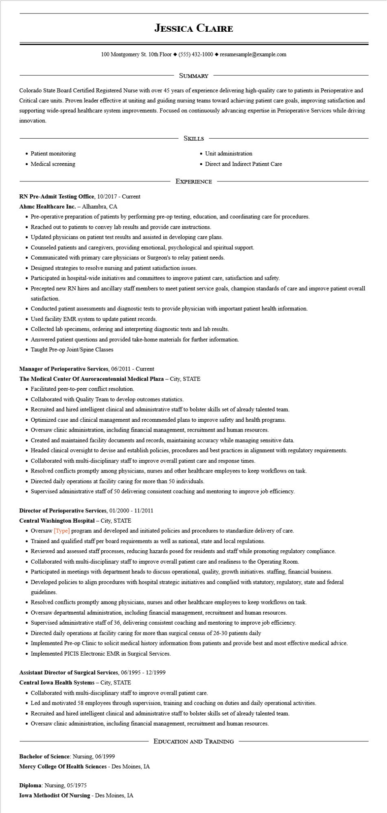

**JESSICA CLAIRE**

100 Montgomery St. 10th Floor (555) 432-1000◆ resumesample@example.com

SUMMARY

Colorado State Board Certified Registered Nurse with over 45 years of experience delivering high-quality care to patients in Perioperative and Critical care units. Proven leader effective at uniting and guiding nursing teams toward achieving patient care goals, improving satisfaction and supporting wide-spread healthcare system improvements. Focused on continuously advancing expertise in Perioperative Services while driving innovation.

• Patient monitoring

• Medical screening

SKILLS

• Unit administration

• Direct and Indirect Patient Care

EXPERIENCE

RN Pre-Admit Testing Office, 10/2017 - Current

**Ahmc Healthcare Inc. - Alhambra, CA**

• Pre-operative preparation of patients by performing pre-op testing, education, and coordinating care for procedures.

• Reached out to patients to convey lab results and provide care instructions.

• Updated physicians on patient test results and assisted in developing care plans.

• Counseled patients and caregivers, providing emotional, psychological and spiritual support.

• Communicated with primary care physicians or Surgeon's to relay patient needs.

• Designed strategies to resolve nursing and patient satisfaction issues.

• Participated in hospital-wide initiatives and committees to improve patient care, satisfaction and safety.

• Precepted new RN hires and ancillary staff members to meet patient service goals, champion standards of care and improve patient overall satisfaction.

• Conducted patient assessments and diagnostic tests to provide physician with important patient health information.

• Used facility EMR system to update patient records.

• Collected lab specimens, ordering and interpreting diagnostic tests and lab results.

• Answered patient questions and provided take-home materials for further information.

• Taught Pre-op Joint/Spine Classes

**Manager of Perioperative Services, 06/2011 - Current**

**The Medical Center Of Auroracentennial Medical Plaza - City, STATE**

• Facilitated peer-to-peer conflict resolution.

• Collaborated with Quality Team to develop outcomes statistics.

• Recruited and hired intelligent clinical and administrative staff to bolster skills set of already talented team.

• Optimized case and clinical management and recommended plans to improve safety and health programs.

• Oversaw clinic administration, including financial management, recruitment and human resources.

• Created and maintained facility documents and records, maintaining accuracy while managing sensitive data.

• Headed clinical oversight to devise and establish policies, procedures and best practices in alignment with regulatory requirements.

• Collaborated with multi-disciplinary staff to improve overall patient care and response times.

• Resolved conflicts promptly among physicians, nurses and other healthcare employees to keep workflows on task.

• Directed daily operations at facility caring for more than 50 individuals.

• Supervised administrative staff of 50 delivering consistent coaching and mentoring to improve job efficiency.

**Director of Perioperative Services, 01/2000 - 11/2011**

**Central Washington Hospital - City, STATE**

• Oversaw [Type] program and developed and initiated policies and procedures to standardize delivery of care.

• Trained and qualified staff per board requirements as well as national, state and local regulations.

• Reviewed and assessed staff processes, reducing hazards posed for residents and staff while promoting regulatory compliance.

• Collaborated with multi-disciplinary staff to improve overall patient care and readiness to the Operating Room.

• Participated in meetings with department heads to discuss operational, quality, growth initiatives. staffing, financial business.

• Developed policies to align procedures with hospital strategic initiatives and complied with statutory, regulatory, state and federal guidelines.

• Resolved conflicts promptly among physicians, nurses and other healthcare employees to keep workflows on task.

• Oversaw departmental administration, including financial management, recruitment and human resources.

• Supervised administrative staff of 36, delivering consistent coaching and mentoring to improve job efficiency.

• Directed daily operations at facility caring for more than surgical census of 26-30 patients daily

• Implemented Pre-op Clinic to solicit medical history information from patients and provide best and most effective medical advice.

• Implemented PICIS Electronic EMR in Surgical Services.

**Assistant Director of Surgical Services, 06/1995 - 12/1999**

**Central Iowa Health Systems - City, STATE**

• Collaborated with multi-disciplinary staff to improve overall patient care.

• Led and motivated 58 employees through supervision, training and coaching on duties and daily operational activities.

• Recruited and hired intelligent clinical and administrative staff to bolster skills set of already talented team.

• Oversaw clinic administration, including financial management, recruitment and human resources.

Bachelor of Science: Nursing, 06/1999

**Mercy College Of Health Sciences - Des Moines, IA**

**Diploma: Nursing, 05/1975**

Iowa Methodist Of Nursing - Des Moines, IA

**EDUCATION AND TRAINING**