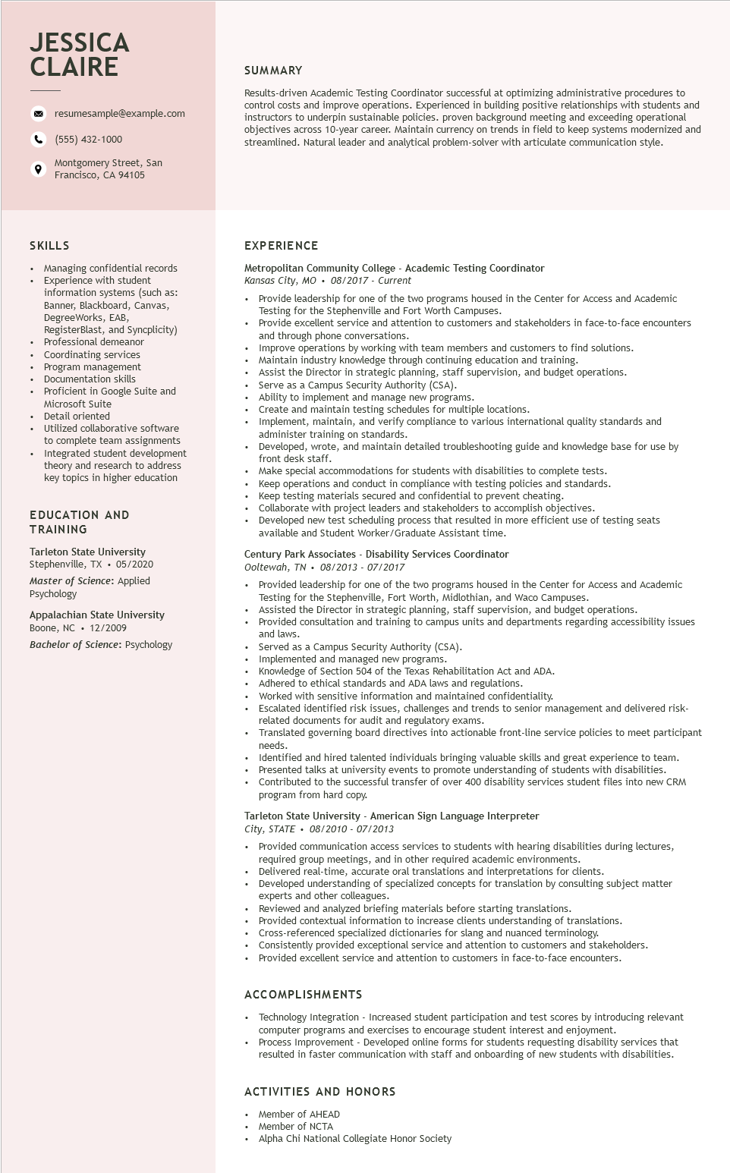

**JESSICA CLAIRE**

°

resumesample@example.com

(555) 432-1000

Montgomery Street, San Francisco, CA 94105

SUMMARY

Results-driven Academic Testing Coordinator successful at optimizing administrative procedures to control costs and improve operations. Experienced in building positive relationships with students and instructors to underpin sustainable policies. proven background meeting and exceeding operational objectives across 10-year career. Maintain currency on trends in field to keep systems modernized and streamlined. Natural leader and analytical problem-solver with articulate communication style.

SKILLS

Managing confidential records Experience with student

information systems (such as: Banner, Blackboard, Canvas, Degree Works, EAB,

RegisterBlast, and Syncplicity) Professional demeanor Coordinating services Program management Documentation skills

Proficient in Google Suite and

Microsoft Suite Micros

• Detail oriented

Utilized collaborative software to complete team assignments

• Integrated student development theory and research to address key topics in higher education

EDUCATION AND TRAINING

Tarleton State University

Stephenville, TX. 05/2020

Master of Science: Applied Psychology

Appalachian State University Boone, NC 12/2009

Bachelor of Science: Psychology

**EXPERIENCE**

Metropolitan Community College - Academic Testing Coordinator

*Kansas City, MO 08/2017 Current*

•

Provide leadership for one of the two programs housed in the Center for Access and Academic Testing for the Stephenville and Fort Worth Campuses.

Provide excellent service and attention to customers and stakeholders in face-to-face encounters and through phone conversations.

Improve operations by working with team members and customers to find solutions.

Maintain industry knowledge through continuing education and training.

Assist the Director in strategic planning, staff supervision, and budget operations.

Serve as a Campus Security Authority (CSA).

Ability to implement and manage new programs.

Create and maintain testing schedules for multiple locations.

• Implement, , maintain, and verify compliance to various international quality standards and rents man administer training on standards.

Developed, wrote, and maintain detailed troubleshooting guide and knowledge base for use by

desk staff.

Make special accommodations for students with disabilities to complete tests.

make special acc

Keep operations and conduct in compliance with testing policies and standards.

Keep testing materials secured and confidential to prevent cheating.

Collaborate with project leaders and stakeholders to accomplish objectives.

Developed new test scheduling process that resulted in more efficient use of testing seats available and Student Worker/Graduate Assistant time.

Century Park Associates - Disability Services Coordinator Ooltewah, TN 08/2013 - 07/2017

Provided leadership for one of the two programs housed in the Center for Access and Academic Testing for the Stephenville, Fort Worth, Midlothian, and Waco Campuses.

Assisted the Director in strategic planning, staff supervision, and budget operations.

Provided consultation and training to campus units and departments regarding accessibility issues and laws.

• Served as a Campus Security Authority (CSA).

Implemented and managed new programs.

Knowledge of Section 504 of the Texas Rehabilitation Act and ADA.

Adhered to ethical standards and ADA laws and regulations.

Worked with sensitive information and maintained confidentiality.

Escalated identified risk issues, challenges and trends to senior management and delivered risk- related documents for audit and regulatory exams.

Translated governing board directives into actionable front-line service policies to meet participant needs.

Identified and hired talented individuals bringing valuable skills and great experience to team. Presented talks at university events to promote understanding of students with disabilities. Contributed to the successful transfer of over 400 disability services student files into new CRM program from hard copy.

Tarleton State University American Sign Language Interpreter

*City, STATE*

•

*08/2010 - 07/2013*

Provided communication access services to students with hearing disabilities during lectures, required group meetings, and in other required academic environments.

Delivered real-time, accurate oral translations and interpretations for clients.

Developed understanding of specialized concepts for translation by consulting subject matter experts and other colleagues.

Reviewed and analyzed briefing materials before starting translations.

Provided contextual information to increase clients understanding of translations.

Cross-referenced specialized dictionaries for slang and nuanced terminology.

Consistently provided exceptional service and attention to customers and stakeholders. Provided excellent service and attention to customers in face-to-face encounters.

ACCOMPLISHMENTS

.

Technology Integration - Increased student participation and test scores by introducing relevant computer programs and exercises to encourage student interest and enjoyment.

Process Improvement - Developed online forms for students requesting disability services that resulted in faster communication with staff and onboarding of new students with disabilities.

ACTIVITIES AND HONORS

Member of AHEAD

Member of NCTA

Alpha Chi National Collegiate Honor Society