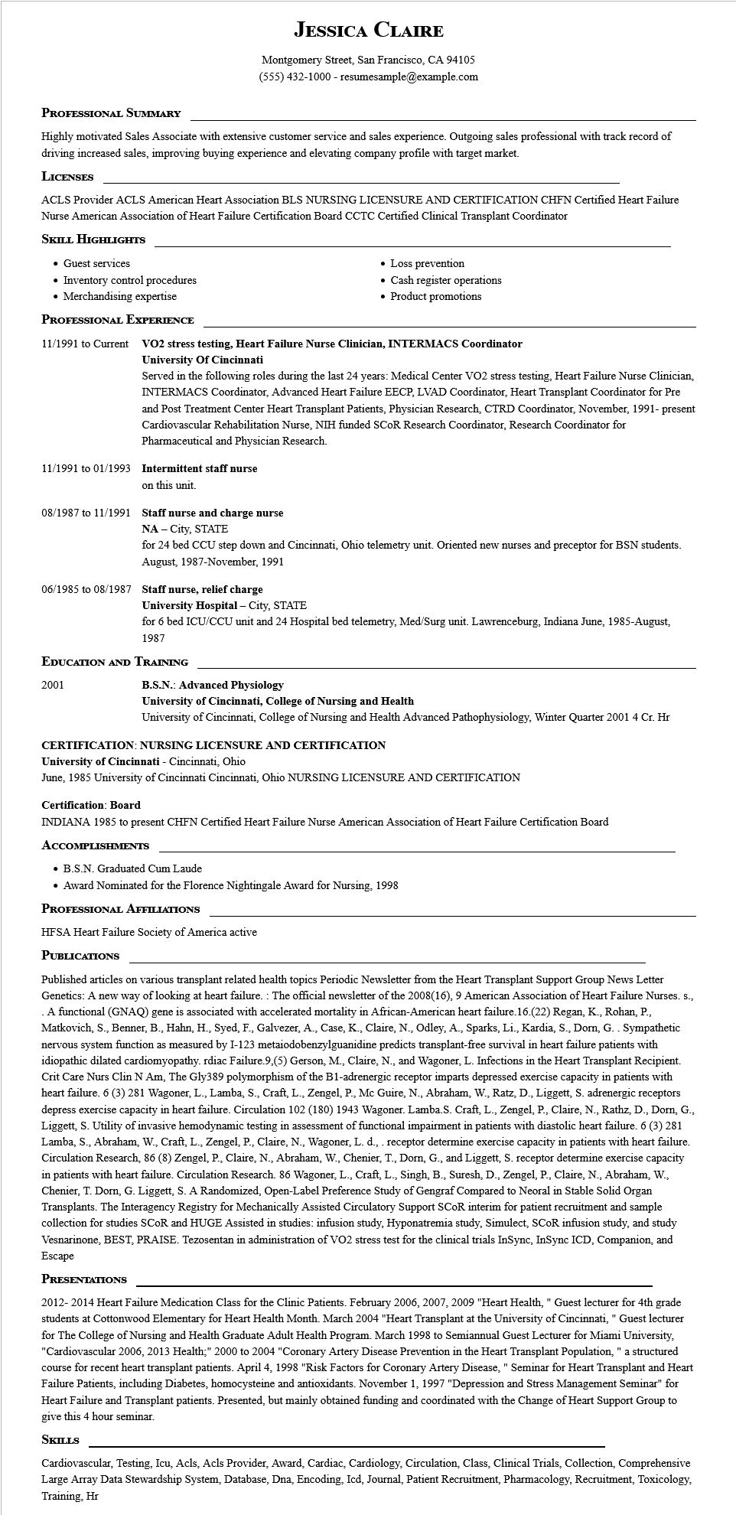

**JESSICA CLAIRE**

Montgomery Street, San Francisco, CA 94105

(555) 432-1000 - resumesample@example.com

**PROFESSIONAL SUMMARY**

Highly motivated Sales Associate with extensive customer service and sales experience. Outgoing sales professional with track record of driving increased sales, improving buying experience and elevating company profile with target market.

**LICENSES**

ACLS Provider ACLS American Heart Association BLS NURSING LICENSURE AND CERTIFICATION CHFN Certified Heart Failure Nurse American Association of Heart Failure Certification Board CCTC Certified Clinical Transplant Coordinator

**SKILL HIGHLIGHTS**

• Guest services

• Inventory control procedures

• Merchandising expertise

**PROFESSIONAL EXPERIENCE**

11/1991 to Current

• Loss prevention

Cash register operations

• Product promotions

**VO2 stress testing, Heart Failure Nurse Clinician, INTERMACS Coordinator University of Cincinnati**

Served in the following roles during the last 24 years: Medical Center VO2 stress testing, Heart Failure Nurse Clinician, INTERMACS Coordinator, Advanced Heart Failure EECP, LVAD Coordinator, Heart Transplant Coordinator for Pre and Post Treatment Center Heart Transplant Patients, Physician Research, CTRD Coordinator, November, 1991- present Cardiovascular Rehabilitation Nurse, NIH funded SCOR Research Coordinator, Research Coordinator for Pharmaceutical and Physician Research.

11/1991 to 01/1993 Intermittent staff nurse

on this unit.

**08/1987 to 11/1991 Staff nurse and charge nurse**

NA-City, STATE

for 24 bed CCU step down and Cincinnati, Ohio telemetry unit. Oriented new nurses and preceptor for BSN students. August, 1987-November, 1991

**06/1985 to 08/1987 Staff nurse, relief charge**

**University Hospital - City, STATE**

for 6 bed ICU/CCU unit and 24 Hospital bed telemetry, Med/Surg unit. Lawrenceburg, Indiana June, 1985-August, 1987

**EDUCATION AND TRAINING**

2001

**B.S.N.: Advanced Physiology**

**University of Cincinnati, College of Nursing and Health**

University of Cincinnati, College of Nursing and Health Advanced Pathophysiology, Winter Quarter 2001 4 Cr. Hr

**CERTIFICATION: NURSING LICENSURE AND CERTIFICATION**

**University of Cincinnati - Cincinnati, Ohio**

June, 1985 University of Cincinnati Cincinnati, Ohio NURSING LICENSURE AND CERTIFICATION

**Certification: Board**

INDIANA 1985 to present CHFN Certified Heart Failure Nurse American Association of Heart Failure Certification Board ACCOMPLISHMENTS

• B.S.N. Graduated Cum Laude

• Award Nominated for the Florence Nightingale Award for Nursing, 1998

**PROFESSIONAL AFFILIATIONS**

HFSA Heart Failure Society of America active

**PUBLICATIONS**

Published articles on various transplant related health topics Periodic Newsletter from the Heart Transplant Support Group News Letter Genetics: A new way of looking at heart failure. The official newsletter of the 2008(16), 9 American Association of Heart Failure Nurses. s., A functional (GNAQ) gene is associated with accelerated mortality in African-American heart failure.16.(22) Regan, K., Rohan, P., Matkovich, S., Benner, B., Hahn, H., Syed, F., Galvezer, A., Case, K., Claire, N., Odley, A., Sparks, Li., Kardia, S., Dorn, G.. Sympathetic nervous system function as measured by I-123 metaiodobenzylguanidine predicts transplant-free survival in heart failure patients with idiopathic dilated cardiomyopathy. rdiac Failure 9,(5) Gerson, M., Claire, N., and Wagoner, L. Infections in the Heart Transplant Recipient. Crit Care Nurs Clin N Am, The Gly389 polymorphism of the B1-adrenergic receptor imparts depressed exercise capacity in patients with heart failure. 6 (3) 281 Wagoner, L., Lamba, S., Craft, L., Zengel, P., Mc Guire, N., Abraham, W., Ratz, D., Liggett, S. adrenergic receptors depress exercise capacity in heart failure. Circulation 102 (180) 1943 Wagoner. Lamba.S. Craft, L., Zengel, P., Claire, N., Rathz, D., Dorn, G., Liggett, S. Utility of invasive hemodynamic testing in assessment of functional impairment in patients with diastolic heart failure. 6 (3) 281 Lamba, S., Abraham, W., Craft, L., Zengel, P., Claire, N., Wagoner, L. d., . receptor determine exercise capacity in patients with heart failure. Circulation Research, 86 (8) Zengel, P., Claire, N., Abraham, W., Chenier, T., Dorn, G., and Liggett, S. receptor determine exercise capacity in patients with heart failure. Circulation Research. 86 Wagoner, L., Craft, L., Singh, B., Suresh, D., Zengel, P., Claire, N., Abraham, W., Chenier, T. Dorn, G. Liggett, S. A Randomized, Open-Label Preference Study of Gengraf Compared to Neoral in Stable Solid Organ Transplants. The Interagency Registry for Mechanically Assisted Circulatory Support SCOR interim for patient recruitment and sample collection for studies SCOR and HUGE Assisted in studies: infusion study, Hyponatremia study, Simulect, SCOR infusion study, and study Vesnarinone, BEST, PRAISE. Tezosentan in administration of VO2 stress test for the clinical trials InSync, InSync ICD, Companion, and Escape

**PRESENTATIONS**

2012-2014 Heart Failure Medication Class for the Clinic Patients. February 2006, 2007, 2009 "Heart Health," Guest lecturer for 4th grade students at Cottonwood Elementary for Heart Health Month. March 2004 "Heart Transplant at the University of Cincinnati," Guest lecturer for The College of Nursing and Health Graduate Adult Health Program. March 1998 to Semiannual Guest Lecturer for Miami University, "Cardiovascular 2006, 2013 Health;" 2000 to 2004 "Coronary Artery Disease Prevention in the Heart Transplant Population," a structured course for recent heart transplant patients. April 4, 1998 "Risk Factors for Coronary Artery Disease," Seminar for Heart Transplant and Heart Failure Patients, including Diabetes, homocysteine and antioxidants. November 1, 1997 "Depression and Stress Management Seminar" for Heart Failure and Transplant patients. Presented, but mainly obtained funding and coordinated with the Change of Heart Support Group to give this hour seminar.

**SKILLS**

Cardiovascular, Testing, Icu, Acls, Acls Provider, Award, Cardiac, Cardiology, Circulation, Class, Clinical Trials, Collection, Comprehensive Large Array Data Stewardship System, Database, Dna, Encoding, Icd, Journal, Patient Recruitment, Pharmacology, Recruitment, Toxicology, Training, Hr