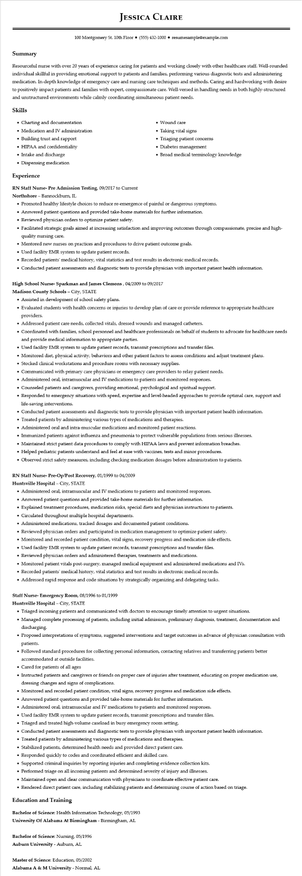

**JESSICA CLAIRE**

100 Montgomery St. 10th Floor⚫ (555) 432-1000⚫ resumesample@example.com

**Summary**

Resourceful nurse with over 20 years of experience caring for patients and working closely with other healthcare staff. Well-rounded individual skillful in providing emotional support to patients and families, performing various diagnostic tests and administering medication. In-depth knowledge of emergency care and nursing care techniques and methods. Caring and hardworking with desire to positively impact patients and families with expert, compassionate care. Well-versed in handling needs in both highly-structured and unstructured environments while calmly coordinating simultaneous patient needs.

**Skills**

• Charting and documentation

• Medication and IV administration

• Building trust and rapport

• HIPAA and confidentiality

• Intake and discharge

• Dispensing medication

**Experience**

**RN Staff Nurse- Pre Admission Testing, 09/2017 to Current**

Northshore - Bannockburn, IL

• Wound care

• Taking vital signs

• Triaging patient concerns

• Diabetes management

• Broad medical terminology knowledge

• Promoted healthy lifestyle choices to reduce re-emergence of painful or dangerous symptoms.

• Answered patient questions and provided take-home materials for further information.

• Reviewed physician orders to optimize patient safety.

• Facilitated strategic goals aimed at increasing satisfaction and improving outcomes through compassionate, precise and high- quality nursing care.

• Mentored new nurses on practices and procedures to drive patient outcome goals.

• Used facility EMR system to update patient records.

• Recorded patients' medical history, vital statistics and test results in electronic medical records.

• Conducted patient assessments and diagnostic tests to provide physician with important patient health information.

**High School Nurse- Sparkman and James Clemons, 04/2009 to 09/2017**

Madison County Schools - City, STATE

• Assisted in development of school safety plans.

• Evaluated students with health concerns or injuries to develop plan of care or provide reference to appropriate healthcare providers.

• Addressed patient care needs, collected vitals, dressed wounds and managed catheters.

• Coordinated with families, school personnel and healthcare professionals on behalf of students to advocate for healthcare needs and provide medical information to appropriate parties.

• Used facility EMR system to update patient records, transmit prescriptions and transfer files.

• Monitored diet, physical activity, behaviors and other patient factors to assess conditions and adjust treatment plans.

• Stocked clinical workstations and procedure rooms with necessary supplies.

• Communicated with primary care physicians or emergency care providers to relay patient needs.

• Administered oral, intramuscular and IV medications to patients and monitored responses.

• Counseled patients and caregivers, providing emotional, psychological and spiritual support.

• Responded to emergency situations with speed, expertise and level-headed approaches to provide optimal care, support and life-saving interventions.

• Conducted patient assessments and diagnostic tests to provide physician with important patient health information.

• Treated patients by administering various types of medications and therapies.

• Administered oral and intra-muscular medications and monitored patient reactions.

• Immunized patients against influenza and pneumonia to protect vulnerable populations from serious illnesses.

• Maintained strict patient data procedures to comply with HIPAA laws and prevent information breaches.

• Helped pediatric patients understand and feel at ease with vaccines, tests and minor procedures.

• Observed strict safety measures, including checking medication dosages before administration to patients.

RN Staff Nurse- Pre-Op/Post Recovery, 01/1999 to 04/2009

Huntsville Hospital - City, STATE

• Administered oral, intramuscular and IV medications to patients and monitored responses.

• Answered patient questions and provided take-home materials for further information.

• Explained treatment procedures, medication risks, special diets and physician instructions to patients.

• Circulated throughout multiple hospital departments.

• Administered medications, tracked dosages and documented patient conditions.

• Reviewed physician orders and participated in medication management to optimize patient safety.

• Monitored and recorded patient condition, vital signs, recovery progress and medication side effects.

• Used facility EMR system to update patient records, transmit prescriptions and transfer files.

• Reviewed physician orders and administered therapies, treatments and medications.

• Monitored patient vitals post-surgery, managed medical equipment and administered medications and IVs.

• Recorded patients' medical history, vital statistics and test results in electronic medical records.

• Addressed rapid response and code situations by strategically organizing and delegating tasks.

**Staff Nurse- Emergency Room, 08/1996 to 01/1999**

**Huntsville Hospital - City, STATE**

• Triaged incoming patients and communicated with doctors to encourage timely attention to urgent situations.

• Managed complete processing of patients, including initial admission, preliminary diagnosis, treatment, documentation and discharging.

• Proposed interpretations of symptoms, suggested interventions and target outcomes in advance of physician consultation with patients.

• Followed standard procedures for collecting personal information, contacting relatives and transferring patients better accommodated at outside facilities.

• Cared for patients of all ages

• Instructed patients and caregivers or friends on proper care of injuries after treatment, educating on proper medication use, dressing changes and signs of complications.

• Monitored and recorded patient condition, vital signs, recovery progress and medication side effects.

• Answered patient questions and provided take-home materials for further information.

• Administered oral, intramuscular and IV medications to patients and monitored responses.

• Used facility EMR system to update patient records, transmit prescriptions and transfer files.

• Triaged and treated high-volume caseload in busy emergency room setting.

• Conducted patient assessments and diagnostic tests to provide physician with important patient health information.

• Treated patients by administering various types of medications and therapies.

• Stabilized patients, determined health needs and provided direct patient care.

• Responded quickly to codes and coordinated efficient and skilled care.

• Supported criminal inquiries by reporting injuries and completing evidence collection kits.

• Performed triage on all incoming patients and determined severity of injury and illnesses.

• Maintained open and clear communication with physicians to coordinate effective patient care.

• Rendered direct patient care, including stabilizing patients and determining course of action based on triage.

**Education and Training**

Bachelor of Science: Health Information Technology, 05/1993

**University of Alabama At Birmingham - Birmingham, AL**

Bachelor of Science: Nursing, 05/1996

Auburn University - Auburn, AL

**Master of Science: Education, 05/2002**

Alabama A & M University - Normal, AL