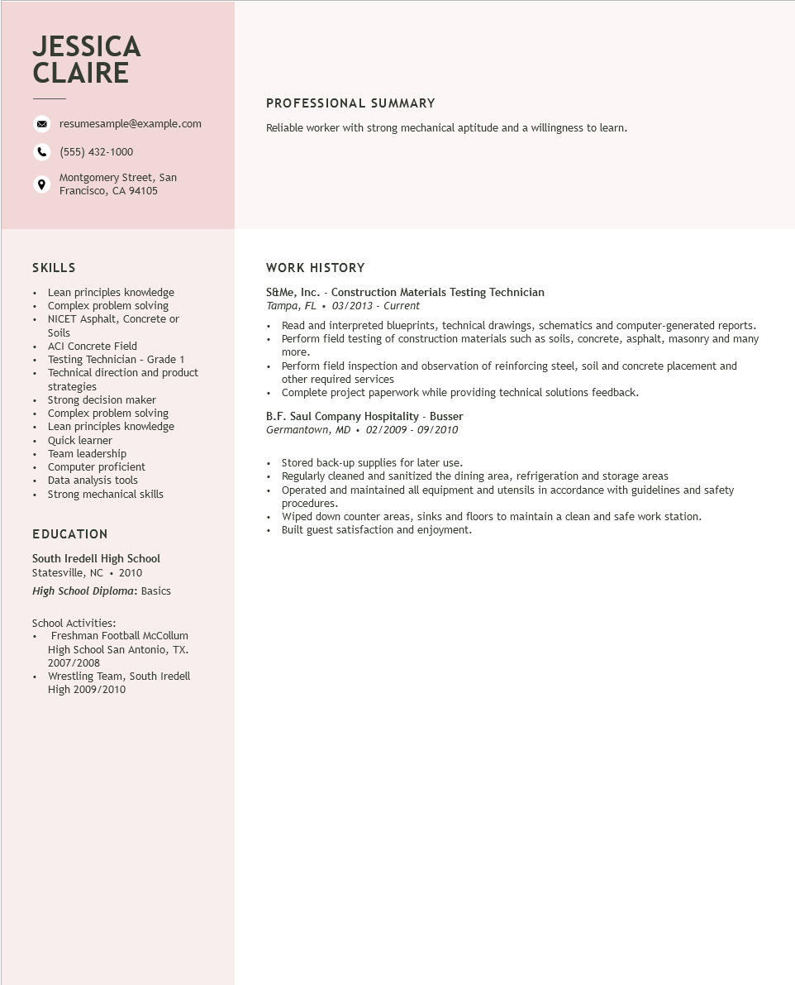

**JESSICA CLAIRE**

resumesample@example.com

(555) 432-1000

Montgomery Street, San Francisco, CA 94105

PROFESSIONAL SUMMARY

Reliable worker with strong mechanical aptitude and a willingness to learn.

SKILLS

• Lean principles knowledge

•

+

Complex problem solving

NICET Asphalt, Concrete or Soils

• ACI Concrete Field

•

·

•

•

•

Testing Technician - Grade 1

Technical direction and product strategies

Strong decision maker

Complex problem solving

Lean principles knowledge

Quick learner

Team leadership

Computer proficient

• Data analysis tools Strong mechanical skills

EDUCATION

South Iredell High School Statesville, NC. 2010 High School Diploma: Basics

School Activities:

+

Freshman Football McCollum High School San Antonio, TX. 2007/2008

Wrestling Team, South Iredell

High 2009/2010

**WORK HISTORY**

S&Me, Inc. - Construction Materials Testing Technician Tampa, FL. 03/2013 - Current

•

Read and interpreted blueprints, technical drawings, schematics and computer-generated reports. Perform field testing of construction materials such as soils, concrete, asphalt, masonry and many

•

more.

• Perform field inspection and observation of reinforcing steel, soil and concrete placement and other required services

• Complete project paperwork while providing technical solutions feedback.

B.F. Saul Company Hospitality - Busser Germantown, MD 02/2009 - 09/2010

Stored back-up supplies for later use.

Regularly cleaned and sanitized the dining area, refrigeration and storage areas

Operated and maintained all equipment and utensils in accordance with guidelines and safety procedures.

Wiped down counter areas, sinks and floors to maintain a clean and safe work station. Built guest satisfaction and enjoyment.