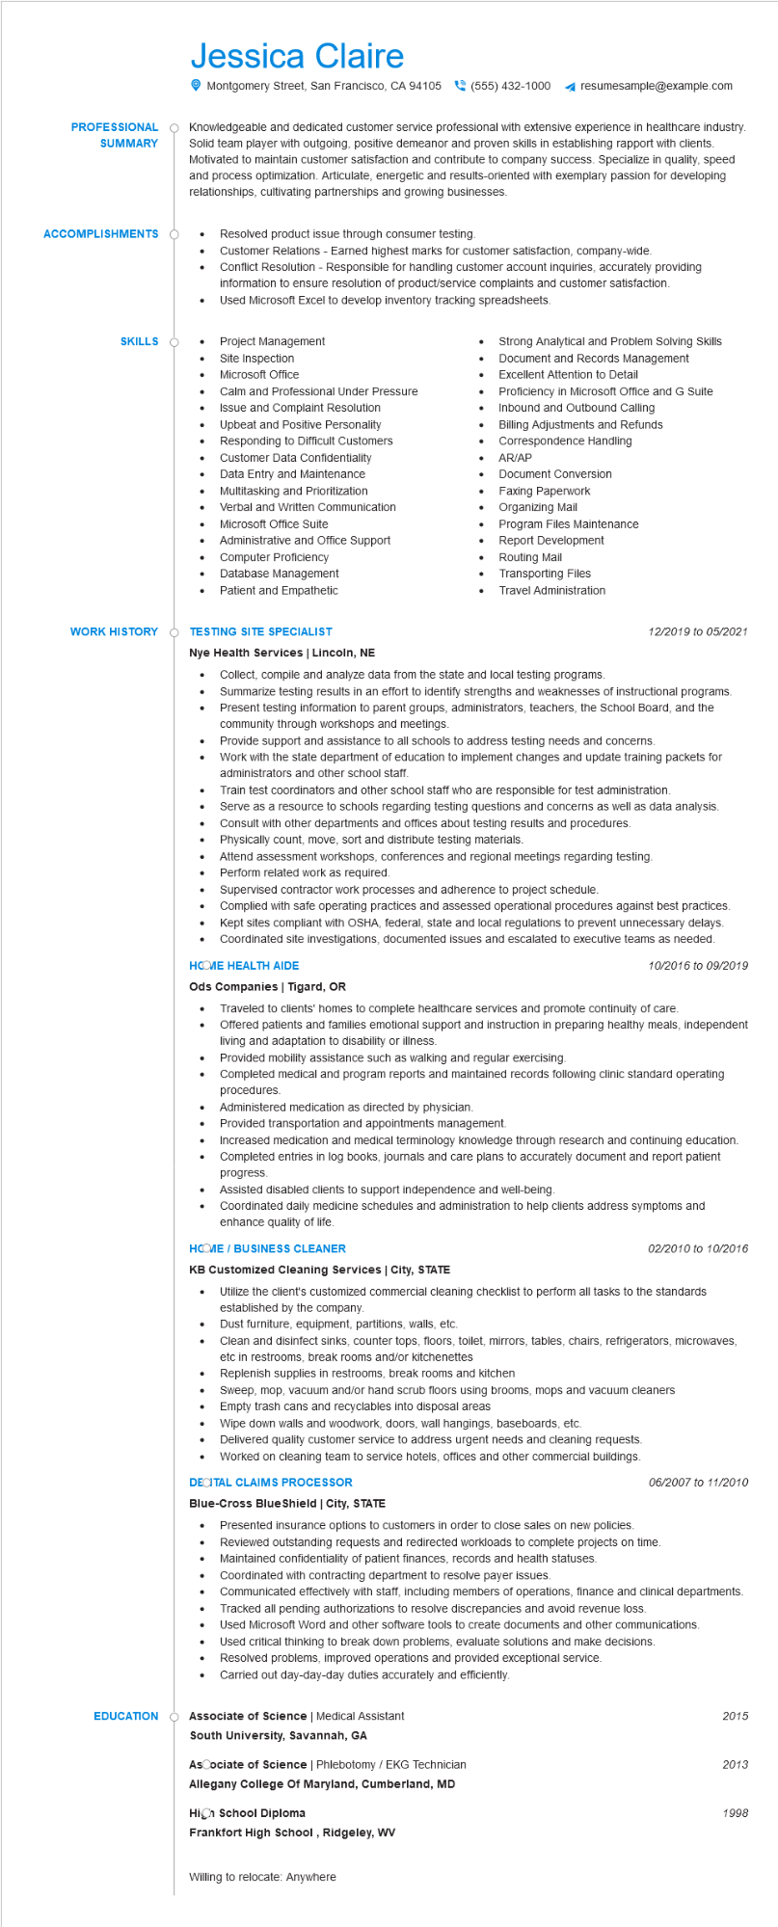

**PROFESSIONAL**

**SUMMARY**

**ACCOMPLISHMENTS**

**SKILLS**

Jessica Claire

Montgomery Street, San Francisco, CA 94105 (555) 432-1000

resumesample@example.com

Knowledgeable and dedicated customer service professional with extensive experience in healthcare industry. Solid team player with outgoing, positive demeanor and proven skills in establishing rapport with clients. Motivated to maintain customer satisfaction and contribute to company success. Specialize in quality, speed and process optimization. Articulate, energetic and results-oriented with exemplary passion for developing relationships, cultivating partnerships and growing businesses.

•

Resolved product issue through consumer testing.

Customer Relations - Earned highest marks for customer satisfaction, company-wide. Conflict Resolution - Responsible for handling customer account inquiries, accurately providing information to ensure resolution of product/service complaints and customer satisfaction. Used Microsoft Excel to develop inventory tracking spreadsheets.

•

Strong Analytical and Problem Solving Skills Document and Records Management Excellent Attention to Detail

Project Management

•

Site Inspection

Microsoft Office

Calm and Professional Under Pressure

•

Inbound and Outbound Calling

Proficiency in Microsoft Office and G Suite

•

•

•

Issue and Complaint Resolution

Upbeat and Positive Personality Responding to Difficult Customers

Customer Data Confidentiality

Data Entry and Maintenance

Multitasking and Prioritization

Verbal and Written Communication

Microsoft Office Suite

Administrative and Office Support

•

Computer Proficiency

Database Management

•

Patient and Empathetic

•

•

Billing Adjustments and Refunds

Correspondence Handling

AR/AP

Document Conversion

Faxing Paperwork

Organizing Mail

Program Files Maintenance Report Development

Routing Mail Transporting Files

Travel Administration

**WORK HISTORY**

**TESTING SITE SPECIALIST**

**Nye Health Services | Lincoln, NE**

• Collect, compile and analyze data from the state and local testing programs.

•

12/2019 to 05/2021

Summarize testing results in an effort to identify strengths and weaknesses of instructional programs.

Present testing information to parent groups, administrators, teachers, the School Board, and the community through workshops and meetings.

Provide support and assistance to all schools to address testing needs and concerns.

Work with the state department of education to implement changes and update training packets for administrators and other school staff.

**EDUCATION**

Serve as a resource to schools regarding testing questions and concerns as well as data analysis.

•

Train test coordinators and other school staff who are responsible for test administration.

•

Consult with other departments and offices about testing results and procedures.

•

Physically count, move, sort and distribute testing materials.

Attend assessment workshops, conferences and regional meetings regarding testing. Perform related work as required.

Supervised contractor work processes and adherence to project schedule.

Complied with safe operating practices and assessed operational procedures against best practices. Kept sites compliant with OSHA, federal, state and local regulations to prevent unnecessary delays. Coordinated site investigations, documented issues and escalated to executive teams as needed.

**HCOME HEALTH AIDE**

**Ods Companies | Tigard, OR**

......

10/2016 to 09/2019

Traveled to clients' homes to complete healthcare services and promote continuity of care.

Offered patients and families emotional support and instruction in preparing healthy meals, independent living and adaptation to disability or illness.

Provided mobility assistance such as walking and regular exercising.

Completed medical and program reports and maintained records following clinic standard operating procedures.

Administered medication as directed by physician.

Provided transportation and appointments management.

Increased medication and medical terminology knowledge through research and continuing education. Completed entries in log books, journals and care plans to accurately document and report patient progress.

Assisted disabled clients to support independence and well-being.

Coordinated daily medicine schedules and administration to help clients address symptoms and enhance quality of life.

**HCOME / BUSINESS CLEANER**

**KB Customized Cleaning Services | City, STATE**

02/2010 to 10/2016

• Utilize the client's customized commercial cleaning checklist to perform all tasks to the standards established by the company.

• Dust furniture, equipment, partitions, walls, etc.

Clean and disinfect sinks, counter tops, floors, toilet, mirrors, tables, chairs, refrigerators, microwaves, etc in restrooms, break rooms and/or kitchenettes

Replenish supplies in restrooms, break rooms and kitchen

Sweep, mop, vacuum and/or hand scrub floors using brooms, mops and vacuum cleaners

.

Empty trash cans and recyclables into disposal areas

Wipe down walls and woodwork, doors, wall hangings, baseboards, etc.

Delivered quality customer service to address urgent needs and cleaning requests.

• Worked on cleaning team to service hotels, offices and other commercial buildings. DECITAL CLAIMS PROCESSOR

**Blue-Cross BlueShield | City, STATE**

06/2007 to 11/2010

• Presented insurance options to customers in order to close sales on new policies. Reviewed outstanding requests and redirected workloads to complete projects on time. Maintained confidentiality of patient finances, records and health statuses.

•

Coordinated with contracting department to resolve payer issues.

Communicated effectively with staff, including members of operations, finance and clinical departments. Tracked all pending authorizations to resolve discrepancies and avoid revenue loss.

Used Microsoft Word and other software tools to create documents and other communications.

•

Used critical thinking to break down problems, evaluate solutions and make decisions. Resolved problems, improved operations and provided exceptional service.

Carried out day-day-day duties accurately and efficiently.

Associate of Science | Medical Assistant

**South University, Savannah, GA**

Ascociate of Science | Phlebotomy/EKG Technician

Allegany College Of Maryland, Cumberland, MD

**High School Diploma**

**Frankfort High School, Ridgeley, WV**

Willing to relocate: Anywhere

2015

2013

1998