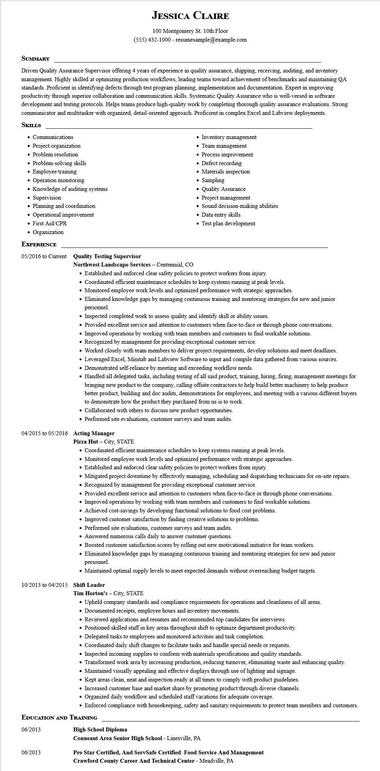

**JESSICA CLAIRE**

100 Montgomery St. 10th Floor (555) 432-1000 - resumesample@example.com

**SUMMARY**

Driven Quality Assurance Supervisor offering 4 years of experience in quality assurance, shipping, receiving, auditing, and inventory management. Highly skilled at optimizing production workflows, leading teams toward achievement of benchmarks and maintaining QA standards Proficient in identifying defects through test program planning, implementation and documentation. Expert in improving productivity through superior collaboration and communication skills. Systematic Quality Assurance who is well-versed in software development and testing protocols. Helps teams produce high-quality work by completing thorough quality assurance evaluations. Strong communicator and multitasker with organized, detail-oriented approach. Proficient in complex Excel and Labview deployments.

**SKILLS**

• Communications

• Project organization

• Problem resolution

• Problem-solving skills

• Employee training

• Operation monitoring

• Knowledge of auditing systems

• Supervision

• Planning and coordination

• Operational improvement

• First Aid/CPR

• Organization

**EXPERIENCE**

05/2016 to Current Quality Testing Supervisor

Northwest Landscape Services - Centennial, CO

• Inventory management

Team management

• Process improvement

• Defect recording

• Materials inspection

• Sampling

Quality Assurance

• Project management

• Sound decision-making abilities

• Data entry skills

• Test plan development

• Established and enforced clear safety policies to protect workers from injury.

• Coordinated efficient maintenance schedules to keep systems running at peak levels.

• Monitored employee work levels and optimized performance with strategic approaches.

• Eliminated knowledge gaps by managing continuous training and mentoring strategies for new and junior personnel.

• Inspected completed work to assess quality and identify skill or ability issues.

• Provided excellent service and attention to customers when face-to-face or through phone conversations.

• Improved operations by working with team members and customers to find workable solutions.

• Recognized by management for providing exceptional customer service.

• Worked closely with team members to deliver project requirements, develop solutions and meet deadlines.

• Leveraged Excel, Minitab and Labview Software to input and compile data gathered from various sources.

• Demonstrated self-reliance by meeting and exceeding workflow needs.

• Handled all delegated tasks, including testing of all said product, training, hiring, firing, management meetings for bringing new product to the company, calling offsite contractors to help build better machinery to help produce better product, building and doc audits, demonstrations for employees, and meeting with a various different buyers to demonstrate how the product they purchased from us is to work.

• Collaborated with others to discuss new product opportunities.

• Performed site evaluations, customer surveys and team audits.

04/2015 to 05/2016 Acting Manager

**Pizza Hut - City, STATE**

• Coordinated efficient maintenance schedules to keep systems running at peak levels.

• Monitored employee work levels and optimized performance with strategic approaches.

• Established and enforced clear safety policies to protect workers from injury.

• Mitigated project downtime by effectively managing, scheduling and dispatching technicians for on-site repairs.

• Recognized by management for providing exceptional customer service.

• Provided excellent service and attention to customers when face-to-face or through phone conversations.

• Improved operations by working with team members and customers to find workable solutions.

• Achieved cost-savings by developing functional solutions to food cost problems.

• Improved customer satisfaction by finding creative solutions to problems.

• Performed site evaluations, customer surveys and team audits.

• Answered numerous calls daily to answer customer questions.

• Boosted customer satisfaction scores by rolling out new motivational initiative for team workers.

• Eliminated knowledge gaps by managing continuous training and mentoring strategies for new and junior personnel.

• Maintained optimal supply levels to meet expected demands without overreaching budget targets.

10/2013 to 04/2015 Shift Leader

Tim Horton's - City, STATE

• Upheld company standards and compliance requirements for operations and cleanliness of all areas.

• Documented receipts, employee hours and inventory movements.

• Reviewed applications and resumes and recommended top candidates for interviews.

• Positioned skilled staff in key areas throughout shift to optimize department productivity.

• Delegated tasks to employees and monitored activities and task completion.

• Coordinated daily shift changes to facilitate tasks and handle special needs or requests.

• Inspected incoming supplies to conform with materials specifications and quality standards.

• Transformed work area by increasing production, reducing turnover, eliminating waste and enhancing quality.

• Maintained visually appealing and effective displays through use of lighting and signage.

• Kept areas clean, neat and inspection-ready at all times to comply with product guidelines.

• Increased customer base and market share by promoting product through diverse channels.

• Organized daily workflow and scheduled staff vacations for adequate coverage.

• Enforced compliance with housekeeping, safety and sanitary requirements to protect team members and customers.

**EDUCATION AND TRAINING**

06/2013

**High School Diploma**

**Conneaut Area Senior High School - Linesville, PA**

06/2013

**Pro Star Certified, And ServSafe Certified: Food Service And Management**

**Crawford County Career And Technical Center - Meadville, PA**