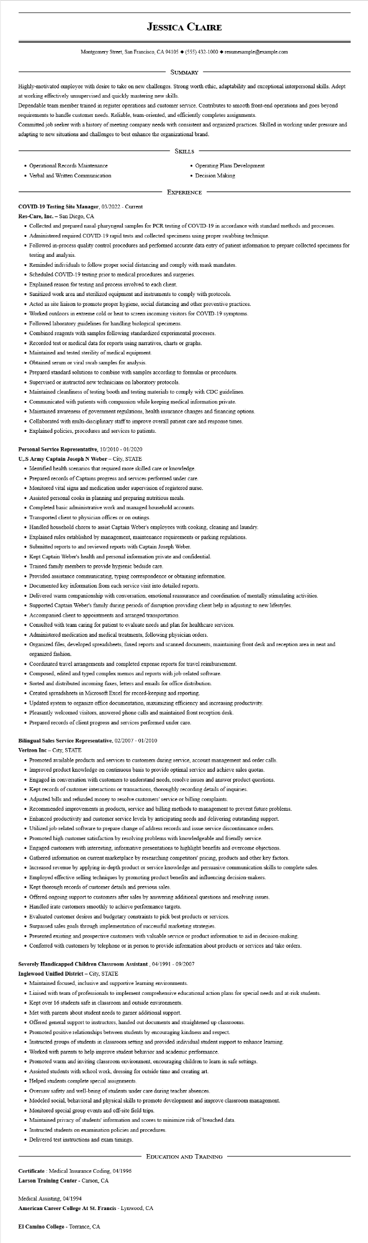

**JESSICA CLAIRE**

Montgomery Street, San Francisco, CA 94105 ♦ (555) 432-1000 resumesample@example.com

SUMMARY

Highly-motivated employee with desire to take on new challenges. Strong worth ethic, adaptability and exceptional interpersonal skills. Adept

at working effectively unsupervised and quickly mastering new skills.

Dependable team member trained in register operations and customer service. Contributes to smooth front-end operations and goes beyond requirements to handle customer needs. Reliable, team-oriented, and efficiently completes assignments.

Committed job seeker with a history of meeting company needs with consistent and organized practices. Skilled in working under pressure and adapting to new situations and challenges to best enhance the organizational brand.

• Operational Records Maintenance

• Verbal and Written Communication

SKILLS

• Operating Plans Development

• Decision Making

EXPERIENCE

COVID-19 Testing Site Manager, 03/2022 - Current

Res-Care, Inc. - San Diego, CA

• Collected and prepared nasal-pharyngeal samples for PCR testing of COVID-19 in accordance with standard methods and processes.

• Administered required COVID-19 rapid tests and collected specimens using proper swabbing technique.

• Followed in-process quality control procedures and performed accurate data entry of patient information to prepare collected specimens for testing and analysis.

• Reminded individuals to follow proper social distancing and comply with mask mandates.

• Scheduled COVID-19 testing prior to medical procedures and surgeries.

• Explained reason for testing and process involved to each client.

• Sanitized work area and sterilized equipment and instruments to comply with protocols.

• Acted as site liaison to promote proper hygiene, social distancing and other preventive practices.

• Worked outdoors in extreme cold or heat to screen incoming visitors for COVID-19 symptoms.

• Followed laboratory guidelines for handling biological specimens.

• Combined reagents with samples following standardized experimental processes.

• Recorded test or medical data for reports using narratives, charts or graphs.

• Maintained and tested sterility of medical equipment.

• Obtained serum or viral swab samples for analysis.

• Prepared standard solutions to combine with samples according to formulas or procedures.

• Supervised or instructed new technicians on laboratory protocols.

• Maintained cleanliness of testing booth and testing materials to comply with CDC guidelines.

• Communicated with patients with compassion while keeping medical information private.

• Maintained awareness of government regulations, health insurance changes and financing options.

• Collaborated with multi-disciplinary staff to improve overall patient care and response times.

• Explained policies, procedures and services to patients.

**Personal Service Representative, 10/2010 - 01/2020**

**U,.S Army Captain Joseph N Weber - City, STATE**

• Identified health scenarios that required more skilled care or knowledge.

• Prepared records of Captains progress and services performed under care.

• Monitored vital signs and medication under supervision of registered nurse.

• Assisted personal cooks in planning and preparing nutritious meals.

• Completed basic administrative work and managed household accounts.

• Transported client to physician offices or on outings.

• Handled household chores to assist Captain Weber's employees with cooking, cleaning and laundry.

• Explained rules established by management, maintenance requirements or parking regulations.

• Submitted reports to and reviewed reports with Captain Joseph Weber.

• Kept Captain Weber's health and personal information private and confidential.

• Trained family members to provide hygienic bedside care.

• Provided assistance communicating, typing correspondence or obtaining information.

• Documented key information from each service visit into detailed reports.

• Delivered warm companionship with conversation, emotional reassurance and coordination of mentally stimulating activities.

• Supported Captain Weber's family during periods of disruption providing client help in adjusting to new lifestyles.

• Accompanied client to appointments and arranged transportation.

• Consulted with team caring for patient to evaluate needs and plan for healthcare services.

• Administered medication and medical treatments, following physician orders.

• Organized files, developed spreadsheets, faxed reports and scanned documents, maintaining front desk and reception area in neat and organized fashion.

• Coordinated travel arrangements and completed expense reports for travel reimbursement.

• Composed, edited and typed complex memos and reports with job-related software.

• Sorted and distributed incoming faxes, letters and emails for office distribution.

• Created spreadsheets in Microsoft Excel for record-keeping and reporting.

• Updated system to organize office documentation, maximizing efficiency and increasing productivity.

• Pleasantly welcomed visitors, answered phone calls and maintained front reception desk.

• Prepared records of client progress and services performed under care.

**Bilingual Sales Service Representative, 02/2007 - 01/2010**

**Verizon Inc - City, STATE**

• Promoted available products and services to customers during service, account management and order calls.

• Improved product knowledge on continuous basis to provide optimal service and achieve sales quotas.

• Engaged in conversation with customers to understand needs, resolve issues and answer product questions.

• Kept records of customer interactions or transactions, thoroughly recording details of inquiries.

• Adjusted bills and refunded money to resolve customers' service or billing complaints.

• Recommended improvements in products, service and billing methods to management to prevent future problems.

• Enhanced productivity and customer service levels by anticipating needs and delivering outstanding support.

• Utilized job-related software to prepare change of address records and issue service discontinuance orders.

• Promoted high customer satisfaction by resolving problems with knowledgeable and friendly service.

• Engaged customers with interesting, informative presentations to highlight benefits and overcome objections.

• Gathered information on current marketplace by researching competitors' pricing, products and other key factors.

• Increased revenue by applying in-depth product or service knowledge and persuasive communication skills to complete sales.

• Employed effective selling techniques by promoting product benefits and influencing decision-makers.

• Kept thorough records of customer details and previous sales.

• Offered ongoing support to customers after sales by answering additional questions and resolving issues.

• Handled irate customers smoothly to achieve performance targets.

• Evaluated customer desires and budgetary constraints to pick best products or services.

• Surpassed sales goals through implementation of successful marketing strategies.

• Presented existing and prospective customers with valuable service or product information to aid in decision-making.

• Conferred with customers by telephone or in person to provide information about products or services and take orders.

**Severely Handicapped Children Classroom Assistant, 04/1991 - 09/2007**

**Inglewood Unified District - City, STATE**

• Maintained focused, inclusive and supportive learning environments.

• Liaised with team of professionals to implement comprehensive educational action plans for special needs and at-risk students.

• Kept over 16 students safe in classroom and outside environments.

• Met with parents about student needs to garner additional support.

• Offered general support to instructors, handed out documents and straightened up classrooms.

• Promoted positive relationships between students by encouraging kindness and respect.

• Instructed groups of students in classroom setting and provided individual student support to enhance learning.

• Worked with parents to help improve student behavior and academic performance.

• Promoted warm and inviting classroom environment, encouraging children to learn in safe settings.

• Assisted students with school work, dressing for outside time and creating art.

• Helped students complete special assignments.

• Oversaw safety and well-being of students under care during teacher absences.

• Modeled social, behavioral and physical skills to promote development and improve classroom management.

• Monitored special group events and off-site field trips.

• Maintained privacy of students' information and scores to minimize risk of breached data.

• Instructed students on examination policies and procedures.

• Delivered test instructions and exam timings.

EDUCATION AND TRAINING

Certificate: Medical Insurance Coding, 04/1996

**Larson Training Center - Carson, CA**

Medical Assisting, 04/1994

**American Career College At St. Francis - Lynwood, CA**

El Camino College - Torrance, CA