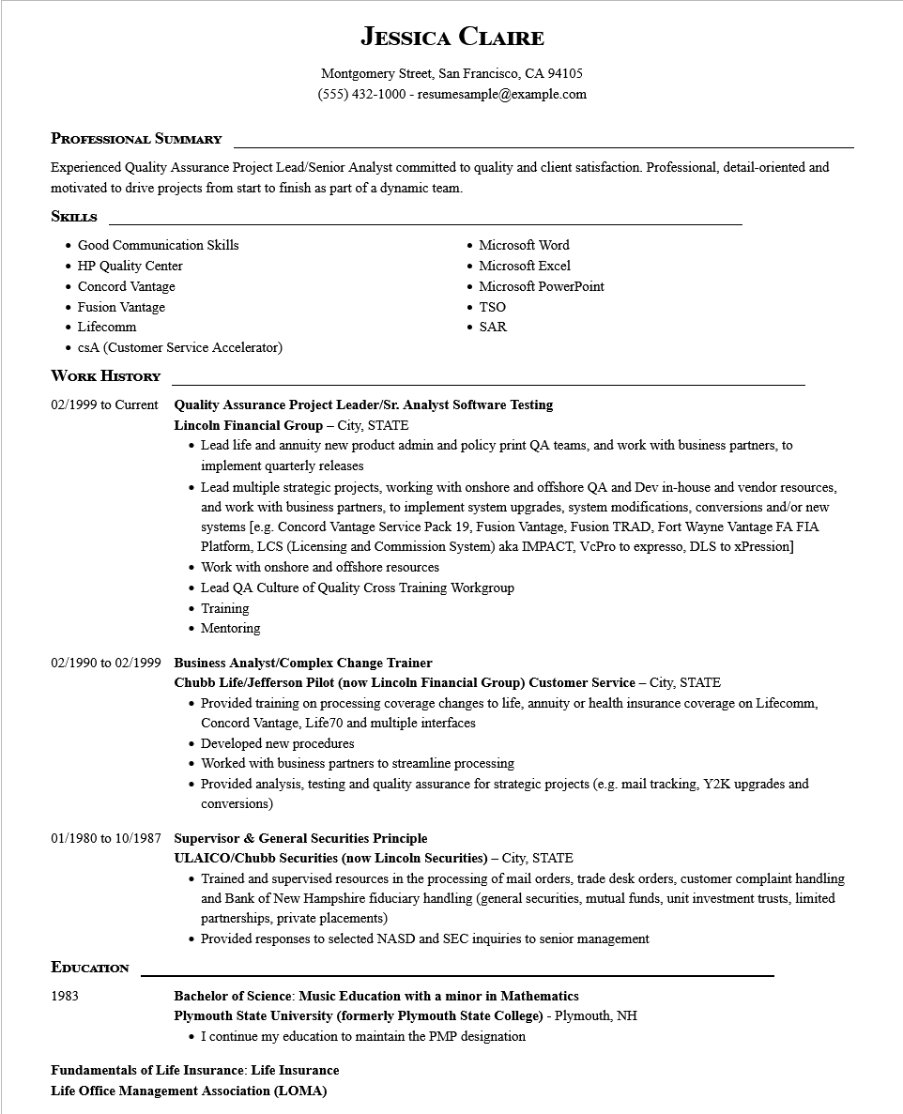

**JESSICA CLAIRE**

Montgomery Street, San Francisco, CA 94105

(555) 432-1000-resumesample@example.com

**PROFESSIONAL SUMMARY**

Experienced Quality Assurance Project Lead/Senior Analyst committed to quality and client satisfaction. Professional, detail-oriented and motivated to drive projects from start to finish as part of a dynamic team.

**SKILLS**

• Good Communication Skills

• HP Quality Center

• Concord Vantage

• Fusion Vantage

Microsoft Word

• Microsoft Excel

• Microsoft PowerPoint

• TSO

• Lifecomm

• CSA (Customer Service Accelerator)

**WORK HISTORY**

• SAR

**02/1999 to Current Quality Assurance Project Leader/Sr. Analyst Software Testing**

**Lincoln Financial Group - City, STATE**

• Lead life and annuity new product admin and policy print QA teams, and work with business partners, to implement quarterly releases

• Lead multiple strategic projects, working with onshore and offshore QA and Dev in-house and vendor resources, and work with business partners, to implement system upgrades, system modifications, conversions and/or new systems [e.g. Concord Vantage Service Pack 19, Fusion Vantage, Fusion TRAD, Fort Wayne Vantage FA FIA Platform, LCS (Licensing and Commission System) aka IMPACT, VcPro to expresso, DLS to xPression] • Work with onshore and offshore reso resources

• Lead QA Culture of Quality Cross Training Workgroup

• Training

• Mentoring

**02/1990 to 02/1999 Business Analyst/Complex Change Trainer**

**Chubb Life/Jefferson Pilot (now Lincoln Financial Group) Customer Service - City, STATE**

• Provided training on processing coverage changes to life, annuity or health insurance coverage on Lifecomm, Concord Vantage, Life70 and multiple interfaces

• Developed new procedures

• Worked with business partners to streamline processing

• Provided analysis, testing and quality assurance for strategic projects (e.g. mail tracking, Y2K upgrades and conversions)

**01/1980 to 10/1987 Supervisor & General Securities Principle**

**ULAICO/Chubb Securities (now Lincoln Securities) - City, STATE**

Trained and supervised resources in the processing of mail orders, trade desk orders, customer complaint handling and Bank of New Hampshire fiduciary handling (general securities, mutual funds, unit investment trusts, limited partnerships, private placements)

Provided responses to selected NASD and SEC inquiries to senior management

**EDUCATION**

1983

**Bachelor of Science: Music Education with a minor in Mathematics Plymouth State University (formerly Plymouth State College) - Plymouth, NH I continue my education to maintain the PMP designation**

**Fundamentals of Life Insurance: Life Insurance Life Office Management Association (LOMA)**