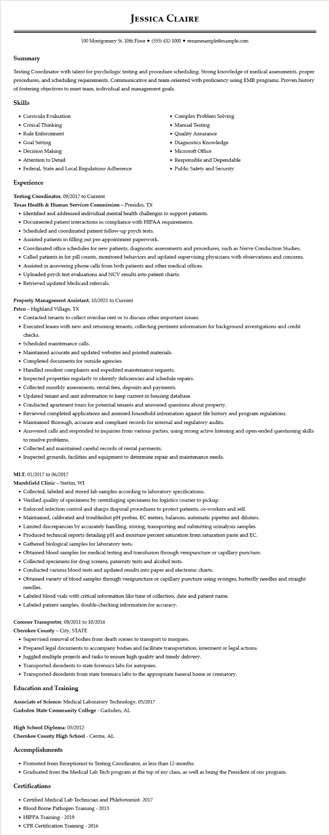

**JESSICA CLAIRE**

100 Montgomery St. 10th Floor (555) 432-1000⚫ resumesample@example.com

**Summary**

Testing Coordinator with talent for psychologic testing and procedure scheduling. Strong knowledge of medical assessments, proper procedures, and scheduling requirements. Communicative and team-oriented with proficiency using EMR programs. Proven history of fostering objectives to meet team, individual and management goals.

**Skills**

• Curricula Evaluation

• Critical Thinking

• Rule Enforcement

• Goal Setting

• Decision Making

• Attention to Detail

• Federal, State and Local Regulations Adherence

**Experience**

Testing Coordinator, 09/2017 to Current

Texas Health & Human Services Commission - Presidio, TX

•

Complex Problem Solving

• Manual Testing

• Quality Assurance

• Diagnostics Knowledge

• Microsoft Office

• Responsible and Dependable

• Public Safety and Security

• Identified and addressed individual mental health challenges to support patients.

• Documented patient interactions in compliance with HIPAA requirements.

• Scheduled and coordinated patient follow-up psych tests.

• Assisted patients in filling out pre-appointment paperwork.

• Coordinated office schedules for new patients, diagnostic assessments and procedures, such as Nerve Conduction Studies.

• Called patients in for pill counts, monitored behaviors and updated supervising physicians with observations and concerns.

• Assisted in answering phone calls from both patients and other medical offices.

• Uploaded psych test evaluations and NCV results into patient charts.

• Retrieved updated Medicaid referrals.

Property Management Assistant, 10/2021 to Current

Petco - Highland Village, TX

• Contacted tenants to collect overdue rent or to discuss other important issues.

• Executed leases with new and returning tenants, collecting pertinent information for background investigations and credit checks.

• Scheduled maintenance calls.

• Maintained accurate and updated websites and printed materials.

• Completed documents for outside agencies.

• Handled resident complaints and expedited maintenance requests.

• Inspected properties regularly to identify deficiencies and schedule repairs.

• Collected monthly assessments, rental fees, deposits and payments.

• Updated tenant and unit information to keep current in housing database.

• Conducted apartment tours for potential tenants and answered questions about property.

• Reviewed completed applications and assessed household information against file history and program regulations.

• Maintained thorough, accurate and compliant records for internal and regulatory audits.

• Answered calls and responded to inquiries from various parties, using strong active listening and open-ended questioning skills to resolve problems.

• Collected and maintained careful records of rental payments.

• Inspected grounds, facilities and equipment to determine repair and maintenance needs.

MLT, 01/2017 to 06/2017

Marshfield Clinic - Stettin, WI

• Collected, labeled and stored lab samples according to laboratory specifications.

• Verified quality of specimens by centrifuging specimens for logistics courier to pickup.

• Enforced infection control and sharps disposal procedures to protect patients, co-workers and self.

• Maintained, calibrated and troubleshot pH probes, EC meters, balances, automatic pipettes and diluters.

• Limited discrepancies by accurately handling, storing, transporting and submitting urinalysis samples.

• Produced technical reports detailing pH and moisture percent saturation from saturation paste and EC. • Gathered biological samples for laboratory tests.

• Obtained blood samples for medical testing and transfusion through venipuncture or capillary puncture.

• Collected specimens for drug screens, paternity tests and alcohol tests.

• Conducted various blood tests and updated results into paper and electronic charts.

• Obtained variety of blood samples through venipuncture or capillary puncture using syringes, butterfly needles and straight needles.

• Labeled blood vials with critical information like time of collection, date and patient name.

• Labeled patient samples, double-checking information for accuracy.

**Coroner Transporter, 08/2011 to 10/2016**

**Cherokee County - City, STATE**

• Supervised removal of bodies from death scenes to transport to morgues.

• Prepared legal documents to accompany bodies and facilitate transportation, interment or legal actions.

• Juggled multiple projects and tasks to ensure high quality and timely delivery.

• Transported decedents to state forensics labs for autopsies.

• Transported decedents from state forensics labs to the appropriate funeral home or crematory.

**Education and Training**

Associate of Science: Medical Laboratory Technology, 05/2017

**Gadsden State Community College - Gadsden, AL**

High School Diploma: 05/2012

**Cherokee County High School - Centre, AL**

**Accomplishments**

• Promoted from Receptionist to Testing Coordinator, in less than 12-months.

• Graduated from the Medical Lab Tech program at the top of my class, as well as being the President of our program.

**Certifications**

• Certified Medical Lab Technician and Phlebotomist- 2017

• Blood Borne Pathogen Training - 2013

• HIPPA Training - 2019

• CPR Certification Training - 2016