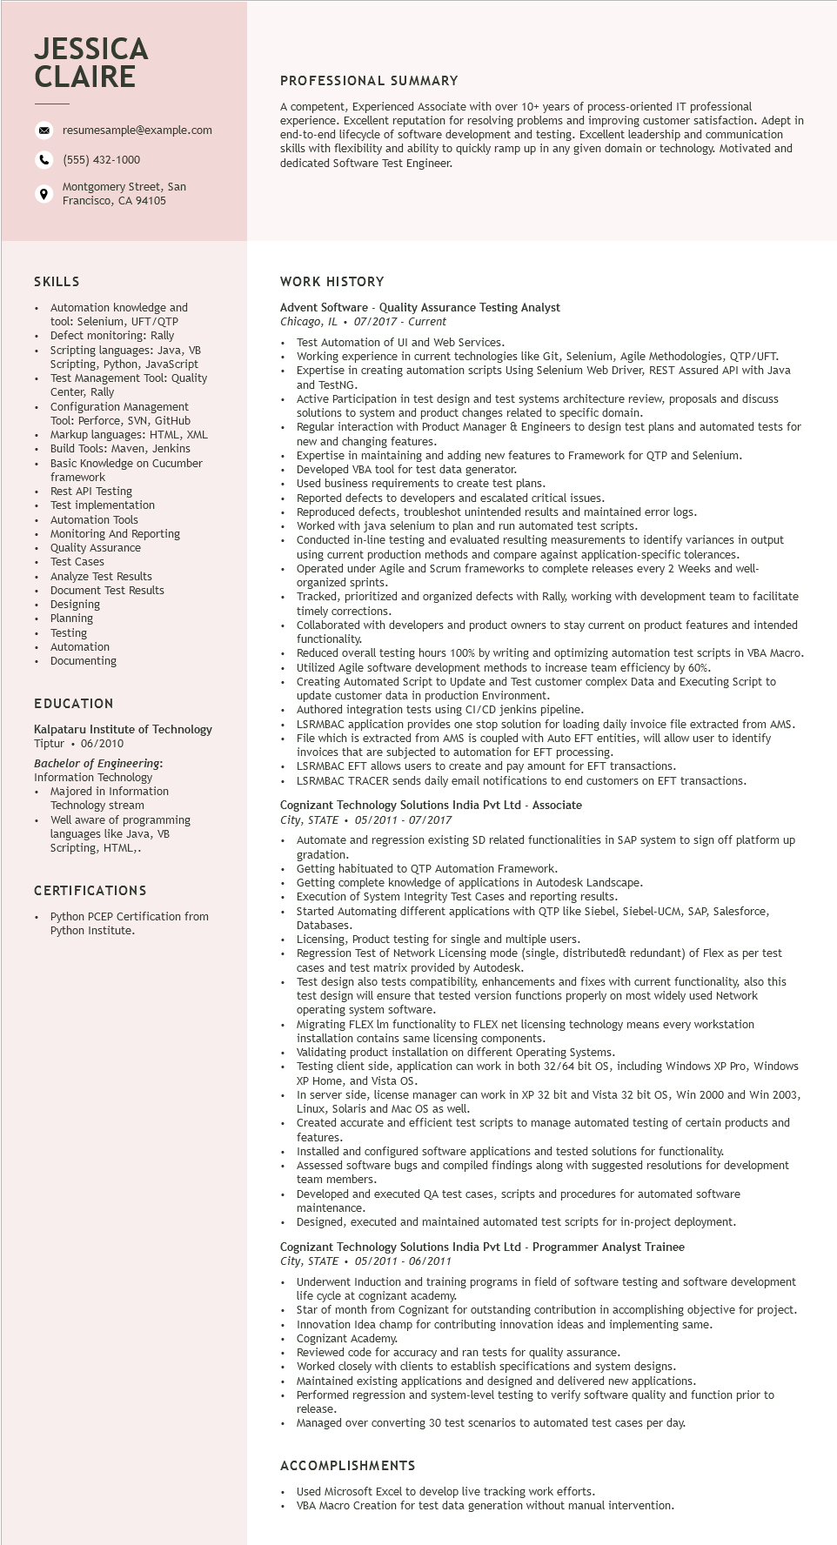

**JESSICA CLAIRE**

°

resumesample@example.com

(555) 432-1000

Montgomery Street, San Francisco, CA 94105

**PROFESSIONAL SUMMARY**

A competent, Experienced Associate with over 10+ years of process-oriented IT professional experience. Excellent reputation for resolving problems and improving customer satisfaction. Adept in end-to-end lifecycle of software development and testing. Excellent leadership and communication skills with flexibility and ability to quickly ramp up in any given domain or technology. Motivated and dedicated Software Test Engineer.

**SKILLS**

Automation knowledge and tool: Selenium, UFT/QTP Defect monitoring: Rally

• Scripting languages: Java, VB Python, JavaScript Scripting,

Test Management Tool: Quality Center, Rally

Configuration Management Tool: Perforce, SVN, GitHub

Markup languages: HTML, XML Build Tools:

Build Tools: Maven, Jenkins

Basic Knowledge on Cucumber

basic Nowic

framework

Rest API Testing

Test implementation

Automation Tools

• Monitoring And Reporting

• Quality Assurance

Test Cases

• Analyze Test Results

•

Document Test Results

• Designing

• Planning

Testing

• Automation

• Documenting

**EDUCATION**

Kalpataru Institute of Technology Tiptur 06/2010

Bachelor of Engineering:

Information Technology • Majored in Information Technology stream

Well aware of programming languages like Java, VB Scripting, HTML,.

CERTIFICATIONS

• Python PCEP Certification from

Python Institute.

WORK HISTORY

Advent Software - Quality Assurance Testing Analyst

*Chicago, IL 07/2017 - Current*

•

Test Automation of UI and Web Services.

• Working experience in current technologies like Git, Selenium, Agile Methodologies, QTP/UFT. Expertise in creating automation scripts Using Selenium Web Driver, REST Assured API with Java and TestNG.

• Active Participation in test design and test systems architecture review, proposals and discuss solutions to system and product changes related to specific domain.

Regular interaction with Product Manager & Engineers to design test plans and automated tests for new and changing features.

New and Chal

Expertise in maintaining and adding new features to Framework for QTP and Selenium.

Developed VBA tool for test data generator.

Used business requirements to create test plans.

Reported defects to developers and escalated critical issues.

Reproduced defects, troubleshot unintended results and maintained error logs.

Worked with java selenium to plan and run automated test scripts.

Conducted in-line testing and evaluated resulting measurements to identify variances in output

using current production methods and compare against application-specific tolerances. Operated under Agile and Scrum frameworks to complete releases every 2 Weeks and well- organized

d sprints.

Tracked, prioritized and organized defects with Rally, working with development team to facilitate timely corrections.

Collaborated with developers and product owners to stay current on product features and intended functionality.

Reduced overall testing hours 100% by writing and optimizing automation test scripts in VBA Macro. Utilized Agile software development methods to increase team efficiency by 60%.

Creating Automated Script to Update and Test customer complex Data and Executing Script to update e customer data in production Environment.

Authored I integration tests using CI/CD jenkins pipeline.

LSRMBAC application provides one stop solution for loading daily invoice file extracted from AMS.

File which is extracted from AMS is coupled with Auto EFT entities, will allow user to identify invoices that are subjected to automation for EFT processing.

LSRMBAC EFT allows users to create and pay amount for EFT transactions.

LSRMBAC TRACER sends daily email notifications to end customers on EFT transactions.

Cognizant Technology Solutions India Pvt Ltd - Associate

*City, STATE⚫ 05/2011 - 07/2017*

Automate and regression existing SD related functionalities in SAP system to sign off platform up gradation.

Getting habituated to QTP Automation Framework.

Getting complete knowledge of applications in Autodesk Landscape.

Execution of System Integrity Test Cases and reporting results.

Started Automating different applications with QTP like Siebel, Siebel-UCM, SAP, Salesforce, Databases.

Licensing, Product testing for single and multiple users.

Regression Test of Network Licensing mode (single, distributed& redundant) of Flex as per test cases and test matrix provided by Autodesk.

Test design also tests compatibility, enhancements and fixes with current functionality, also this test t design will ensure that tested version functions properly on most widely used Network operating system software.

Migrating FLEX Im functionality to FLEX net licensing technology means every workstation installation contains same licensing components.

Validating product installation on different Operating Systems.

Testing client side, application can work in both 32/64 bit OS, including Windows XP Pro, Windows XP Hon Home, and Vista OS.

In server side, license manager can work in XP 32 bit and Vista 32 bit OS, Win 2000 and Win 2003, Linux, Solaris and Mac OS as well.

Created accurate and efficient test scripts to manage automated testing of certain products and

features.

Installed and configured software applications and tested solutions for functionality.

Assessed software bugs and compiled findings along with suggested resolutions for development team members.

Developed and executed QA test cases, scripts and procedures for automated software maintenance.

Designed, executed and maintained automated test scripts for in-project deployment.

Cognizant Technology Solutions India Pvt Ltd - Programmer Analyst Trainee

*City, STATE⚫ 05/2011 - 06/2011*

Underwent Induction and training programs in field of software testing and software development life cycle at cognizant academy.

Star of month from Cognizant for outstanding contribution in accomplishing objective for project. Innovation Idea champ for contributing innovation ideas and implementing same.

Cognizant Academy.

Reviewed code for accuracy and ran tests for quality assurance.

Worked closely with clients to establish specifications and system designs.

Maintained existing applications and designed and delivered new applications.

Performed regression and system-level testing to verify software quality and function prior to release.

Managed over converting 30 test scenarios to automated test cases per day.

**ACCOMPLISHMENTS**

Used Microsoft Excel to develop live tracking work efforts.

VBA Macro Creation for test data generation without manual intervention.