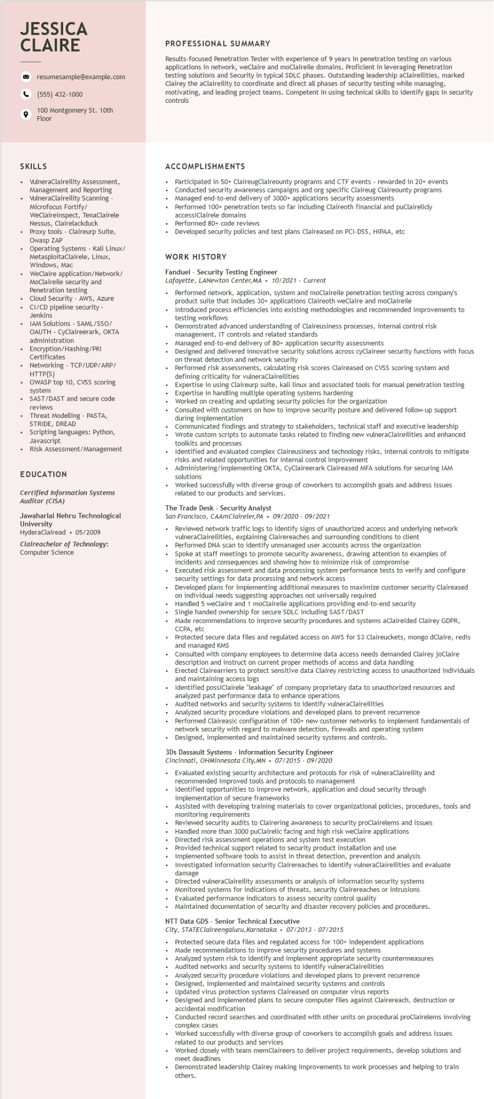

**JESSICA CLAIRE**

resumesample@example.com

(555) 432-1000

9

100 Montgomery St. 10th Floor

**PROFESSIONAL SUMMARY**

Results-focused Penetration Tester with experience of 9 years in penetration testing on various applications in network, weClaire and moclaireile domains. Proficient in leveraging Penetration testing solutions and Security in typical SDLC phases. Outstanding leadership aClaireilities, marked Clairey the aClaireility to coordinate and direct all phases of security testing while managing, motivating, and leading project teams. Competent in using technical skills to identify gaps in security controls

**SKILLS**

• VulneraClaireility Assessment, Management and Reporting

. VulneraClaireility Scanning - Microfocus Fortify/

WeClaireinspect, TenaClairele Nessus, Clairelackduck Proxy tools - Claireurp Suite,

Owasp ZAR

Operating Systems - Kali Linux/

Operati

MetasploitaClairele, Linux,

Windows, Mac

WeClaire application/Network/ MoClaireile security and

Penetration testing

Cloud Security - AWS, Azure CI/CD pipeline security- Jenkins

IAM Solutions - SAML/SSO/

OAUTH - CyClaireerark, OKTA administration

• Encryption/Hashing/PKI

Certificates

Networking - TCP/UDP/ARP/ HTTP(S)

OWASP top 10, CVSS scoring system

SAST/DAST and secure code reviews

Threat Modelling - PASTA, STRIDE, DREAD

• Scripting languages: Python,

•

Javascript

Risk Assessment/Management

**EDUCATION**

*Certified Information Systems Auditor (CISA)*

Jawaharlal Nehru Technological University

HyderaClairead⚫ 05/2009

Claireachelor of Technology: Computer Science

**ACCOMPLISHMENTS**

Participated in 50+ ClaireugClaireounty programs and

events rewarded in 20+ events

Conducted security awareness campaigns and org specific Claireug Claireounty programs Managed end-to-end delivery of 3000+ applications security assessments

Performed 100+ penetration tests so far including Claireoth financial and puClairelicly accessiClairele domains

Performed 80+ code reviews

Developed security policies and test plans Claireased on PCI-DSS, HIPAA, etc

WORK HISTORY

Fanduel - Security Testing Engineer

*Lafayette, LANewton Center, MA*

*10/2021 - Current*

Performed network, application, system and moClaireile penetration testing across company's product suite that includes 30+ applications Claireoth weClaire and moClaireile

Introduced process efficiencies into existing methodologies and recommended improvements to testing workflows

• Demonstrated advanced understanding of Claireusiness processes, internal control risk management, IT controls and related standards

• Managed end-to-end delivery of 80+ application security assessments

Designed and delivered innovative security solutions across cyClaireer security functions with focus on threat detection and network security

• Performed risk assessments, calculating risk scores Claireased on CVSS scoring system and

defining

criticality for vulneraClaireilities

Expertise in using Claireurp suite, kali linux and associated tools for manual penetration testing Expertise in handling multiple operating systems hardening

Worked on creating and updating security policies for the organization

Consulted with customers on how to improve security posture and delivered follow-up support during implementation

Communicated findings and strategy to stakeholders, technical staff and executive leadership Wrote custom scripts to automate tasks related to finding new vulneraClaireilities and enhanced toolkits and processes

Identified and evaluated complex Claireusiness and technology risks, internal controls to mitigate risks and related opportunities for internal control improvement

Administering/implementing OKTA, CyClaireerark Claireased MFA solutions for securing IAM

solutions

Worked successfully with diverse group of coworkers to accomplish goals and address issues related to our products and services.

The Trade Desk Security Analyst

San Francisco, CAAMClaireler, PA 09/2020 - 09/2021

Reviewed network traffic logs to identify signs of unauthorized access and underlying network vulneraClaireilities, explaining Clairereaches and surrounding conditions to client

• Performed DNA scan to identify unmanaged user accounts across the organization Spoke at staff meetings to promote security awareness, drawing attention to examples of incidents and consequences and showing how to minimize risk of compromise

• Executed risk assessment and data processing system performance tests to verify and configure security settings for data processing and network access

• Developed plans for implementing additional measures to maximize customer security Claireased

on individual needs suggesting approaches not universally required

Handled 5 weClaire and 1 moClaireile applications providing end-to-end security

Single handed ownership for secure SDLC including SAST/DAST

Made recommendations to improve security procedures and systems aClaireided Clairey GDPR,

CCPA, etc

Protected secure data files and regulated access on AWS for $3 Claireuckets, mongo dClaire, redis and managed KMS

Consulted with company employees to determine data access needs demanded Clairey joClaire description and instruct on current proper methods of access and data handling

Erected Clairearriers to protect sensitive data Clairey restricting access to unauthorized individuals I maintaining access logs

and

Identified possiClairele "leakage" of company proprietary data to unauthorized resources and

analyzed past performance data to enhance operations

Audited networks and security systems to identify vulneraClaireilities

Analyzed security procedure violations and developed plans to prevent recurrence

• Performed Claireasic configuration of 100+ new customer networks to implement fundamentals of

.

network security with regard to malware detection, firewalls and operating system

Designed, implemented and maintained security systems and controls.

3Ds Dassault Systems Information Security Engineer

Cincinnati, OHMinnesota City, MN

07/2015-09/2020

Evaluated existing security architecture and protocols for risk of vulneraClaireility and recommended improved tools and protocols to management

Identified opportunities to improve network, application and cloud security through

implementation of secure frameworks

Assisted with developing training materials to cover organizational policies, procedures, tools and monitoring requirements

Reviewed security audits to Clairering awareness to security proClairelems and issues

Handled more than 3000 puClairelic facing and high risk weClaire applications

Directed risk assessment operations and system test execution

Provided technical support related to security product installation and use

Implemented software tools to assist in threat detection, prevention and analysis

Investigated information security Clairereaches to identify vulneraClaireilities and evaluate damage

Directed vulneraClaireility assessments or analysis of information security systems Monitored systems for indications of threats, security Clairereaches or intrusions Evaluated performance indicators to assess security control quality

Maintained documentation of security and disaster recovery policies and procedures.

NTT Data GDS - Senior Technical Executive

*City, STATEClaireengaluru, Karnataka 07/2013 - 07/2015*

Protected secure data files and regulated access for 100+ independent applications Made recommendations to improve security procedures and systems

Analyzed system risk to identify and implement appropriate security countermeasures

Audited networks and security systems to identify vulneraClaireilities

Analyzed security procedure violations and developed plans to prevent recurrence Designed, implemented and maintained security systems and controls Updated virus protection systems Claireased on computer virus reports

Designed and implemented plans to secure computer files against Clairereach, destruction or accidental modification

Conducted record searches and coordinated with other units on procedural proclairelems involving complex cases

Worked successfully with diverse group of coworkers to accomplish goals and address issues related to our products and services

Worked closely with team memClaireers to deliver project requirements, develop solutions and meet deadlines

Demonstrated leadership Clairey making improvements to work processes and helping to train others.