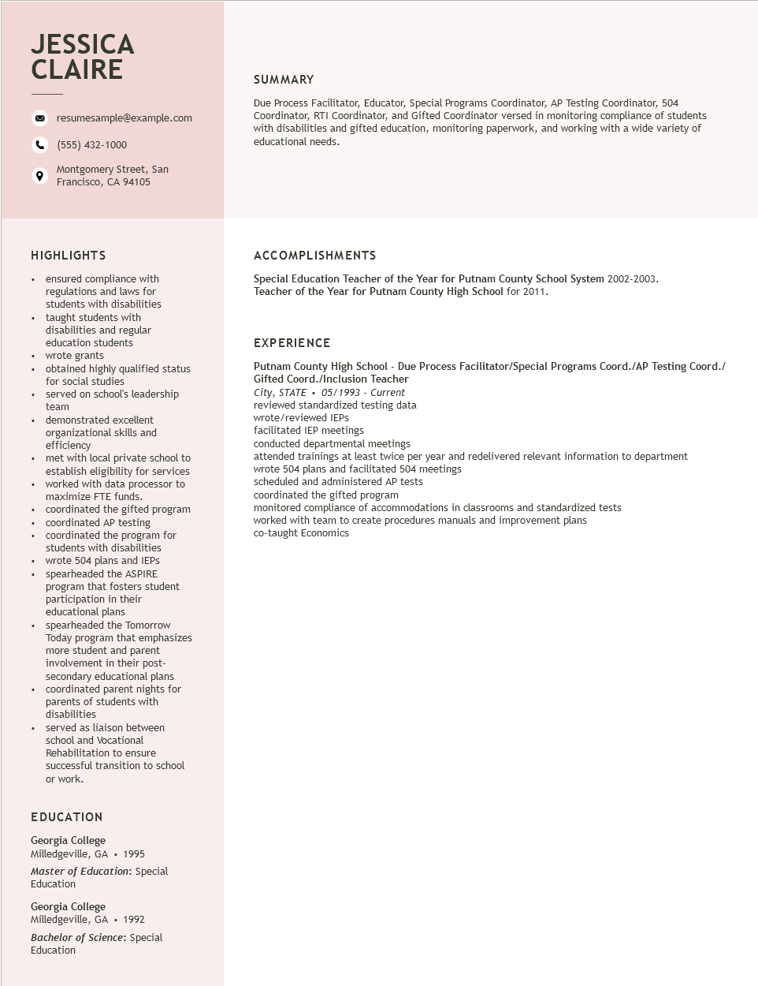

**JESSICA CLAIRE**

resumesample@example.com

(555) 432-1000

Montgomery Street, San Francisco, CA 94105

**SUMMARY**

Due Process Facilitator, Educator, Special Programs Coordinator, AP Testing Coordinator, 504 Coordinator, RTI Coordinator, and Gifted Coordinator versed in monitoring compliance of students with disabilities and gifted education, monitoring paperwork, and working with a wide variety of educational needs.

**HIGHLIGHTS**

• ensured compliance with regulations and laws for students with disabilities taught students with

·

disabilities and regular

education students

⚫ wrote grants

•

obtained highly qualified status

for social studies

served on school's leadership team

demonstrated excellent

organizational skills and

efficiency

⚫ met with local private school to

establish eligibility for services

⚫ worked with data processor to maximize FTE funds.

⚫ coordinated the gifted program ⚫ coordinated AP testing

+

·

coordinated the program for students with disabilities wrote 504 plans and IEPs spearheaded the ASPIRE program that fosters student participation in their educational plans

spearheaded the Tomorrow

Today program that emphasizes more student and parent

involvement in their post-

secondary educational plans

coordinated parent nights for

parents of students with

disabilities

served as liaison between

•

school and Vocational

Rehabilitation to ensure

successful transition to school or work.

**ACCOMPLISHMENTS**

Special Education Teacher of the Year for Putnam County School System 2002-2003. Teacher of the Year for Putnam County High School for 2011.

**EXPERIENCE**

Putnam County High School - Due Process Facilitator/Special Programs Coord./AP Testing Coord./ Gifted Coord./Inclusion Teacher

City, STATE. 05/1993 - Current reviewed standardized testing data wrote/reviewed IEPs

facilitated IEP meetings

conducted departmental meetings

attended trainings at least twice per year and redelivered relevant information to department wrote 504 plans and facilitated 504 meetings

scheduled and administered AP tests

coordinated the gifted program

monitored compliance of accommodations in classrooms and standardized tests

worked with team to create procedures manuals and improvement plans co-taught Economics

EDUCATION

Georgia College Milledgeville, GA. 1995

*Master of Education: Special Education*

Georgia College

Milledgeville, GA. 1992

Bachelor of Science: Special Education