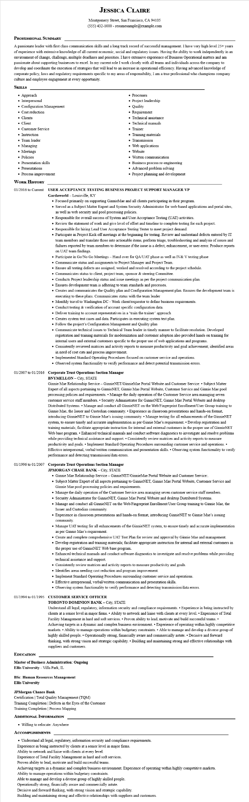

**JESSICA CLAIRE**

Montgomery Street, San Francisco, CA 94105

(555) 432-1000 - resumesample@example.com

**PROFESSIONAL SUMMARY**

A passionate leader with first class communication skills and a long track record of successful management. I have very high level 25+ years of experience with extensive knowledge of all current economic, social and regulatory issues. Having the ability to work independently in an environment of change, challenge, multiple deadlines and priorities. I have extensive experience of Business Operational matters and am passionate about supporting businesses to excel. In my current role I work closely with all teams and individuals across the company to develop and coordinate the execution of strategies that will lead to an increase in operational efficiency. Having advanced knowledge of corporate policy, laws and regulatory requirements specific to my areas of responsibility, I am a true professional who champions company culture and employee engagement at every opportunity.

**SKILLS**

• Approach

• Interpersonal

• Configuration Management

• Cost reduction

• Clients

• Client

• Customer Service

• Instruction

• Team leader

• Managing

• Meetings

• Policies

• Presentation skills

• Presentations

• Process improvement

•

• Processes

• Project leadership

Quality

• Requirement

• Technical assistance

• Technical manuals

Trainer

• Training materials

• Transmission

• Web applications

• Website

• Written communication

• Business process re-engineering

• Advanced problem solving

• Project planning and development

**WORK HISTORY**

**01/2016 to Current USER ACCEPTANCE TESTING BUSINESS PROJECT SUPPORT MANAGER VP Gardaworld-Louisville, KY**

• Focused primarily on supporting GinnieMae and all clients participating in their program.

• Served as a Subject Matter Expert and System Security Administrator for web-based applications and portal sites, as well as web security and pool processing policies.

• Responsible for overall success of System and User Acceptance Testing (UAT) activities.

• Review the statement of work and give level of effort and timeline to complete testing for each project.

• Responsible for hiring Lead User Acceptance Testing Tester to meet project demand.

• Participate in Project Kick off meetings at the beginning for testing. Review and understand defects entered by IT team members and translate those into actionable items, perform triage, troubleshooting and analysis of issues and failures reported by team members to determine if the issue is a defect, enhancement, or user-error. Produce reports on UAT team findings.

• Participate in Go/No Go Meetings - Hand over for QA/UAT phase as well as IV & V testing phase

• Communicate status and assignments to Project Manager and Project Team.

• Ensure all testing defects are assigned, worked and resolved according to the project schedule.

• Communicates status to client, project team, sponsor & steering Committee.

• Conducts Project leadership status and issue meetings as per the project communication plan.

• Ensures development team is adhering to team standards and processes.

• Creates and communicates the Quality plan and Configuration Management plan. Ensures the development team is executing to these plans. Communicates status with the team leader

• Monthly travel to Washington DC - Work client/requestor to define business requirements.

• Conduct testing & verification of account specific configuration data.

• Deliver training to account representatives in a 'train the trainer' approach

• Creates system test cases and data. Participates in executing system test plan.

• Follow the project's Configuration Management and Quality plan

• Communicate technical issues to Technical Team leader in timely manner to facilitate resolution. Developed registration and training materials for modernization and customer adoption also provided hands on training for internal users and external customers specific to the proper use of web applications and programs.

• Consistently reviewed matrices and activity reports to measure productivity and goal achievement; identified areas in need of cost cuts and process improvement.

• Implemented Standard Operating Procedures focused on customer service and operations.

• Observed system functionality to verify performance and detect potential transmission errors.

**01/2007 to 01/2016 Corporate Trust Operations Section Manager**

**BNYMELLON - City, STATE**

Ginnie Mae Relationship Service - GinnieNET/Ginnie Mae Portal Website and Customer Service: Subject Matter Expert of all aspects pertaining to GinnieNET, Ginnie Mae Portal Website, Customer Service and Ginnie Mae pool processing policies and requirements. Manage the daily operation of the Customer Service area managing seven customer service staff members. Security Administrator for GinnieNET, Ginnie Mae Portal Website and desktop Distributed Systems. Manage and conduct all GinnieNET on the Web/Fingerprint Enrollment/User Group training to Ginnie Mae, the Issuer and Custodian community. Experience in classroom presentations and hands-on format, introducing GinnieNET to Ginnie Mae's issuing community. Manage testing for all enhancements of the GinnieNET system, to ensure timely and accurate implementation as per Ginnie Mae's requirement. • Develop registration and training materials; facilitate appropriate instruction for internal and external customers in the proper use of GinnieNET Web base program.⚫ Enhanced technical manuals and conduct software diagnostics to investigate and resolve problems while providing technical assistance and support. Consistently review matrices and activity reports to measure productivity and goals. Implement Standard Operating Procedures surrounding customer service and operations.⚫ Effective interpersonal, verbal/written communication and presentation skills. Observing system functionality to verify performance and detecting transmission/data errors.

**01/1996 to 01/2007 Corporate Trust Operations Section Manager**

**JPMORGAN CHASE BANK - City, STATE**

• Ginnie Mae Relationship Service - GinnieNET/GinnieMae Portal Website and Customer Service:.

• Subject Matter Expert of all aspects pertaining to GinnieNET, Ginnie Mae Portal Website, Customer Service and Ginnie Mae pool processing policies and requirements.

• Manage the daily operation of the Customer Service area managing seven customer service staff members.

• Security Administrator for GinnieNET, Ginnie Mae Portal Website and desktop Distributed Systems.

• Manage and conduct all GinnieNET on the Web/Fingerprint Enrollment/User Group training to Ginnie Mae, the Issuer and Custodian community.

• Experience in classroom presentations and hands-on format, introducing GinnieNET to Ginnie Mae's issuing community.

• Manage UAT testing for all enhancements of the GinnieNET system, to ensure timely and accurate implementation as per Ginnie Mae's requirement.

• Create and complete comprehensive UAT Test Plan for review and approval by Ginnie Mae and management.

• Develop registration and training materials; facilitate appropriate instruction for internal and external customers in the proper use of GinnieNET Web base program.

• Enhanced technical manuals and conduct software diagnostics to investigate and resolve problems while providing technical assistance and support.

• Consistently review matrices and activity reports to measure productivity and goals.

• Identifies areas needing cost reduction and program improvement.

• Implement Standard Operating Procedures surrounding customer service and operations.

• Effective interpersonal, verbal/written communication and presentation skills.

• Observing system functionality to verify performance and detecting transmission/data errors.

**01/1994 to 01/1995 CUSTOMER SERVICE OFFICER**

**TORONTO DOMINION BANK - City, STATE**

Understand all legal, regulatory, information security and compliance requirements. Experience in being instructed by clients at a senior level in major firms. Ability to network and liaise with clients at every level.⚫ Experience of Total Facility Management in hard and soft services. Proven ability to lead, motivate and build successful teams.⚫ Achieving targets in a dynamic and complex business environment. • Experience of operating within highly competitive markets. Ability to manage operations within budgetary constraints. Able to manage and develop a diverse group of highly skilled people.⚫ Operationally strong, financially aware and commercially astute.• Decisive and forward thinking, with strong vision and strategic capability.⚫ Building and maintaining strong and effective relationships with suppliers and customers.

**EDUCATION**

**Master of Business Administration: Ongoing**

**Ellis University - Villa Park, IL**

**BSC: Human Resources Management**

**Ellis University**

**JPMorgan Chance Bank**

Certification Total Quality Management (TQM)

Training Completion | Defects in the Eyes of the Customer

Training Completion | Process Mapping

**ADDITIONAL INFORMATION**

• Willing to relocate: Anywhere

**ACCOMPLISHMENTS**

• Understand all legal, regulatory, information security and compliance requirements.

Experience in being instructed by clients at a senior level in major firms.

Ability to network and liaise with clients at every level.

Experience of Total Facility Management in hard and soft services.

Proven ability to lead, motivate and build successful teams.

Achieving targets in a dynamic and complex business environment. Experience of operating within highly competitive markets.

Ability to manage operations within budgetary constraints.

Able to manage and develop a diverse group of highly skilled people.

Operationally strong, financially aware and commercially astute.

Decisive and forward thinking, with strong vision and strategic capability.

Building and maintaining strong and effective relationships with suppliers and customers.